Effects of Ants on the Reproductive Success of Pastinaca sativa
Jing Yang and Dana Dudle
Biology Department, DePauw University,
November 2005

Introduction

Pollinators are essential for the development of fruit and seed crops of many flowering plants. Ants are common flower visitors, and several empirical studies emphasize the interactions of ants and plants. In most of cases, ants are considered to be “villains” in floral interactions. Pollination biologists originated the concept of ants as “the prototype of nectar thieves” in the late 19th century. This concept has been continuously challenged by other biologists (Hickman 1974). Botanists and entomologists suggested the rarity of ants being successful pollinators is caused by the primary importance of their close relatives, such as bees, and their physical barriers, such as sticky tissues and glandular hairs that inhibit them from accessing flowers (Beattie et al. 1984). However, others have suggested that ants may contribute to higher reproductive success of some plants such as orchids (Bates 1979).

Study Species

Pastinaca sativa, the wild parsnip, is a biennial species of the family Apiaceae and a common plant in abandoned fields (Figure 1). Many wild parsnips live along the roads and trails of the DePauw University Nature Park. Most P. sativa begin to flower in early June and fruits start to develop three weeks after they have flowered. The inflorescence of this species is composed of many individual umbrella-like clusters called umbels (Figure 2). During the flowering season, the plants are visited by many insects, such as beetles, bees, and flies. In our observations, ants re the most common visitors on the plants in the DePauw Nature Park (Figure 3).
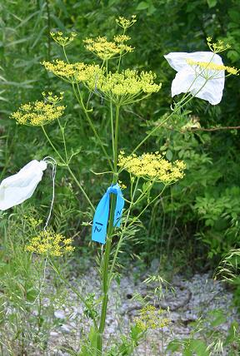
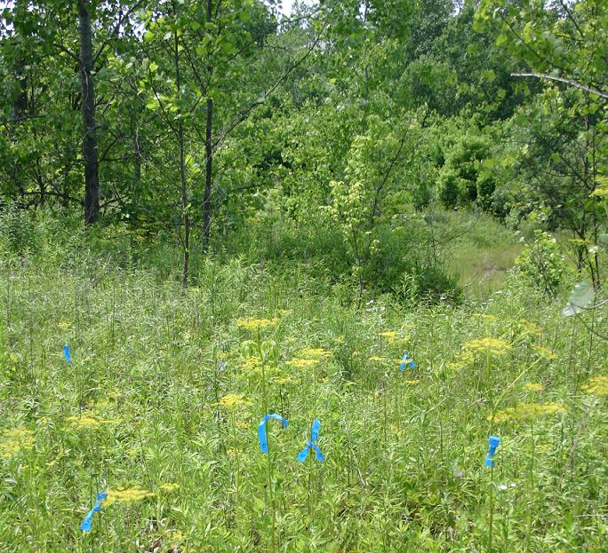
Figure 1. A small population of wild parsnip in an abandoned field.
As a species of the family Apiaceae, wild parsnip has a long flower stalk
with multiple umbrella-like clusters of yellow flowers.

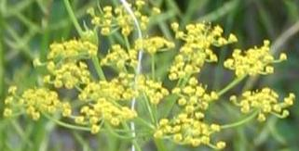
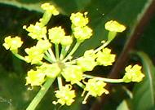

Figure 2. Each umbrella-like clusters of yellow flowers is called an umbel (left), and
every umbel is made up of numerous umbellets (right).

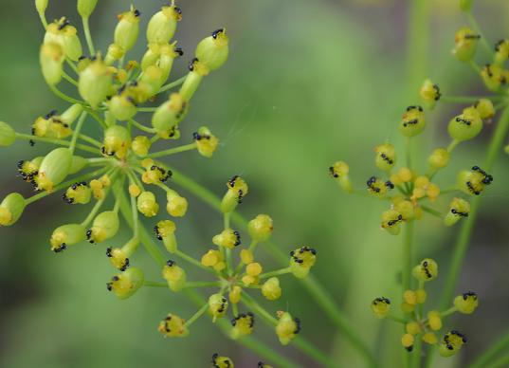
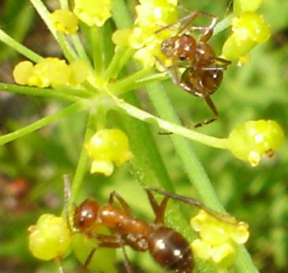
Figure 3. Starting at the end of May, the wild parsnip begins to flower. The blossom of the plant attracts large numbers of both small black ants (left) and red ants (right).

Purpose

In this study, we are assessing the importance of ant visitors in the reproductive success of Pastinaca sativa (wild parsnips). Do ants contribute to the reproductive success of the plants? Do ants pollinate P. sativa? If ants are excluded from plants, do plants produce fewer seeds?

Methods

We observed a small population of wild parsnip, Pastinaca sativa) in the DePauw University Nature Park. We conducted two different sets of pollinator exclusion experiments with either two or four types of treatments on 41 individual plants.

Pollinator Exclusion

We chose 31 individual plants, all of a similar developmental stage, from one patch of plants. All individual plants were marked and labeled immediately. On each individual plant, four umbels of similar size were randomly assigned to one of four treatments (Figure 4):

1. Open pollination: no insects were excluded
2. Crawling insect exclusion: Tanglefoot was applied to the stem of the umbel.
3. Flying insect exclusion: a wire bag was placed around the umbel
4. All insect exclusion: both Tanglefoot and a wire bag were applied to the flower

Some plants were lost after a storm and by the weight of the net bag. Thus, we chose 10 more wild parsnips for the second set of pollination experiments. The second set of pollination experiments consisted of two treatments: 1. Open pollination and 2. Crawling insect exclusion. Tanglefoot was applied to the umbel assigned to crawling exclusion treatment.

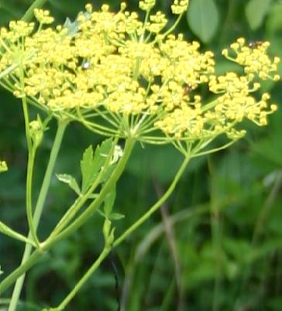
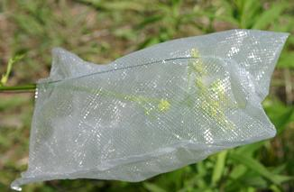
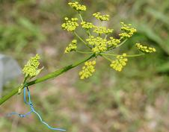
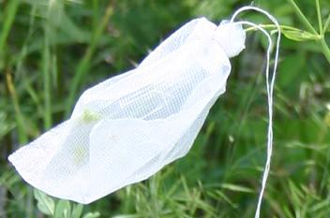
Figure 4. – Open-pollinated umbels were untreated and were free for the insect visitors (top left). To exclude crawling insects, a layer of Tanglefoot was applied to the stem of the umbel (bottom left). To exclude flying insects, a wire bag was placed around the umbel so that only crawling insects were allowed (top right). To exclude both flying and crawling insects, a wire bag and Tanglefoot were applied at the same time (bottom right).

Pollinator Observation

During the first two weeks of June, we surveyed the initial number of flowers and the date of flowering. Furthermore, the effectiveness of the treatments was assessed everyday to ensure the accuracy of the data.

On June 19, we observed pollinator visitation for three 10-minute periods on the open-pollinated and crawling-insect exclusion umbels of ten plants. During each 10-minute period, we recorded (a) the number of insects that were present on the umbel when the observation started and (b) the number of insects that arrived during the 10-minute period.

Also on June 19, we recorded the morphology of the labeled plants. We measured plant height, inflorescence density, light intensity, and presence of flowering neighbors.

Fruit Set Assessment

During the first week of July, we collected each labeled umbel and counted the number of fruits and seeds per umbel. Each fruit was examined on a light box to count the number of seeds it contained (Figure 5). When the light box is on, the light passes through the surface if there are not any opaque materials, such as the seeds inside the fruit. The light fills up the empty fruits, making them transparent when observed in a dark room.

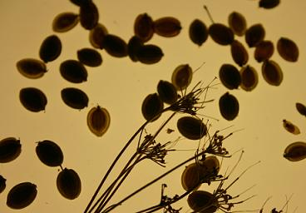
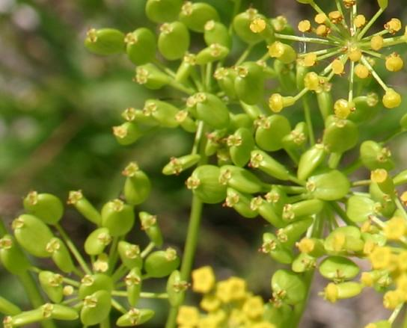
Figure 5. Wild parsnip fruits on the plant (far left) and on the top of the light box (near left and bottom). Fruits can successfully produce up to 2 seeds.
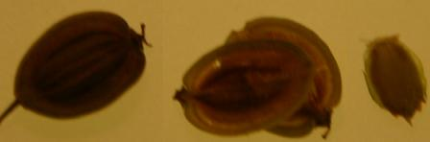

Results

Does the initial number of flowers per umbel vary among treatments? NO. There were no significant differences in the number of flowers per umbel for the four treatments (Figure 6; df = 95, p = 0.71). This means the umbels may be compared across the treatments.

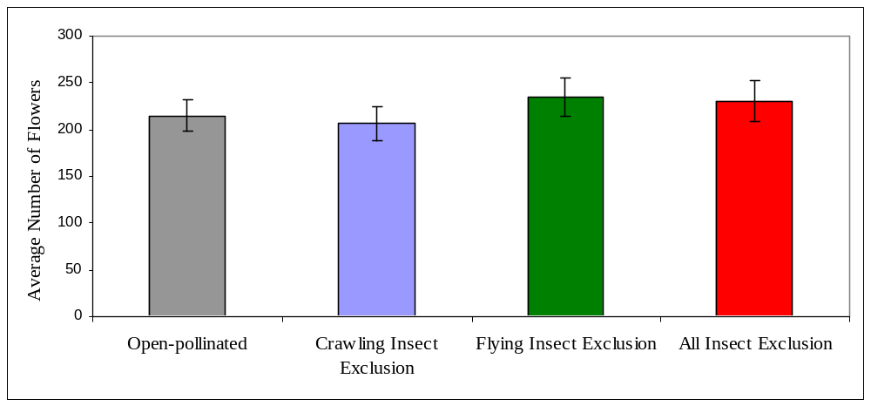
Figure 6. Average initial number of flowers per umbel for the four treatments.

Does the height of inflorescences differ among treatments? NO. The heights of the 96 inflorescences on the first 30 plants did not significantly differ among the four treatments (Figure 7; df = 95, p = 0.15).

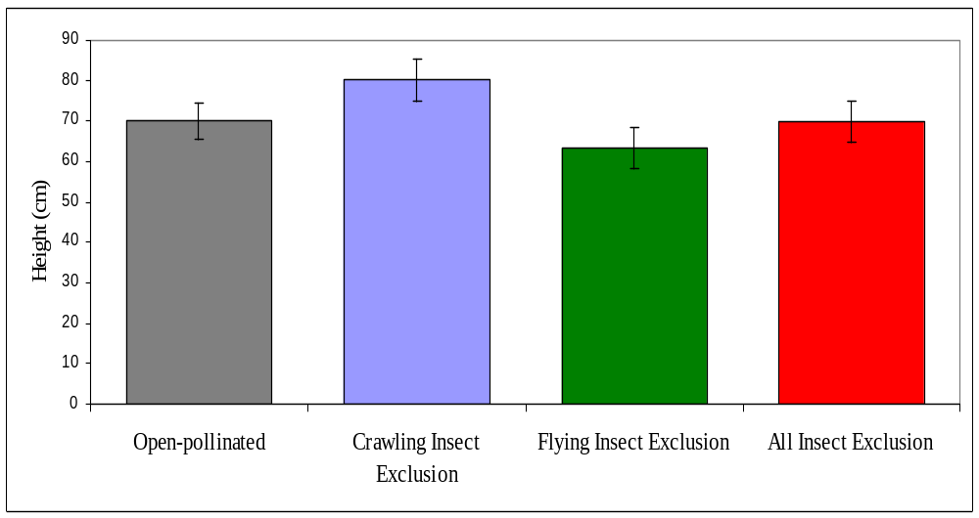
Figure 7. Heights of inflorescences for the four treatments for the first 30 plants.

Inflorescent height did not differ among the last 10 plants (Figure 8; p = 0.027). However, inflorescences on the last 10 plants were significantly taller than the first 30 plants. Therefore, our analysis compared each set of plants separately.

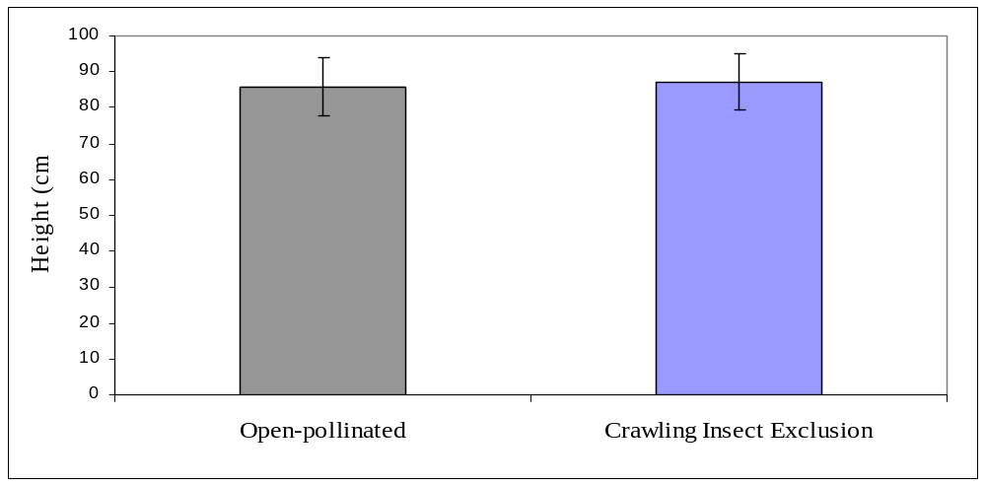
Figure 8. Heights of inflorescences for the two treatments for the last 10 plants.

Do the treatments vary in the number of insects visitors they attract? YES and NO.
In most of the observations, there were no significant differences. Open-pollinated umbels were visited significantly more often by all insects combined (df = 9, p = 0.03) and by ants (df = 9, p = 0.03) than crawling-insect exclusion umbels (Figure 9). There were no differences in visits by flies, beetles, or bees.

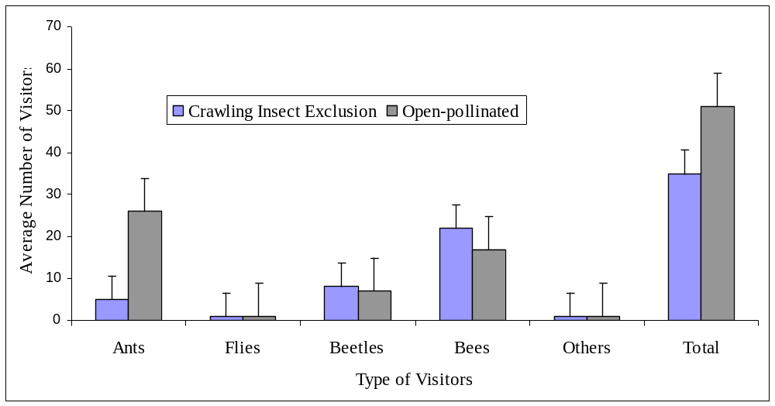
Figure 9. Number of visits to open-pollinated umbels and crawling-insect exclusion umbels during
10 minute observation periods.

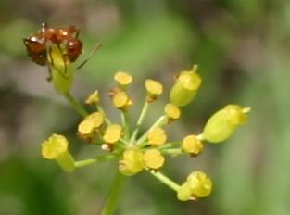
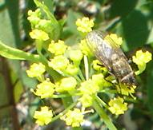

Figure 10. An ant (left) and a fly (right) visiting wild parsnip in the Nature Park.

Do the numbers of fruits per flower vary among treatments? NO. There were no differences in numbers of fruits per flower among treatments (Figure 11).

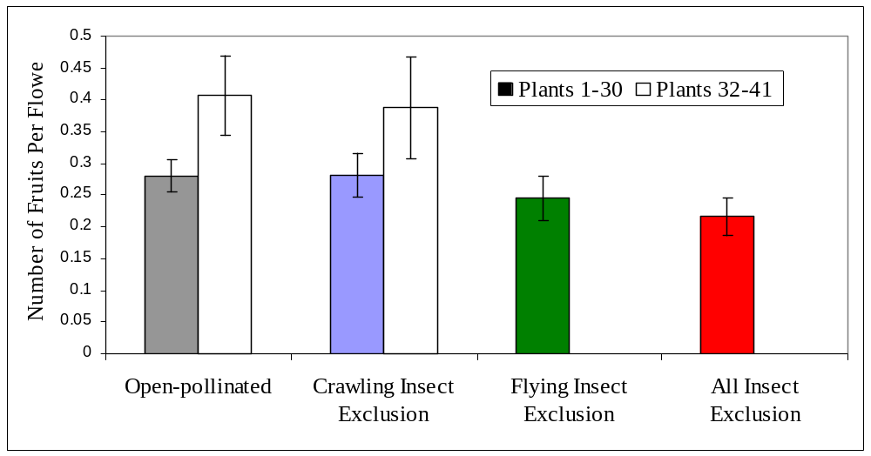

Figure 11. Average number of fruits produced per flower by treatment.

Do the numbers of the seeds per flower vary among treatments? YES and NO. Excluding ants did not significantly reduce the seed set (df = 24, p = 0.4). Excluding flying insects resulted in significantly lower seed set (df = 17, p = 0.006). Allowing ants access to flowers did not increase the seed set relative to the total exclusion (df = 13, p = 0.6).

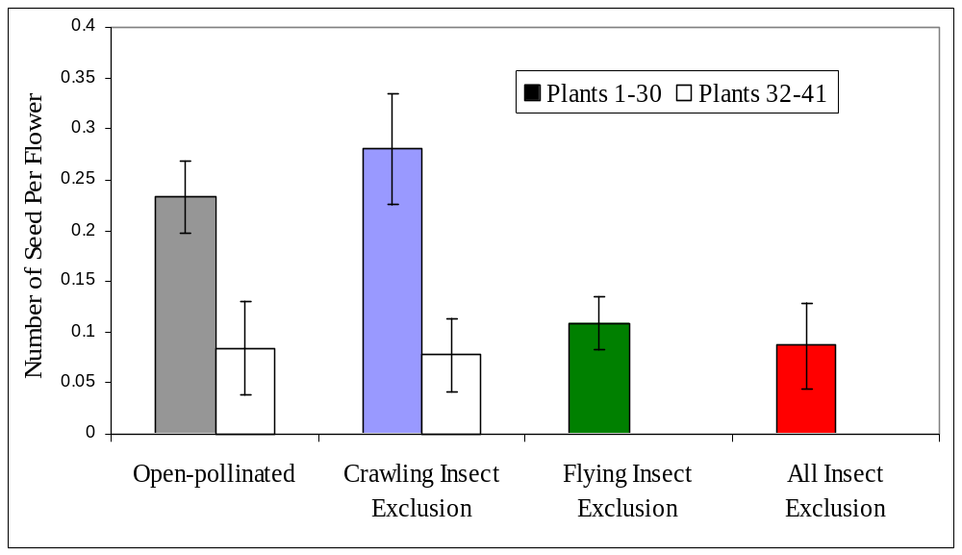
Figure 12. The total number of seeds produced per flower for all treatments.

What factors significantly influence the number of seeds produced per flower? Does inflorescence density affect seed production? NO. Does light intensity affect seed production? NO. Does height of umbels affect seed production? YES. Taller umbels produced more seeds than shorter umbels (Figure 13).

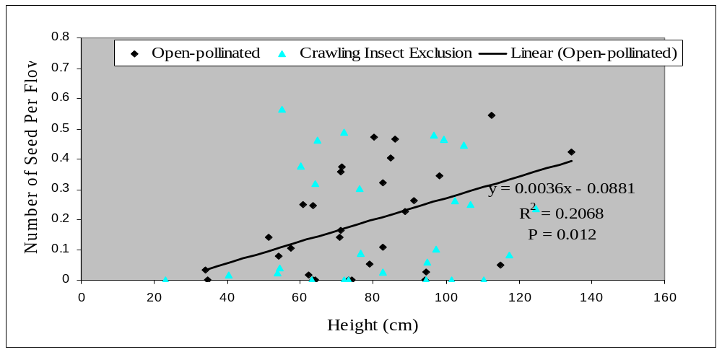
Figure 13. Height of open-pollinated umbels was significantly correlated with the number of
seeds per flower.
Discussion

Pollinator Attraction

Inflorescence density, light intensity, and umbel height are all factors that could contribute to the amount of visitors or pollinator attraction. Inflorescence density and light intensity did not significantly influence the number of visitors to wild parsnips. Umbel height was significantly correlated with the number of flower visitors. Therefore, umbel height was the most important factor contributing to reproductive success of wild parsnips.

Pollinators/Visitors

The majority of wild parsnip visitors were bees, beetles, and ants. Even though there were numerous ants on both the open-pollinated and the flying insect exclusion umbels, the presence of ants did not increase the amount of fruit or seed production. In addition, there were no differences in fruit or seed production between the open-pollinated and crawling insect exclusion umbels. Thus, the ants may not be useful visitors for the wild parsnip but may be “nectar thieves”. However, our study shows no evidence that ants were harmful to the wild parsnips.

On the umbels that allowed only ants to access the flowers, the number of seeds per fruit significantly decreased. Therefore, he ants could not fully compensate for the absence of flying insects. Another possibility is that wild parsnips may be pollinated primarily by flying insects.

Fruit and Seed Set

In addition to the relationship between insects and wild parsnip, we observed a seasonal pattern of fruit and seed set. The later plants produced the same amount of fruits, but produced fewer seeds than the earlier plants. This result could be due to changes during the flowering season such as increased competition for pollinators from other flowering plants (roses and other umbelliferae plants).

Future Work

- It is important to understand the timing of flowering of these wild parsnips for the overall study. Our study started late in the season, which may have caused a problem for the later treated plants. However, we did observe seasonal changes in the fruit and seed set.

- The sample size and the number of observations of pollinators should be increased. This would contribute a better idea of the types of general visitors and pollinators and also reduce the statistical error.

- Future work should investigate whether or not ants are “nectar thieves” by measuring the nectar of the flowers while observing visitors and assessing the quality of fruits and seeds of the flowers.

Acknowledgments

I would like to thank Beth Drewes, Betsy Feighner, Lauren Guggina, Kyra Reed, Libby Allard and Karl Koehler who helped me throughout the summer, and Professor Dana A. Dudle for being supportive and helpful. I would also like to thank the DePauw Faculty Development Committee and Department of Biology for this great opportunity.

References

Bates, R. 1979. Leporella fimbriata and its ant pollinators. Bulletin of the Native Orchid Society 11:9-10.

Beattie, A.J., C. Turnbull, and R.B. Knox. 1984. Ant inhibition of pollen function – a possible reason why ant pollination is rare. American Journal of Botany 71:421-426.

Hickman, J. C. 1974. Pollination by ants: a low-energy system. Science 184:1290-1292.

