Outdoor Explorers: Discovering the Need for Environmental Conservation

Laura Stevens
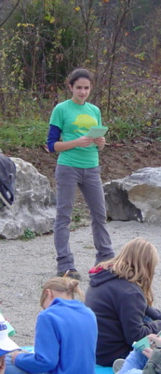
December 18, 2004

Abstract: Seeing as how the most prominent environmental issues of today are human induced and environmental education has been shown to reduce acts of environmental degradation, while also using the findings of other programs, we constructed a local outdoor environmental education curriculum in the name of conservationism. “Outdoor Explorers” – divided into four stations: animals, plants, soil and water – included hands-on activities that illustrated ecological concepts with an underlying theme of ecological conservation. We oversaw the animal station curriculum construction and execution. Activities for the animal station included observing skull adaptations, constructing food chains, identifying animal tracks, and observing cockroaches. Students from Greencastle Middle School participated in the “Outdoor Explorers” program at the DePauw University Nature Park. We hypothesized that students would find the trip fun, engaging, and knowledgeable. More specifically, we expected students to gain environmental knowledge.

We administered a survey after the field trip to ask students if they had fun and if they found activities interesting or educational. At least 80% of the students agreed that they did. The same survey demonstrated that less than 60% found the level of the activities to be of appropriate difficulty and leaving students engaged in the environmental sciences. Students were tested before and after the field trip to gauge a change in environmental knowledge. For these pre- and post-tests (n – 97), we observed an average increase in score of 2.47 (from 19.98 to 22.45; p << 0.001, paired t-test). For the component of the pre- and post-tests that related only to the animal station, the average score increased 0.47 (from 2.60 to 3.07; p << 0.001, paired t-test). Thus there was a slight gain in environmental knowledge. The pre- and post-tests were poorly designed, however, and more conclusive results would likely be observed if a more effective and objective test were written. Also, many improvements can be made to the curriculum to increase the effectiveness of the educational activities. Survey feedback suggested adding more hands-on activities, more time, and more challenging activities, for example. These improvements can be made in future executions of “Outdoor Explorers” as there is now a curricular base and the aforementioned advice.
Laura Stevens, one of the student teachers, leading a portion of the Outdoors Explorers curriculum.

Introduction

A prominent cause of the present-day global ecological crisis is that nature is misunderstood. Without a basic conception of environmental science, many are simply unable to perceive that an action is environmentally harmful. Environmental education has been shown to diminish acts of environmental degradation (Chen-Yin et al. 2004). It is crucial to ensure effective conservation that people understand environmental science; targeting youth is especially effective because they are more likely to choose a career path in science and because they often have less than adults to unlearn (Sejnowski 2003). In addition, it is possible for adults to learn from children that have had environmental education. In one case, parents were more likely to recycle if their child had participated in an environmental education program (Evans et al. 1996). Thus environmental education has proved to be valuable in environmental conservation.

Past studies have shown certain structures of environmental education to be more effective than others. Ecosystem concepts taught in elementary school classrooms were most successful when the underlying mechanisms were taught first; engaging activities rather than lectures were the more effective manner in which the material was presented (Grotzer 2003). Horton demonstrates that having an outdoor classroom was the number one factor in rediscovering his ecological connections with his native Chesapeake. Also, a National Wildlife Federation program based on human reconnection with nature was launched with a three-pronged approach of entertainment, education, and conservation; it resulted in outstanding support for wolf conservation (Putten 1999). Environmental education programs that take place in a local natural setting have proved to be more effective as “outdoor education must be understood…in local and regional contexts, and that outdoor education programs must be understood as particular contributions to existing relationships between particular communities and particular regions” (brooks 2002).

We integrated the successful facets of these past studies into a new outdoor environmental education program with local sixth graders at the DePauw University Nature Park. With a fun and engaging curriculum, an outdoor setting, hands-on activities, and a review of ecological concepts, the authors hypothesized that students would leave the “Outdoor Explorers” experience feeling engaged and interested in learning more about nature. More specifically, we hypothesized that the students would gain in environmental knowledge.

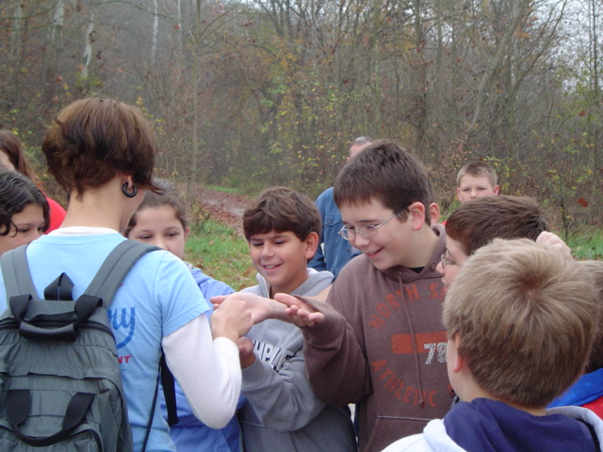
Melinda Voss (left), another one of the student teachers, leading a portion of the Outdoors Explorers curriculum.
Methods

Advance Preparation of Curriculum

The curriculum was divided into four topics – animals, plants, soil and natural history, and water. These topics were assigned to Laura Stevens, Melinda Voss, Andie Wyatt, and Taya Malone. Interconnectedness of the four parts was emphasized (for example, “animals” discussed the importance of water quality for animals) and each part consisted of interactive learning activities, interpretive hikes, and discussions. The overarching theme of the curriculum was conservation biology and human impacts on the environment.

The animal component emphasized the necessity of a healthy habitat. Educational activities were designed to push students to think about the repercussions of changes in an ecosystem. Engaging and exciting elements were added with the intent of both enhancing the educational goal and in hopes of sparking an emotional and intellectual fascination of nature in students.

The curriculum for the animal component contained these activities:

Animal Tracks: Animal tracks were placed along the trail. Students were challenged to identify the animal print using the track guides in their workbook and hypothesize where the animal was headed and why. A data sheet in the workbook asked students for: the location of the print within the park, the environment surrounding the print, the medium the print was found in, the dimensions of the print, and the aforementioned discussion items. This activity was designed to introduce local species, the significance of habitat, and the scientific method.

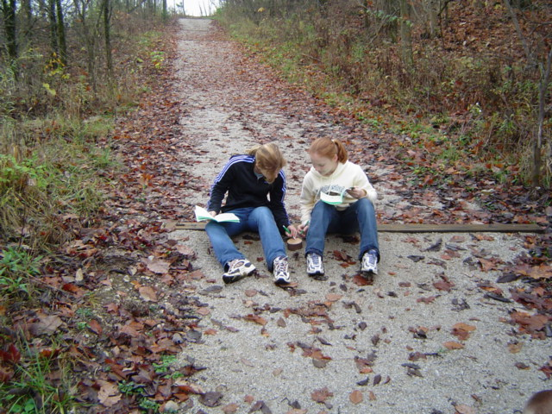
Food Web: An example of a food web was shown and discussed. Cards with drawings of other animals, plants, and abiotic factors were given to groups of students to create their own food web. The student workbook included space for a sketch of the students’ food webs, and asked students to identify an (1) abiotic factor, (2) omnivore, (3) producer (autotroph), (4) carnivore, (5) herbivore, (6) decomposer and (7) detritivore. Students were given several scenarios (extinction of top predator, global warming, habitat destruction, etc.) and asked what effect this would have on the food web. This activity was based on an Environmental Science Activities Kit lesson (Road 1993). The purpose of this activity was to demonstrate the interconnectedness of life and the resonating effects of changes – particularly human-induced – in ecosystems.
Students from Greencastle Middle School, visiting the Nature Park, participating in the “Oudoors Explorers” program
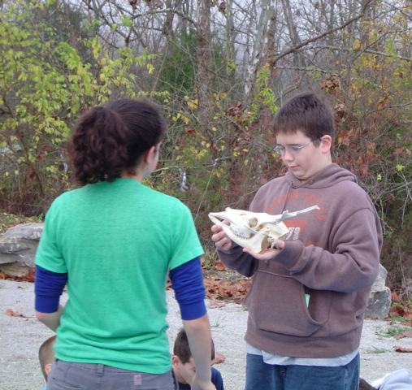
Skulls: Small groups of students were given skulls and asked to identify whether the animal was predator or prey, and whether it was herbivorous, omnivorous, or carnivorous. The students deduced this through observation of the teeth and eye socket position. For example, carnivores have sharp canines and incisors for tearing flesh while herbivores have flat molars for grinding plants; prey usually have monocular vision while predators have binocular vision. Students were challenged to guess what species each skull represented. The purpose of this activity was to familiarize students with locally native species and how they are adapted to play a role in the ecosystem.
Laura Stevens and a student from Greencastle Middle School talking about a mammal skull during the “Outdoors Explorers” event

Arthropods: Madagascar hissing cockroaches were shown to demonstrate the phylum Arthropoda. Students were asked to identify body parts on the cockroaches when presented with a diagram of insect anatomy. Certain adaptations, such as the horns that appear to be large eyes, were discussed with the students. The concepts of invasive exotic species and their possible impacts on ecosystems were also introduced in terms of the food chain and niche concepts learned in the previous activities.

The leader handbook and the student workbook were the two final tangible products. The leader handbook included the entire curriculum, and the student workbook included diagrams, guides (i.e., animal track guide), and worksheets to be completed along the hike. The materials for the activities were collected and prepared prior to the date of the field trip.

Survey, Pre- and Post-Tests

A survey was given to students and teachers to receive feedback on their perception of the success of the field trip. The survey was randomly and anonymously administered to 35 students an teachers 5 days after participating in the field trip. Questions gauged the entertainment, engagement, and educational values of the experience. Answers were on a scale to facilitate quantitative analysis; the available responses were “YES!”, “Yes”, “Sort of”, “Not really”, and “No, not at all”. The survey also asked what students and teachers like best and least about each of the four stations in order to get more concrete feedback to improve the curriculum.

To measure knowledge gained by students during the course of the field trip, we administered pre- and post-tests to 97 students. The pre-test was taken 30 minutes before and the post-test 30 minutes after the field trip. The tests were identical, required mostly short-answer questions, and included two general environmental science questions and questions specific to each station. The “animal” station questions were: (1) What is a food web (also called a food chain)? Give an example of a food web that includes at least three animals; and (2) What is an animal’s habitat? What happens when habitat is destroyed? These questions were aimed to gauge the effectiveness of the activities – which contain themes of food chains and habitat – in understanding the concepts.

Field Trip
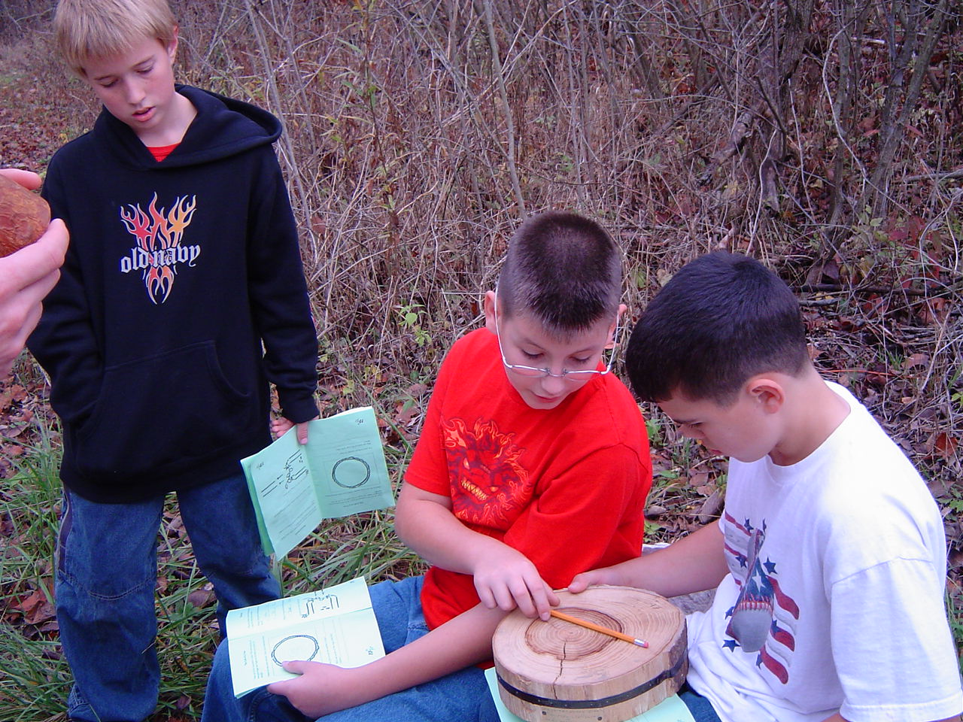
The field trip was held on the morning of October 28, 2004 at the DePauw Nature Park. About 150 sixth graders from Greencastle Middle School participated. Biology teacher Stacie Stoffregen helped to coordinate the event. The animals and plants station, directed by Laura Stevens and Melinda Voss, were held at the Nature Park. The water and soil stations, directed by Taya Malone and Alexandra Wyatt, were held in the Olin Biological Sciences Building on the DePauw University campus. Professors Dana Dudle and Tom Ball directed two other stations at the Nature Park and in the Lilly Athletic Center, respectively. Students were divided into six groups according to their homeroom classes. Each group included 20 to 30 students. Each group was accompanied by the homeroom teacher and several parent chaperones. The groups rotated from station to station, spending approximately 35 minutes at each station with 5 minutes passing time. The entire event occurred from 8:30 a.m. to 12:30 p.m.
Students from Greencastle Middle School looking at cross-sections of trees during the “Outdoor Explorers” activities

Statistical Methods

The responses for the survey questions 1-11 were quantified by the number of responses of each possible answer. For question 20, “What word best describes your experience?”, written answers were assigned a satisfactory, tolerable, or unsatisfactory qualification. Responses were tallied for question 21, “What would you do to improve your experience? Please circle all that apply.” The appropriate station director analyzed questions 12-19; written responses were tallied.

A scoring guide was created for each question of the pre- and post-tests. Scores ranged from 0 for incorrect to 3 for exemplary. Although the tests were graded by the four station leaders, there was an attempt to score as blindly as possible; questions pertaining to the specific stations were graded by someone other than the station leader, and graders were not aware of whether the test was a pre- or post-test. When all scores were assigned, pre- and post-test scores for individual students were matched up. These scores were entered into a Microsoft Excel spreadsheet for analysis. We calculated the mean total pre- and post-test scores along with the standard error for these scores. A paired t-test with a one-tailed p-value was performed to compare the pre- and post-test scores.

Results

Survey Questions 1-11

Questions 4 (“Was the level of difficulty right?”), 5 (“Did activities leave you wanting to learn more?” and 11 (“Would you like to attend similar events?”) received around 40% negative responses (“no”, “not at all”, and “not really”).

Questions 2 (“Did you learn?”), 3 (“Were activities interesting?”), 6 (“Did student teachers explain activities well?”), and 7 (“Did student teachers explain new ideas well?” received around 10% negative responses.

Survey Questions 20 and 21

Question 20 asked “What word best describes your overall experience?” A total of 25 positive responses, 5 tolerable responses, and 4 negative responses were given.

Question 21 asked “What would you change to improve the program? Circle all that apply”. The most popular responses were “More hands-on activities”, then “More time”, followed by “More resting time”.

The skull and cockroach activities at the animal’s station were the favorite among students, while students disliked getting dirty. The teachers wrote that what they liked best was a “variety of activities – well planned in time and content.” The teachers disliked that not all groups were able to do the cockroach activity.

Pre- and Post-test Scores

The average sum score for the pre-test was 19.98 while the average sum post-test score was 22.42. Thus there was a 2.44 average increase in test scores. In addition, the mode pre-test score was 23 and the mode post-test score was 24. The standard error for the pre-tests was 0.59 and for the post-tests was 0.49. The paired t-test produced a one-tailed p-value of less than 0.001.

The average score for the two animal questions of the pre-test was 2.60 while the average post-test score was 3.07. Thus there was a 0.47 average increase in test scores. The standard error for the pre-tests was 0.13 and for the post-tests was 0.11. The paired t-test produced a one-tailed p-value of less than 0.001.

Discussion

Statistical analysis of the pre- and post-tests showed that students, on average, slightly improved their scores. This suggests that students did learn, and were able to reiterate what they learned. Average scores also increased for the portion of the pre- and post-tests that related specifically to the animal stations, average scores also increased.

Although it was shown that students did learn, in general, the pre- and post-tests were inadequately designed. The test was written without knowing exactly how much the students had already learned, and so some questions were too easy and some were too difficult. This made score improvement difficult. More answers were left blank towards the end of the test, and more were left blank in the post-test, most likely because students grew tired. Questions were poorly worded as well. For example, questions 8 and 9 had two parts; some students answered only one of the parts and were consequently marked down. Having short-answer questions also made grading subjective. It would be more effective to have multiple-choice questions instead. If the questions were multiple choice, then they would require less energy on the part of the student and more questions could be asked. This would allow for a more detailed analysis of students’ comprehension of topics covered. Furthermore, the qualitative difference between a score of 0 vs. 3 differed between questions and a score increment of 1 point did not represent equal increments in quality within and between each question. However, in the statistical analysis of the scores, these fallacies were disregarded, undermining the significance of the conclusion that “Outdoor Explorers” did instigate a gain in environmental knowledge.

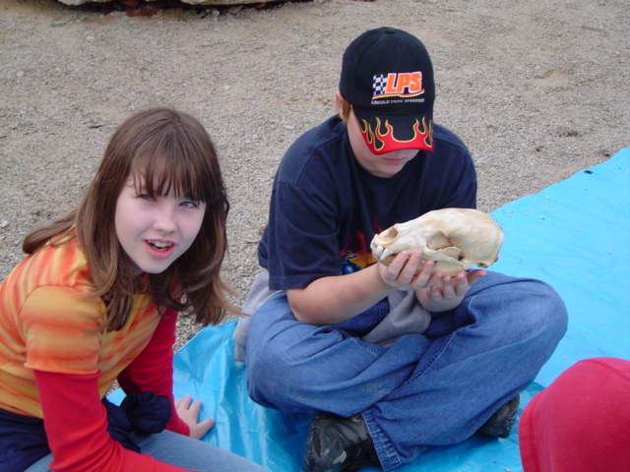
According to the survey, areas that lacked the most related to questions 4, 5, and 11 (Was the level of difficulty right? Did activities leave you wanting to learn more? Would you like to attend similar events?). By making the activities more engaging and something the students can continue at home, the latter two could be improved. Better coordination with the biology teacher would help to gauge the curriculum to a more appropriate level
as well. Also, it would help to pair each individual’s survey with his or her tests. Although students may have perceived the curricula to be too easy, they may not have done well on either of the tests. An analysis of the perceived and actual knowledge gained for each individual could then be performed.

On the other hand, the survey results showed the questions 1, 2, 3, 6, and 7 received the most positive responses (Did you learn? Were activities interesting? Did student teachers explain activities well? Did student teachers explain new ideas well? Did you have fun?). These are definite accomplishments, as they show along with the test results, that our goals were met and our hypothesis was supported. The long-term goal of environmental consciousness, however, was never met. Administering a second post-test several months later to students who attended the field trip, and also to a control group that did not, would measure retention. Adding action questions such as “do you recycle?” would further reflect environmental awareness. As suggested by Chen-Yin et al. (2002) an increase in environmentally respectful actions should be observed.

In response to “what would you change about your experience?”, the most frequent responses were: “more hands-on activities”, “more time”, and “more resting time and breaks”. These can be easily improved by adding more activities while possibly removing lecture components, as recommended by Grotzer et al. (2003). Lengthening the event would solve the latter two problems.

In response to the best and least liked aspects of the animal station, the skull, animal tracks and arthropod activities should be kept. “Getting dirty” was the leading disliked aspect. Warning students that they should dress more appropriately would likely help.

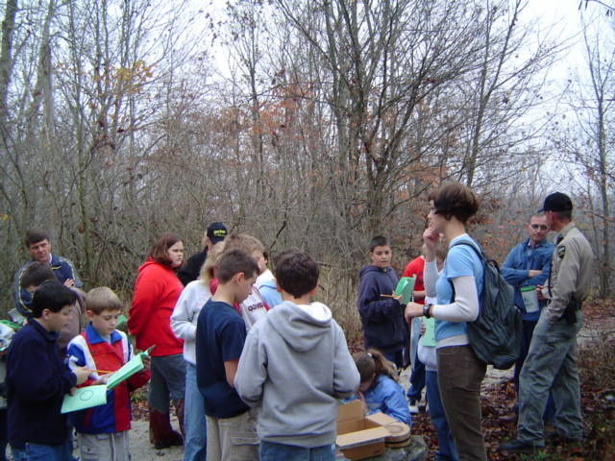
With more time, the activities can be made more in-depth. For example, for the animal tracks activity, students would actually have time to complete the table and think more critically about animal behavior. Plaster molds can also be made of the tracks. The arthropod activity could be extended to include catching arthropods with butterfly nets and examining them with magnifying glasses. During the appropriate season, bird watching and documenting for Project Feeder Watch, would be another appropriate activity.

These activities, along with those executed for this study, were recorded in a notebook, which will serve as a resource for similar events in the future.

Literature Cited

Brooks, A. 2002. Lost in the Australian bush: outdoor education as curriculum. Journal of Curriculum Studies 4: 405-426.

Chen-Yin, T., Chyan, H., and Chieko, K. 2002. The effects of different environmental education programs on the environmental behavior of seventh-grade students and related factors. Journal of Environmental Health 64 (7): 24-29.

Evans, S.M., Gill, M.E., and Marchant, J. 1996. Schoolchildren as educators: the indirect influence of environmental education on parents’ attitudes towards the environment. Journal of Biological Education 30 (4): 243-248.

Grotzer, T.A., and Basca, B.B. 2003. How does grasping the underlying causal structures of ecosystems impact students’ understanding? Journal of Biological Education 38 (1): 16-29.

Putten, M.V. 1999. Entertain, education, and conserve. National Wildlife 37 (4): 9.

Roa, M.L. 1993. Environmental science activities kit. John Wiley and Sons, Inc.

Sejnowski, T.J. 2003. Tap into science 24-7. Science 301 (5633): 601.

