DePauw University
Authorization Agreement for Automatic Deposit (ACH Credits)

I authorize DePauw University and the financial institution listed below to deposit my reimbursements/pay automatically to the account and financial institution listed below. If adjusting entries are required to correct errors, these corrections are also authorized. This authority will remain in effect until I have cancelled this authorization in writing.

IMPORTANT: Your reimbursements/pay will be directly deposited to your bank account and an e-mail will be sent when a payment has been deposited. If you close your account or change accounts, the Business Office must be notified. Any monies going to a closed account will not be paid to you until the funds are returned by the bank.

NOTE: You must also complete the Federal Tax Form W-9 in order to receive payments from the Business Office.

Instructions for completing this form

- Print your name, social security number, student ID number and e-mail address in the space provided.
- Sign and date the form in the space provided.
- Fill in the bank name and account information in the space provided. Be sure and specify if your account is a checking or saving account.
- Attach a copy of your check or a voided check if your bank account is a checking account. For a saving account, documentation showing the bank routing number and the account number must be provided. Please note: Deposit slips from any account are not acceptable.
- Return this form and appropriate supporting documents to the Business Office.

_____________________________________________ ______________________________________
Student Name (Printed) Student ID Number

__________________________________________________________________________________________
Student E-mail Address

_____________________________________________ ______________________________________
Bank Name Bank Routing Number

_____________________________________________ Mark One: □ Checking Account □ Saving Account
Bank Account Number

_____________________________________________ ______________________________________
Student Signature Date

Sample Check:
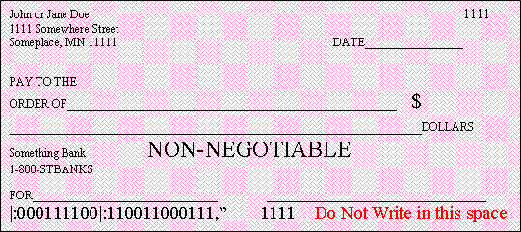
Routing Number
Account Number

