Using Google to Search Public Data

How-To
- Go to google.com
- Type in a variable (see below)
- Type in the location (state, city, county, country)
- Use the left sidebar to add variables
Example:
“gdp Indonesia”
“unemployment Putnam county, IN” **
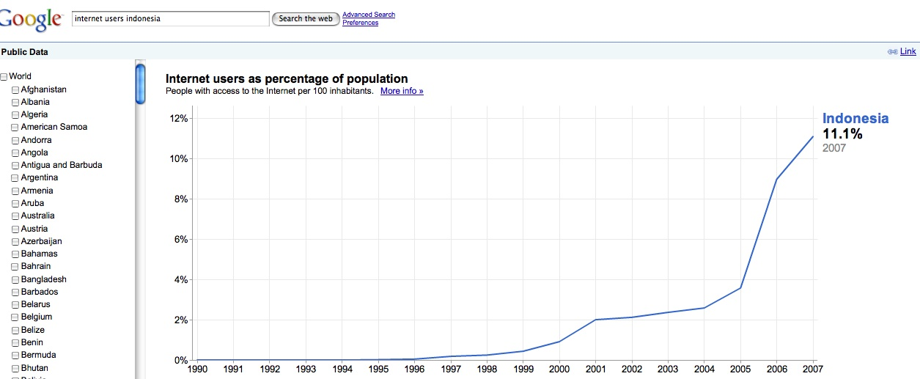

Variables
Google is continually adding to the functionality of their public data features, so this resource may not be exhaustive. At this time, Google offers the following indicators at this time:

World Bank Data:
- CO2 emissions per capita
- Electricity consumption per capita
- Energy use per capita
- Exports as percentage of GDP
- Fertility rate
- GDP deflator change
- GDP growth rate
- GNI per capita in PPP dollars
- Gross Domestic Product
- Gross National Income in PPP dollars
- Imports as percentage of GDP,
- Internet users as percentage of population
- Life expectancy
- Military expenditure as percentage of GDP
- Mortality rate, under 5
- Population
- Population growth rate

Other Data**:
Unemployment
http://www.google.com/publicdata?ds=usunemployment
Population
http://www.google.com/publicdata?ds=uspopulation

**Note: At this time, this feature appears to be unavailable through direct Google search; use the provided links.

