Diversity of Surface Active Invertebrate Communities
at the DePauw Nature Park and Arboretum

Aaron Randolph, Science Research Fellow
With Vanessa L. Artman and Dana A. Dudle
Department of Biology, DePauw University, Greencastle, IN 46135

Abstract
Until recently there haven’t been any data available about the compositions of either the vegetation or the surface active invertebrates (SAI’s) in the nature park or Arboretum. My project focuses on describing the composition of the SAI community and examining the relationships between the SAI community and habitat characteristics at the sites. I hypothesized that composition of SAI communities will differ relative to habitat characteristics at the sites.
Pitfall traps were constructed using 16-oz plastic cups, propylene glycol, chicken wire, and masonite, and were placed in each of three forested sites: Quarry Hillside (QH), Quarry South (QS), and the Arboretum (ARB). Traps were placed at 30m intervals along 3 parallel transects. The captured SAI’s were sorted, identified to order (see Figure 1c), and counts were completed for 30 traps in QH, 30 in QS, and 15 in the ARB (see Figure 1d). We sampled vegetation at ten randomly chosen plots within each forested site and vegetation diversity and structure were compared across sites using 1-way ANOVAs. We calculated mean trap efficiency (SAI’s/ trap / day) for each site, and calculated a Shannon Diversity index, which measures taxonomic diversity and evenness, for each site.
Traps were most successful at QS, with the highest number of trap days, highest total number of captures, and highest capture rates. Shannon diversity index for the invertebrate community did not differ between the three sites; however the composition of the invertebrate community differed between the three sites. Traps in the ARB captured a higher percentage of ants and slugs. QH and QS had a higher percentage of millipedes. Capture rates of springtails were highest at QS and captures of crickets and spiders were highest at QH.
Differences in capture rates and community composition may be due to differences in forest structure and habitat features. For example, lower leaf litter and higher understory vegetation cover at QS may have contributed to higher captures of invertebrates overall, possibly because the SAIs had more mobility throughout the forest. Issues encountered in this specific project include the large number of destroyed and disturbed traps, especially at the Arboretum. This issue could probably addressed by hiding traps under nearby low lying brush. Also, invertebrates were identified to order. Identification to species might be a better indicator of the invertebrate diversity.

Introduction
The newly acquired DePauw Nature Park and DePauw’s Arboretum contain various habitats that have been relatively undisturbed in recent years. These sites each have unique vegetation compositions that differ widely across sites. Surface active invertebrates are an important factor in the forest ecosystem dynamics. Until recently there haven’t been any data available about the compositions of either the vegetation or the surface active invertebrates (SAI’s) in the nature park or Arboretum. My project focuses on describing the composition of the SAI community and examining the relationships between the SAI community and habitat characteristics at the sites.

Hypothesis
Composition of SAI communities will differ relative to habitat characteristics at the sites.

Methods
Pitfall traps were constructed using 16-oz plastic cups, propylene glycol, chicken wire, and masonite (see Figure 1a). In each of three forested sites, Quarry Hillside (QH), Quarry South (QS), and the Arboretum (ARB), traps were placed at 30m intervals along 3 parallel transects. The transects were located near the edge and interior of each site. The contents of the traps were collected periodically and new cups were installed (see Figure 1b). Samples were frozen until identification. The captured SAI’s were sorted, identified to order (see Figure 1c), and counts were completed for 30 traps in QH, 30 in QS, and 15 in the ARB (see Figure 1d). Compiled SAI data were compared with vegetation data.

We sampled vegetation at ten randomly chosen plots within each forested site. Depth of leaf litter was recorded at 12 locations in each plot. In 5-m radius plots, we estimated percent cover of leaf litter, grasses, forbs, seedlings, shrubs, bare ground, and water. We counted shrubs, seedlings, saplings, and trees by species in 5m and 11.3m radius plots.

We calculated mean trap efficiency (SAI’s/ trap / day) for each site, and calculated a Shannon Diversity index, which measures taxonomic diversity and evenness, for each site. Vegetation data were compared across sites using 1-way ANOVAs.

FIGURE 1. Methods used to collect, sort, and identify surface active invertebrates.
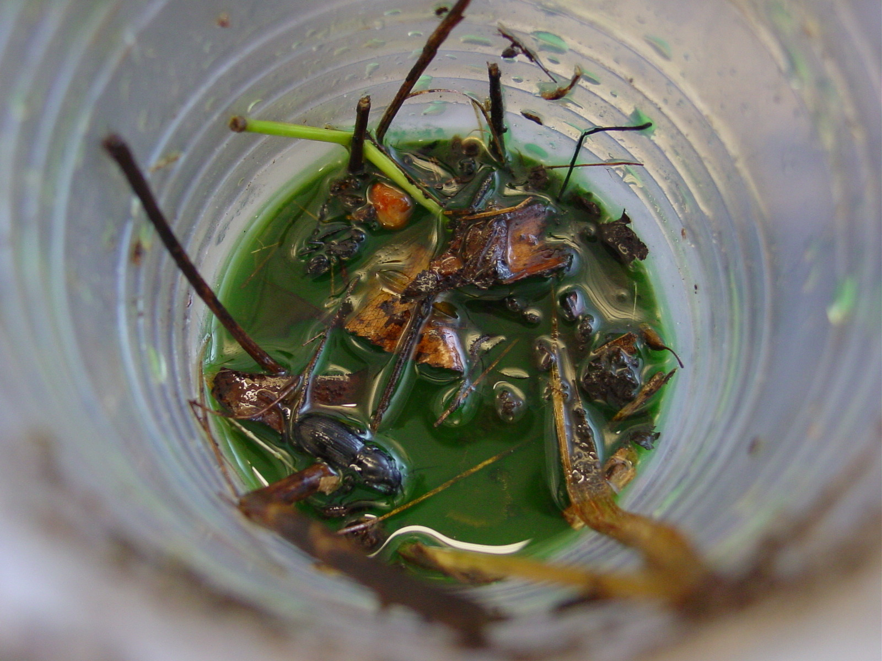
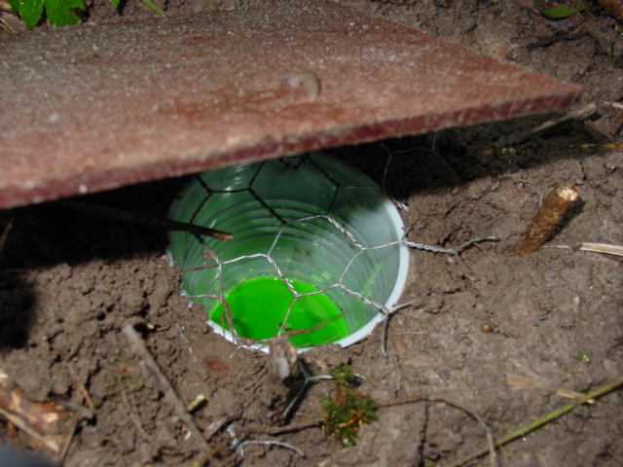

Pitfall trap installed Sample collected

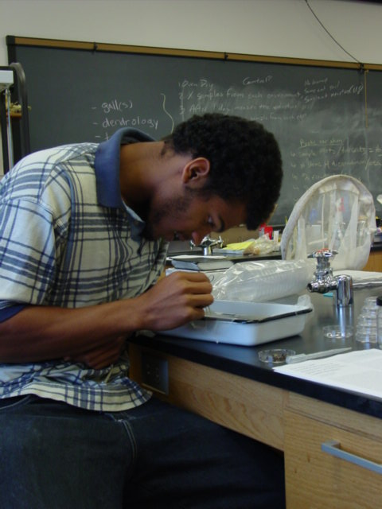
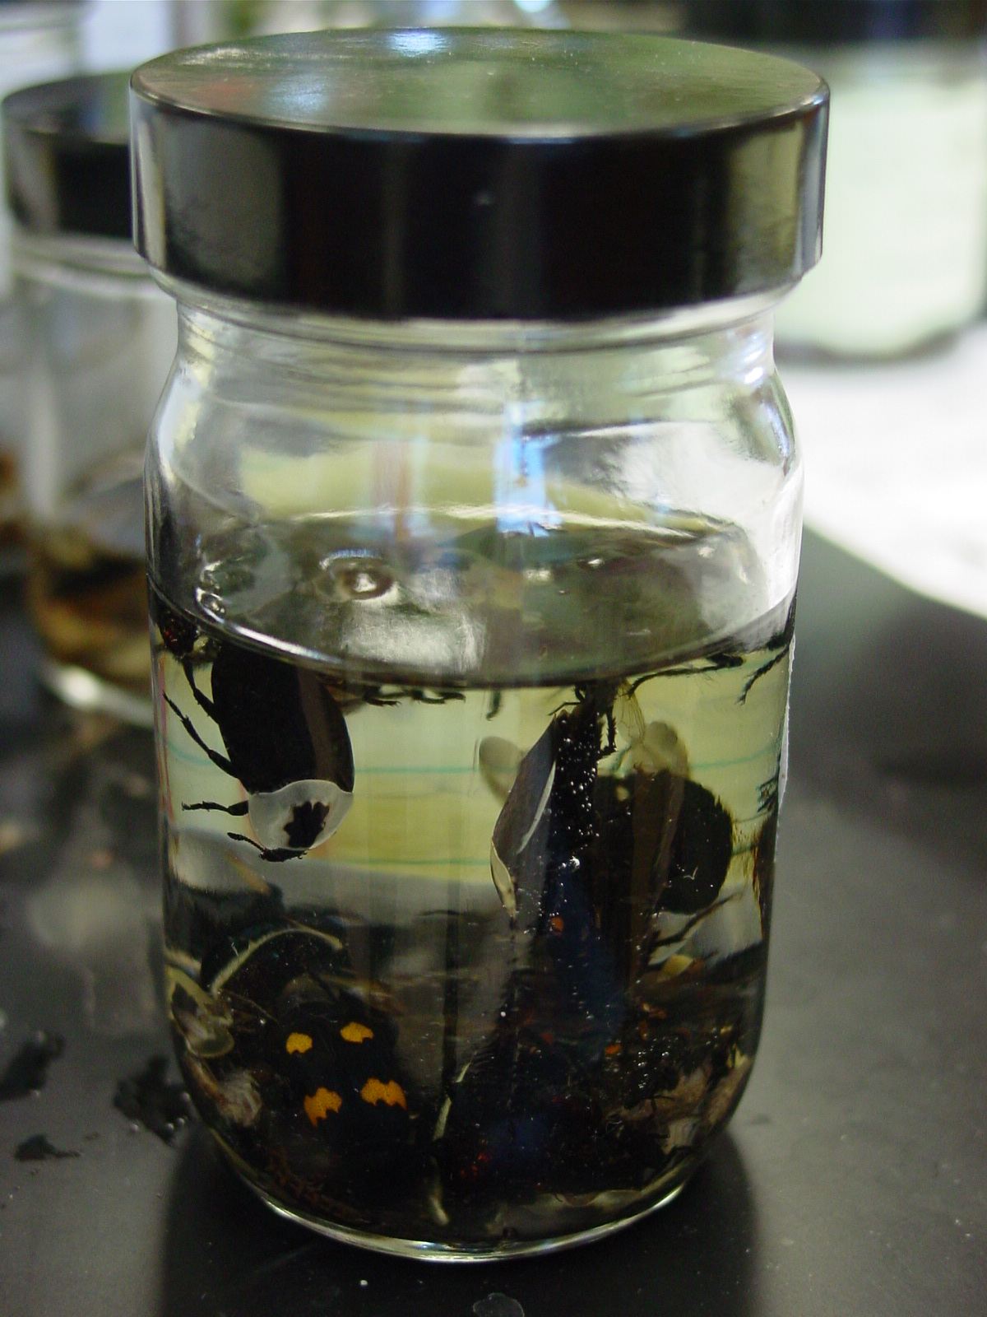

Sorting in the lab Final sample

Figure 2. Composition of surface active invertebrates at three forested sites, arranged by Order.

Figure 3.

Figure 3. Comparison of invertebrate habitat characteristics at the three sites.

Results and Discussion
We caught a total of 3365 invertebrates during the study. The most numerous were isopods (690), millipedes (578), ants (426), springtails (267), beetles (250), and spiders (233).

Traps were most successful at QS, with the highest number of trap days, highest total number of captures, and highest capture rates. The traps were damaged and destroyed the most at the ARB, probably by raccoons and opossums.

The Shannon diversity index for the invertebrate community did not differ between the three sites (see Figure 2).

The composition of the invertebrate community differed between the three sites (see Figure 2). The ARB had a higher percentage of ants and slugs caught. QH and QS had a higher percentage of millipedes. Capture rates of springtails were highest at QS and captures of crickets and spiders were highest at QH.

Differences in capture rates and community composition may be due to differences in forest structure and habitat features. The ARB had higher leaf litter cover and higher leaf litter depth than the other sites (see Figure 3). Leaf litter may support higher slug populations because the cover provides shade and moisture for protection during the day. The QS and QH sites had higher log cover (see Figure 3). More logs may provide habitat for millipedes. Lower leaf litter and higher understory vegetation cover at QS may have contributed to higher captures of invertebrates overall, possibly allowing for more mobility throughout the forest and ultimately more (see Figure 3).

Implications and Future Research
Further research on SAI communities and habitat relations could address factors such as soil moisture, soil nutrient levels, and soil pH, and how these abiotic factors affect abundance, activity, and diversity of surface active invertebrates. Why leaf litter levels differ among the sites is unknown as well as what this variation indicates. Are lower leaf litter levels indicative of higher decomposition rates by surface active invertebrates? Are higher decomposition rates indicative of more rapid recycling of nutrients, thus supporting higher plant growth and higher populations of diverse invertebrate communities?

Future research is appropriate to address these questions. Abiotic factors such as soil moisture and dead plant biomass are of prime importance in terms of changes in invertebrate communities. Implications are significant in terms of future growth, health, and productivity of forest ecosystems.

Issues encountered in this specific project include the high volume of traps destroyed, especially at the Arboretum, which possibly can be lowered by hiding traps under nearby low lying brush. Also, invertebrates were identified to order. Identification to species might be a better indicator of the invertebrate diversity.

Acknowledgments
A special thanks to my fellow members of TEAM BAADD (Bryan Helm, Vanessa Artman, Dana Dudle, and David Pope) for their countless hours of support and uncanny guidance. Thanks to Foster Purrington with the Ohio State Department of Entomology for his help in the pitfall trap design. Thanks to Richard Ryland for contributing the collection bottles. I am very grateful to DePauw University and the Science Research Fellows for funding this project. And most importantly, to my parents Carl and Sheryl Randolph for the unfailing love and support in all that I do.

Sources
The Provincial Museum of Alberta [Internet], Edmonton, Alberta; 1996 [7/8/04 ; 7/27/04]. http://www.pma.edmonton.ab.ca/natural/insects/bugsfaq/millipd.htm

Maryland Cooperative Extension [Internet], Ellicot City, MD. http://www.agnr.umd.edu/users/hgic/pubs/online/hg92%20pfv.pdf

Greenslade P. J. M.; Pitfall Trapping as a Method for Studying Populations of Carabidae (Coleoptera). Imperial College, London.

