Examples of “Scientific Literacy” questions from different instruments

Which of the following is a valid scientific argument?
a) Measurements of sea level on the Gulf Coast taken this year are lower than normal; the average monthly measurements were almost 0.1 cm lower than normal in some areas. These facts prove that sea level rise is not a problem.
b) A strain of mice was genetically engineered to lack a certain gene, and the mice were unable to reproduce. Introduction of the gene back into the mutant mice restored their ability to reproduce. These facts indicate that the gene is essential for mouse reproduction.
c) A poll revealed that 34% of Americans believe that dinosaurs and early humans co-existed because fossil footprints of each species were found in the same location. This widespread belief is appropriate evidence to support the claim that humans did not evolve from ape ancestors.
d) This winter, the northeastern US received record amounts of snowfall, and the average monthly temperatures were more than 2°F lower than normal in some areas. These facts indicate that climate change is occurring.

Background for Question 28: You’ve been doing research to help your grandmother understand two new drugs for osteoporosis. One publication, Eurasian Journal of Bone and Joint Medicine, contains articles with data only showing the effectiveness of one of these new drugs. A pharmaceutical company funded the Eurasian Journal of Bone and Joint Medicine production and most advertisements in the journal are for this company’s products. In your searches, you find other articles that show the same drug has only limited effectiveness.
28. Pick the best answer that would help you decide about the credibility of the Eurasian Journal of Bone and Joint Medicine:
a) It is not a credible source of scientific research because there were advertisements within the journal.
b)It is a credible source of scientific research because the publication lists reviewers with appropriate credentials who evaluated the quality of the research articles prior to publication.
c) It is not a credible source of scientific research because only studies showing the effectiveness of the company’s drugs were included in the journal.
d) It is a credible source of scientific research because the studies published in the journal were later replicated by other researchers.
The following graph appeared in a scientific article about the effects of pesticides on tadpoles in their natural environment.
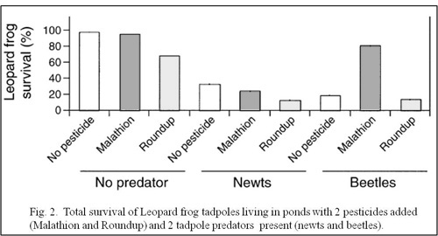

8. When beetles were introduced as predators to the Leopard frog tadpoles, and the pesticide Malathion was added, the results were unusual. Which of the following is a plausible hypothesis to explain these results? (Refer to graph above.)
a) The Malathion killed the tadpoles, causing the beetles to be hungrier and eat more tadpoles.
b) The Malathion killed the tadpoles, so the beetles had more food and their population increased.
c) The Malathion killed the beetles, causing fewer tadpoles to be eaten.
d) The Malathion killed the beetles, causing the tadpole population to prey on each other.

Background for question 18: Energy efficiency of houses depends on the construction materials used and how they are suited to different climates. Data was collected about the types of building materials used in house construction (results shown below). Stone houses are more energy efficient, but to determine if that efficiency depends on roof style, data was also collected on the percentage of stone houses that had either shingles or a metal roof.
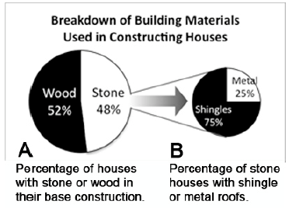
18. What proportion of houses were constructed of a stone base with a shingled roof?
a) 25%
b)36%
c) 48%
d) Cannot be calculated without knowing the original number of survey participants.

x) The oxygen that we breathe comes from plants. True or False? *

x) Lasers work by focusing sound waves. True or False?

x) Electrons are smaller than atoms. True or False?

x) The universe began with a huge explosion. True or False?

x) What is DNA? ___________________________________________________

x) What is radiation? _______________________________________________

