CASHNet – My Account Screen

The following screen will display once logged in to CASHNet. Please see the explanations below for the various sections:
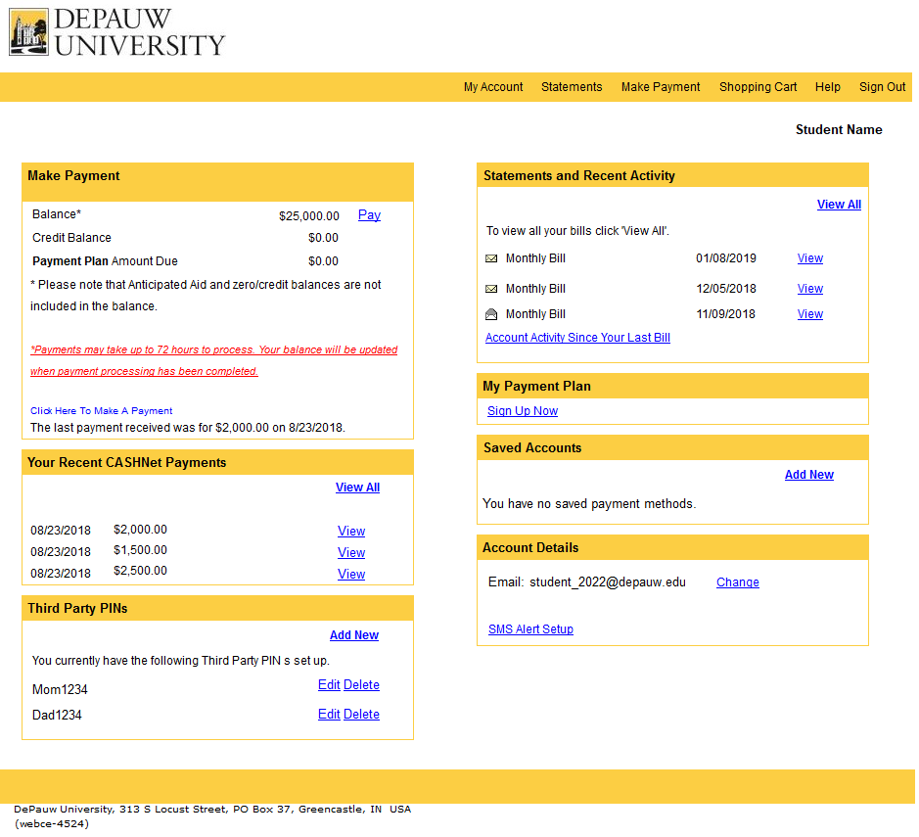
Set up optional text messaging alerts.
Payment methods can be saved to ease future transactions.
Click here to sign up for or view information about the payment plan.
Click here to view activity since the last bill.
View issued monthly statements.
Students can grant parents and/or other designated individuals access to CASHNet.
View recent payments made in CASHNet.
Click on either link to view balances and/or make student account, Greek balance, payment plan, or Emergency Loan payments.

Accessing CASHNet

Students:

Students are able to log in to CASHNet directly from eServices (my.depauw.edu). Simply click the “Billing & Payments (CASHNet)” link under the Financial menu on the left hand-side of the main eServices page.
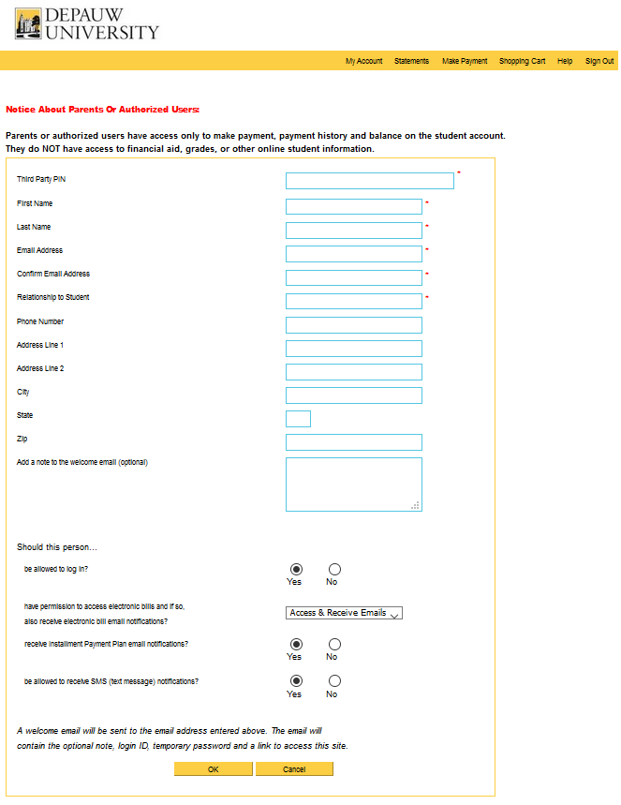
Parents/Third Parties:
CASHNet allows students to grant parents or other authorized users access to make payments, view payment history, account balances, and receive notifications a new invoice has been issued. To grant access, students simply click on the “Add New” link in the “Third Party PINs” section on the “My Account” screen. Complete the required information (see screenshot to the right) and an email will automatically be sent to the parent/third party with their assigned PIN and temporary password.

Please note that CASHNet parent/third party access is only for student payments. Third party access for grades and other services is granted through eServices.
Assign access.
Assign Third Party PIN (username) and complete the profile.

Establishing a Payment Plan

Student balances must be paid in full prior to August 1 for Semester I (fall and winter term) or February 1 for Semester II (spring and May/summer term). If not able to pay in full by these dates, please sign up for DePauw’s 4-Month Payment Plan. To sign up, simply click the “Sign Up Now” link in the “My Payment Plan” section of CASHNet. The payment plan can only be established on CASHNet.

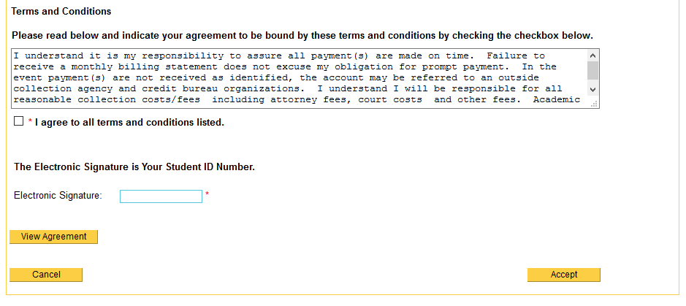
Do not wait to sign up! Any charges or credits (for example, pending financial aid) posted after signing up will adjust your payment plan accordingly.
There is a one-time $40 enrollment fee per semester.
Read the terms and conditions, select “I agree to all terms and conditions listed,” enter your student ID for the “Electronic Signature,” and click “Accept.”
The four monthly payments will be automatically calculated based on the sum of Tuition and Fees, Greek, and Emergency Loan (if applicable) balances, less Anticipated Aid (financial aid that has not yet posted to the account).

Making a Payment

To make a payment:
1.
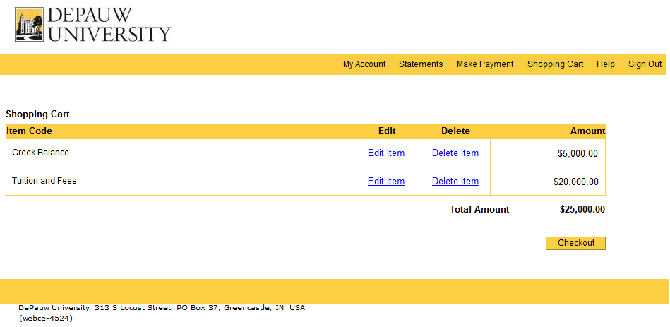
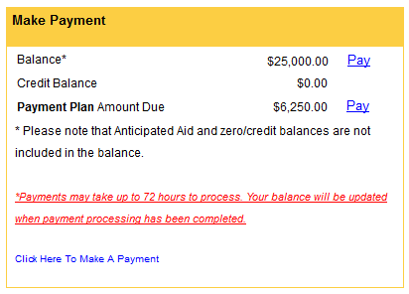
Click here to make a payment towards the entire balance.
Click here to make a payment towards the entire balance.
Click here to make a payment towards the payment plan.

2.
Click here to edit the amount you would like to pay.
Click here to delete the item and remove the amount from the total to pay.
Click here to continue to the payment method page.

Making a Payment (continued)

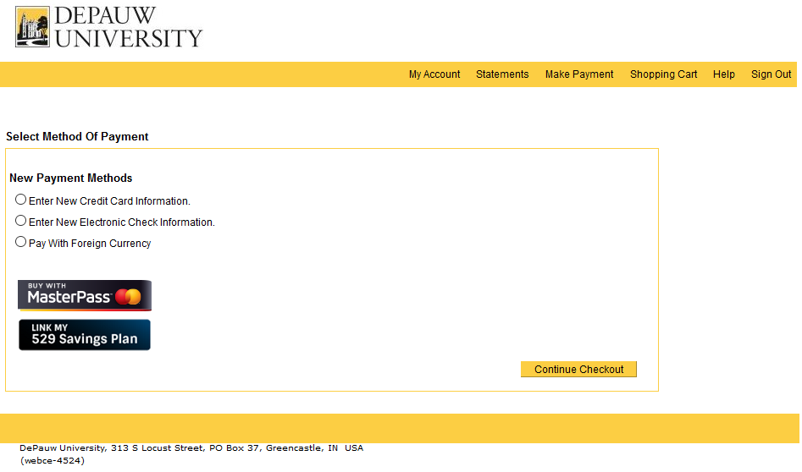
3.
529 Savings Plan
Pay directly through a 529 savings account from a list of participating 529 agencies.

Fee: $10 convenience fee
MasterPass
Pay with your MasterPass-enabled Mastercard.

Fee: 2.9% convenience fee
Foreign Currency
Initiate a wire transfer through Western Union in a specific currency to USD.

Fee: FREE
Electronic Check
Pay with your bank account routing and account number.

Fee: FREE
Credit Card
Pay with any major credit/debit card (Visa, Mastercard, Discover, American Express).

Fee: 2.9% convenience fee

Establish an Automatic Payment Plan

Once signed up for the 4-Month Payment plan, you have the option to set up automatic payments.

1.
Automatic payments will only process on the following dates:

Semester I | Semester II
August 1 | February 1
September 1 | March 1
October 1 | April 1
November 1 | May 1

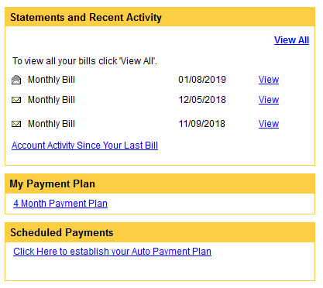
This link will appear after signing up for the 4-Month Payment Plan.

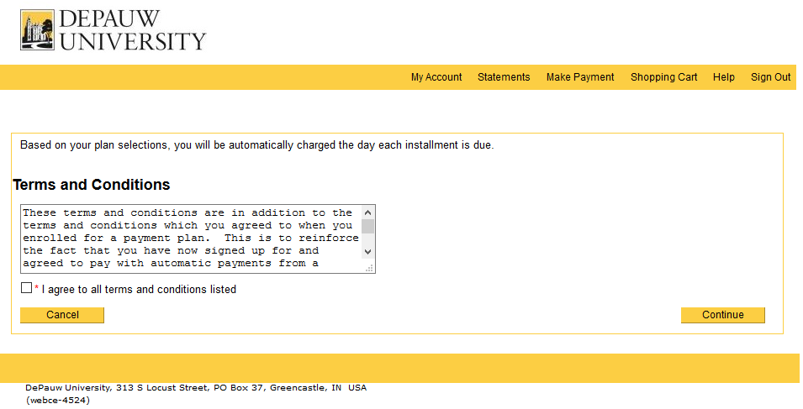
2.
Read the terms and conditions, select “I agree to all terms and conditions listed,” and click “Continue” to select your payment method to use for this Automatic Payment Plan.

Resetting a Third Party PIN Password

Only the student has access to reset a password for a Third Party PIN. Once logged in to CASHNet, the student will click “Edit” in the “Third Party PINs” box on the main CASHNet page.
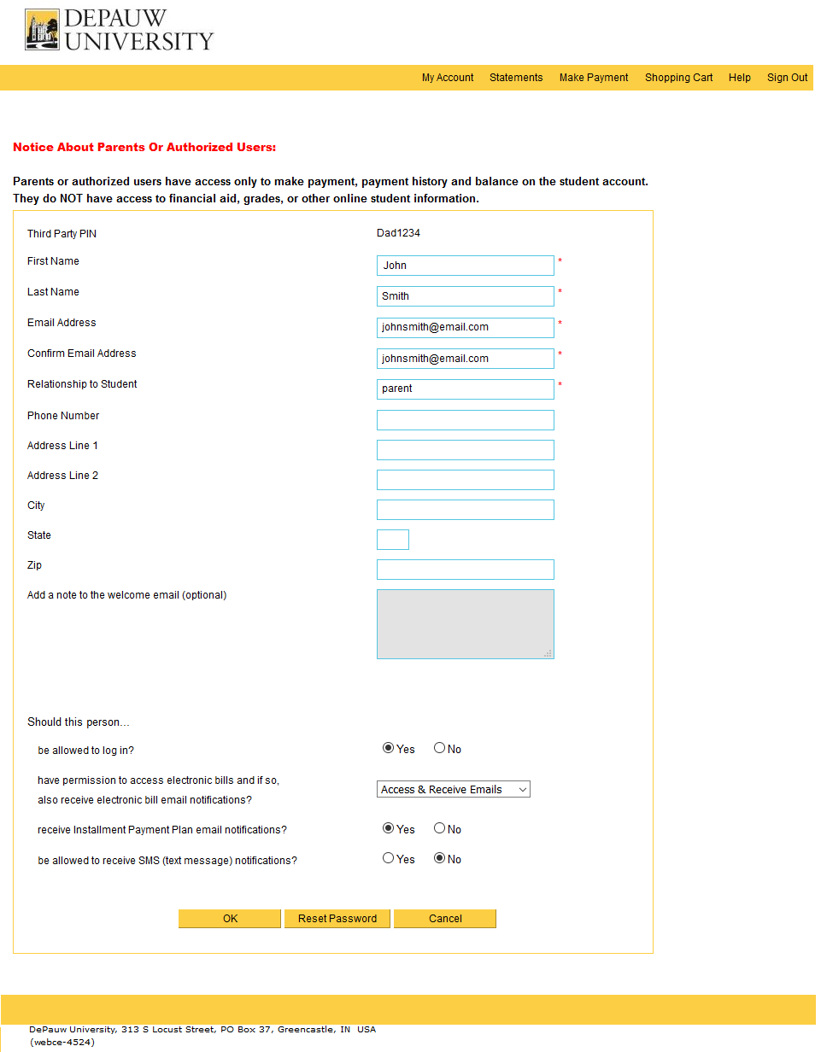
Please note that only the student has access to reset the Third Party PIN password.
The student will click “Reset Password” on the page that displays details of the Third Party PIN.

