Expression of anthocyanins in Apocynum cannabinum stems under light stress

Erica J. Ross, Ryan Edelen, Matthew Howes and Dana A. Dudle
Department of Biology, DePauw University, Greencastle, IN 46135

Introduction

Anthocyanins are water-soluble pigments found in the vacuole of plant cells and are responsible for red, blue, and purple coloring in plants. They can act as protective compounds against damage caused by photooxidation and photoinhibition by absorbing wavelengths of light that chlorophyll cannot, or by serving an antioxidant function (Lee and Gould 2002). Light intensity along with many other environmental stresses increase the synthesis of anthocyanins in leaves (Oberbauer and Starr 2002). In most plants, anthocyanins are displayed in the leaves, flowers, or fruits, but Apocynum cannabinum plants (our focus species) produce anthocyanins in their stems. DePauw’s Nature Park is home to a large population of Apocynum cannabinum that represents a wide range of anthocyanin content from green to deep red. We were interested in studying the cause of this variability within the population as well as plants from different populations. We hypothesized that light intensity as well as genetic differences between families and populations will affect anthocyanin production.

Methods

1.) We collected plants from a variety of locations and habitats from which we had collected fruits. We collected from three populations; DePauw Nature Park Quarry (QB), a field in Buffalo Grove Illinois (BG), and a population from the side of state highway IN-75 (RS). We extracted seeds from 34 maternal plants: 13 RS, 13 QB, and 8 BG.

2.) To plant the seeds, we disconnected the pappus from the seed. In March 2008, we placed 160 seeds on moist filter paper for each maternal plant in a 35° C growth chamber. A total of 28 families had at least 10 seedlings germinate

3.) After 10 days the germinated seeds were transplanted into soil and kept under 24 hour light for several weeks.

4.) In early May the plants were transferred to 3-inch pots and placed in the greenhouse where they received approximately 40% of full sunlight until June 10. There were 1056 plants total.

5.) We selected 508 plants from 15 families. We designated a focal internode (5th node) on each plant to track the color change of the plant throughout the summer. Initial data were collected on June 7th, 8th and 9th inside the field station.
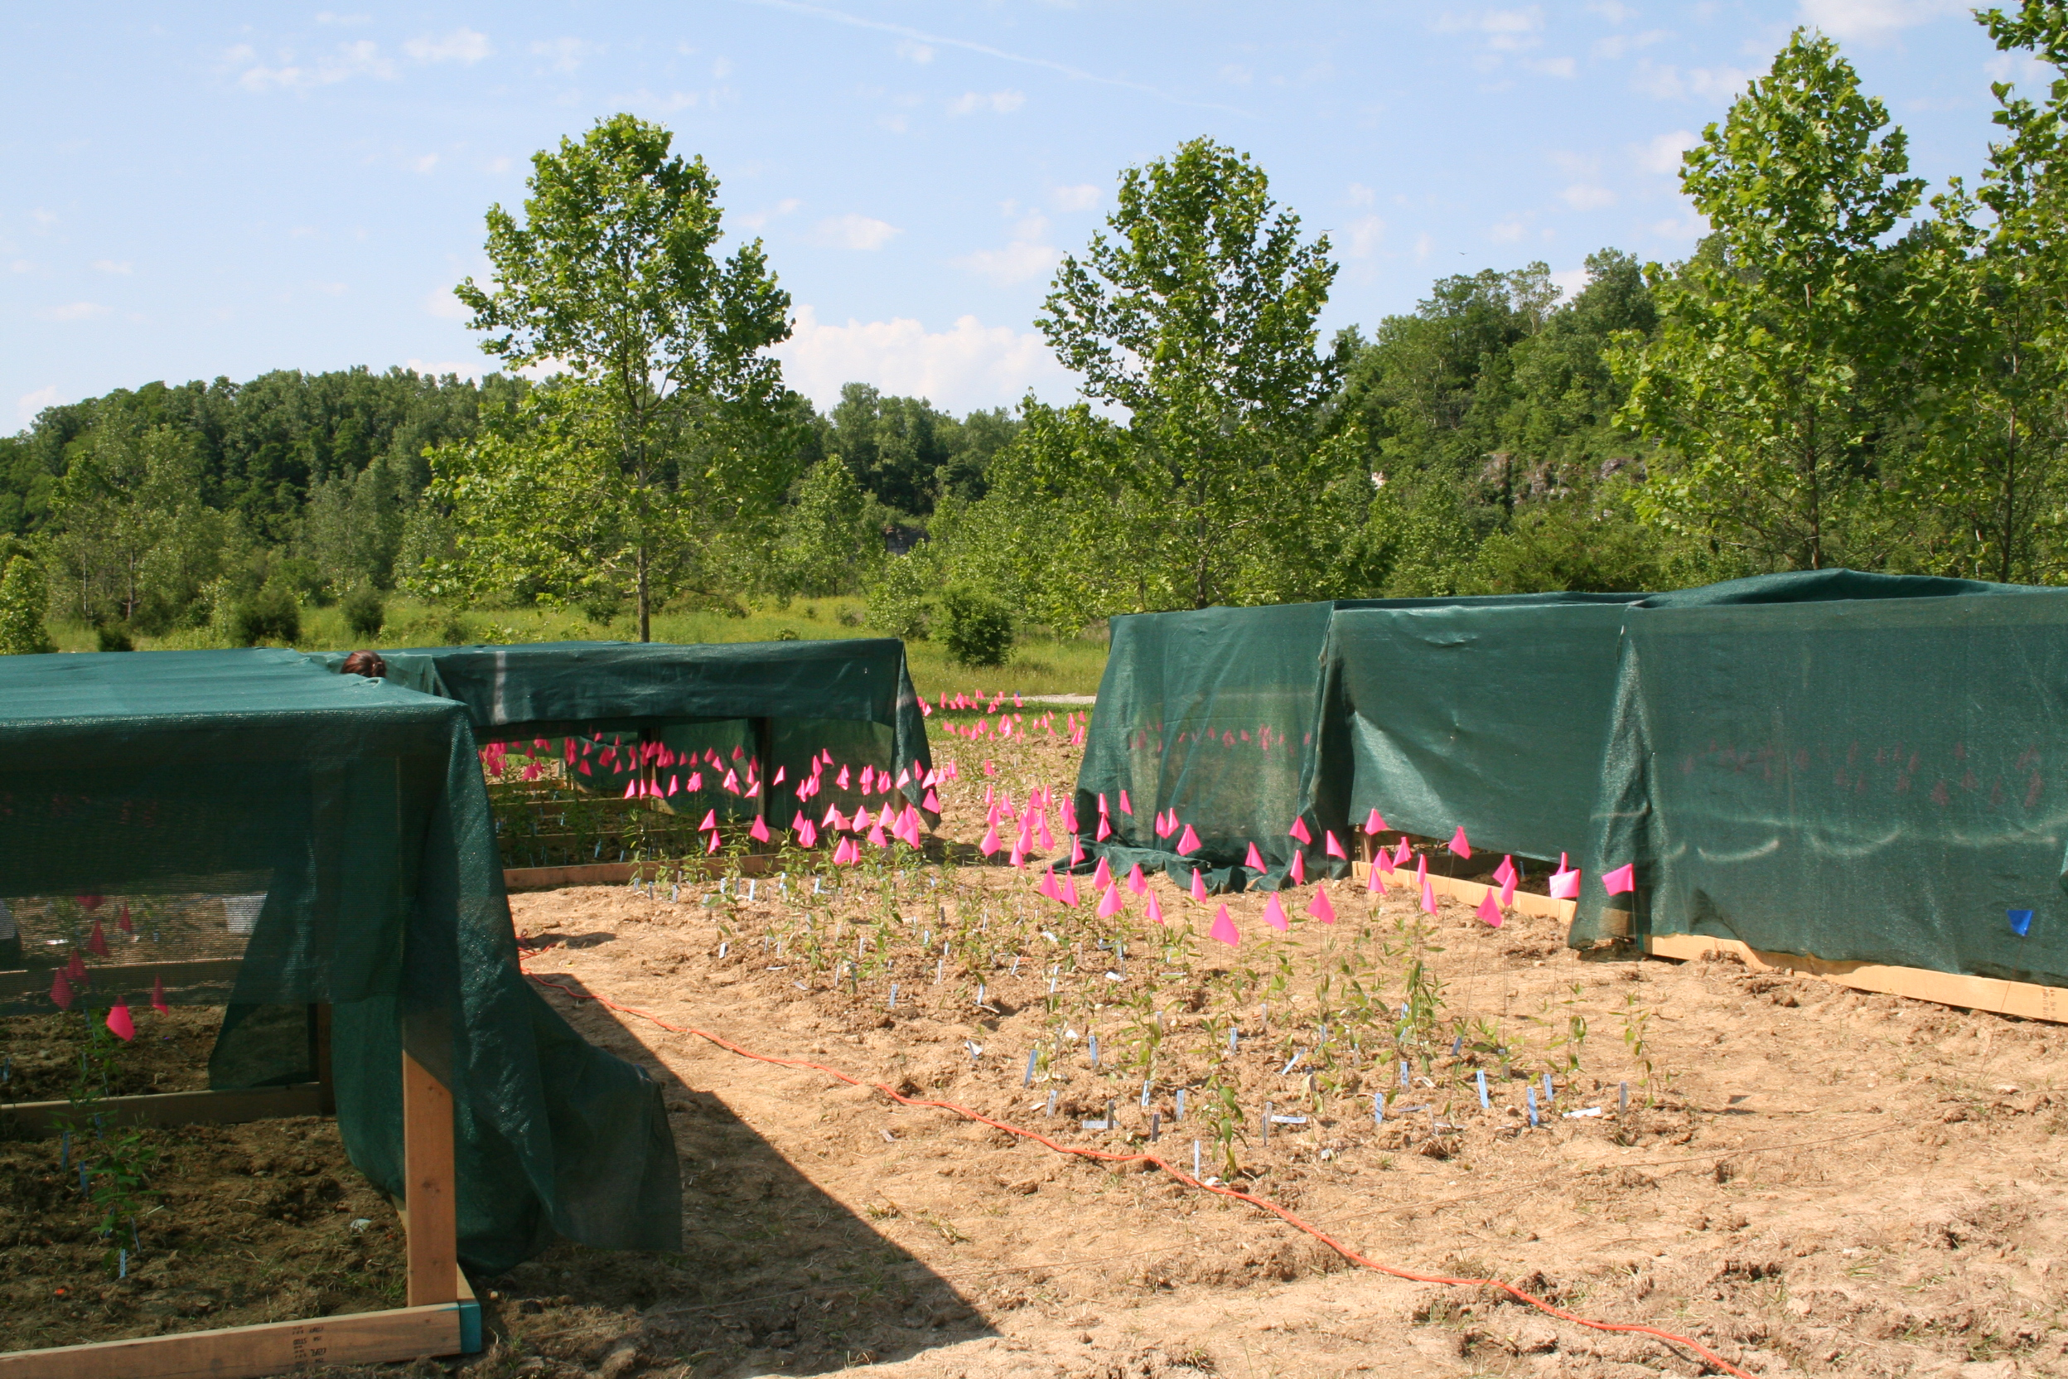
6.) We planted the plants in the experimental garden outside of the Manning Environmental Field Station on June 10, 2008. They were planted 0.3 m apart in a randomized split-plot design The design spread micro-environmental variation across family lines. There were 250 shade plants and 258 sun plants. We built 9 boxes that provided about 60% shade for the shade plants.

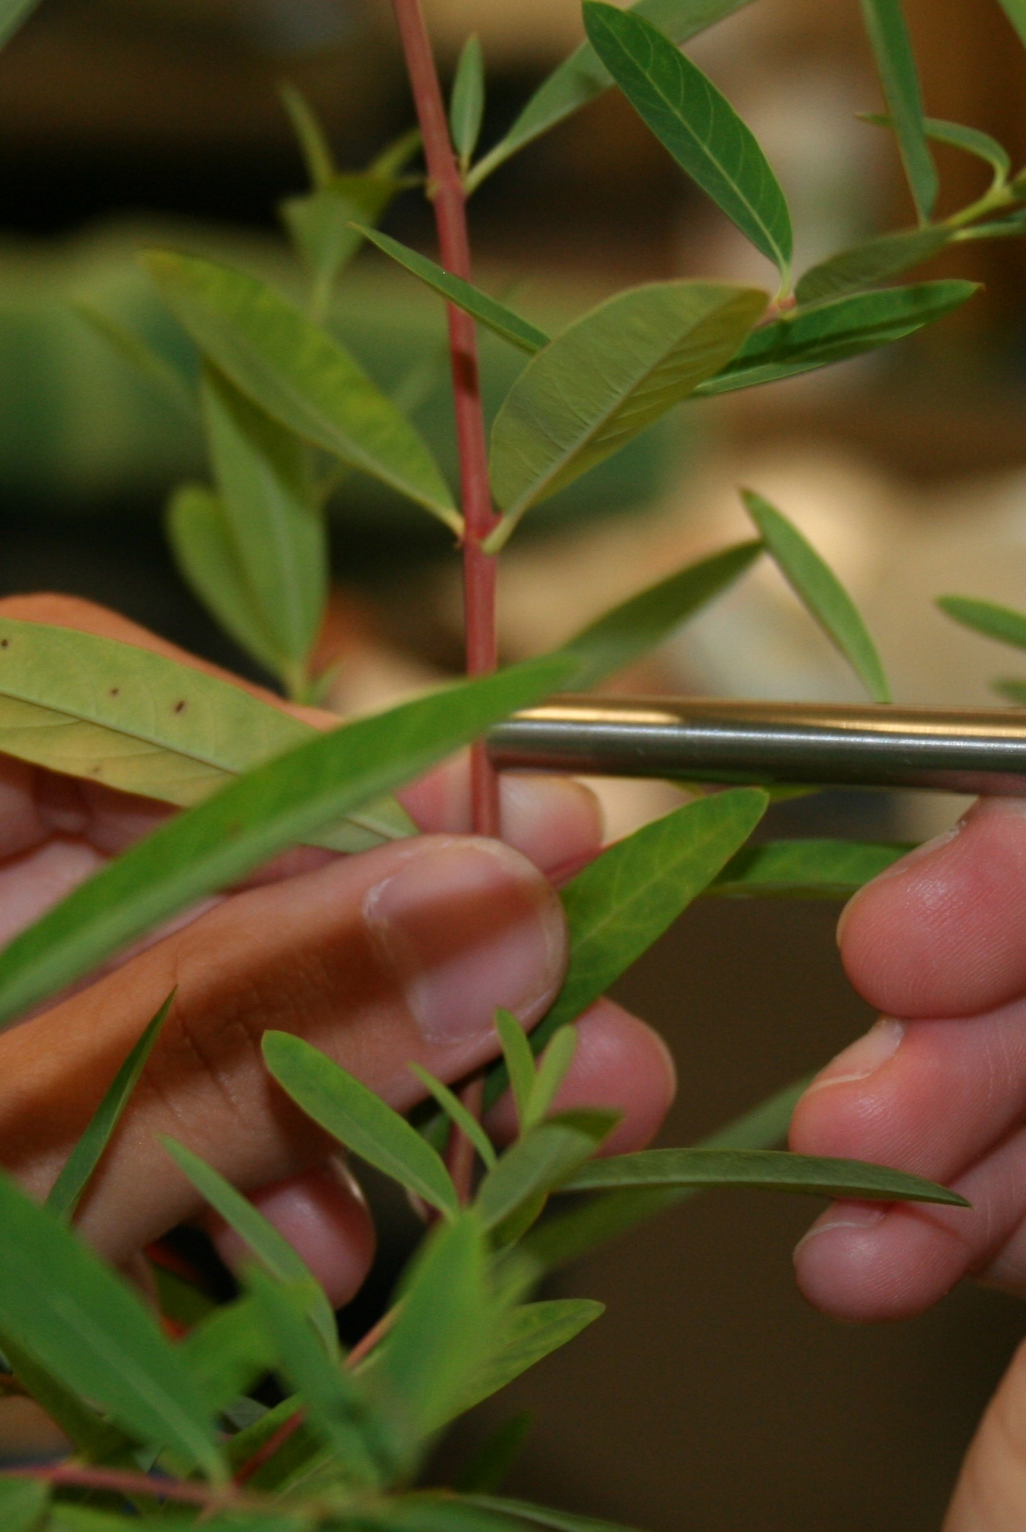
7.) We used a spectrophotometer and an attachable fiber optic probe to collect data on pigment production in the plants. The probe emits light and collects data on the reflectance of the stem at each wavelength in the visible spectrum. We focused on reflectance at a small subset of wavelengths (2003 index) to estimate anthocyanin content. We found the 2003 index to be most accurate for our plant (see Evaluation of Redness Indices)

8.) We measured pigment production on 8 dates over 7 weeks. We also took a final reading on an internode that had grown after the plants had been planted outside.

Results

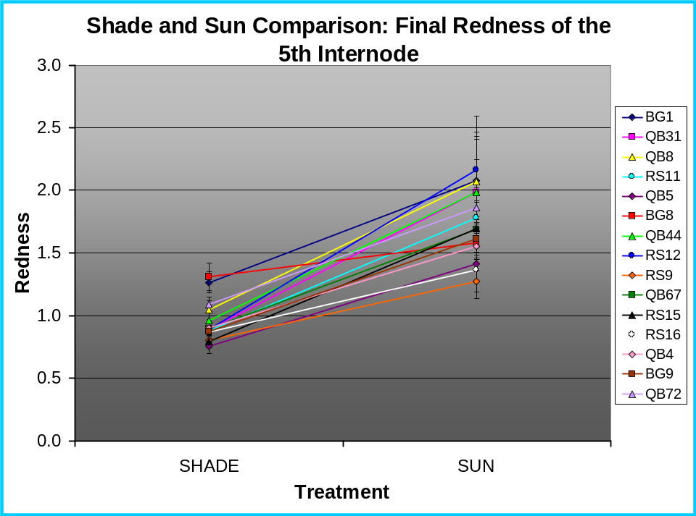

This graph compares the redness of the 5th internode among the shade and sun plants on the final day of measurements. There is a significant difference between treatments; the full sun plants were more red than those in the shade.

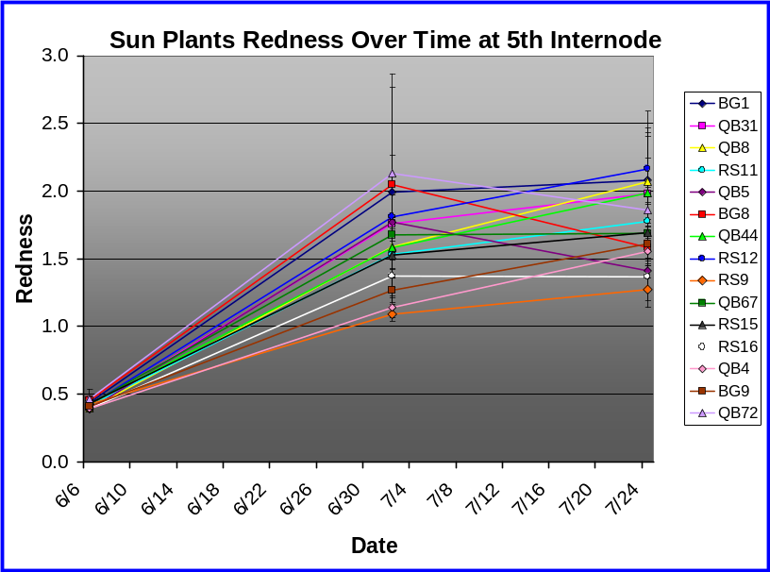

In full sunlight, the plants’ fifth internodes turned red. There were no significant differences among families which means that we did not detect an effect of genetics on the rate and amount of anthocyanin production in full sun.
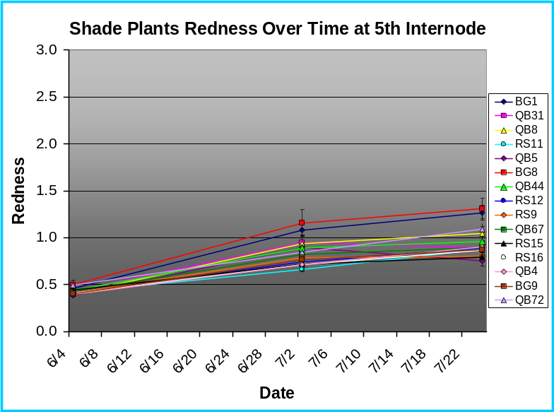

Even under 60% shade, the stems began to turn red. There were significant differences among families, which means that in the shade, we detected apparent genetic differences in the rate and amount of anthocyanin produced.

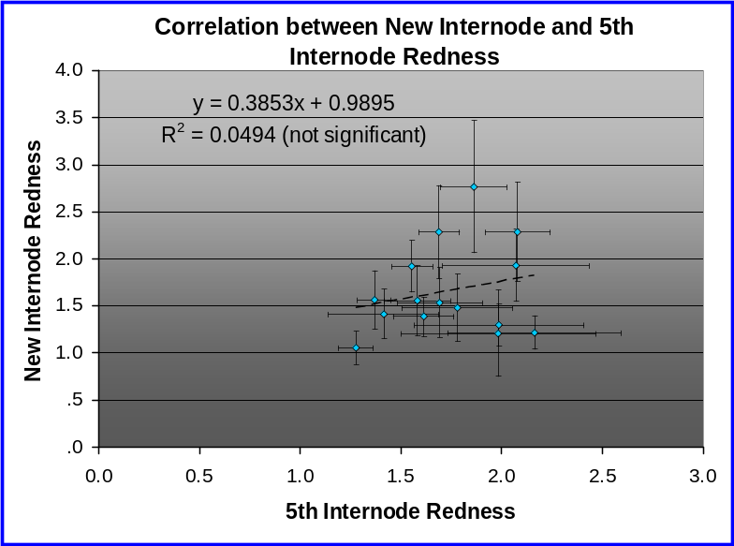

There were significant differences among families when we compared the redness of the 5th internode to the redness of a newly grown internode. However, there was no correlation between the color of the 5th internode and the color of the new internode.

Discussion

Without doubt, Apocynum cannabinum stems turn red in the sun and even under 60% shade. We found a significant difference between the two treatments, with sun plants producing more anthocyanin than their shaded counterparts.

In this experiment we looked for differences among maternal families suggesting that genetics play a role in the rate and amount of anthocyanin production. We had mixed results; we found that there were significant differences among genetic groups in the shade but we could not detect these differences in the sun.

Most surprisingly, there was no correlation between the redness of two internodes on the same plant. This was probably due to great variation in stem color within individual plants.

In previous studies, our lab group found that in nature, greater light intensity corresponds with more variation in redness among plants. This increased variation could be the result of several sources including genetic variation among siblings, micro-environmental variation among plants, and/or oversensitivity of our reflectance probe. It could also be due to that while all of the sun plants have the capability to turn red, some plants remain green for reasons yet unknown.

