Estimating the Potential Impact of Emerald Ash Borer (Coleoptera: Buprestidae) Presence in the DePauw University Nature Park
Megan Walton, Neil Broshears, Alex Eades, and Amanda Hendricks
DePauw University – Greencastle, IN

ABSTRACT Emerald Ash Borer (Coleoptera: Buprestidae) is an invasive beetle that is native to Asia. It is assumed that it arrived in 2002 in the Michigan harbor areas via wooden shipping crates (Haack et al. 2002). The Emerald Ash Borer (EAB) feeds on the phloem of ash tree species (Fraxinus spp.) native to the Northeastern United States and lays its larvae underneath the bark. This activity cuts off the water supply to the tree and leads to the eventual death of the host (Purdue Extension 2008). This poses a large threat to the ecosystem and economy of the areas affected (MacFarlane and Meyer 2005). We investigated whether or not EAB has arrived in Putnam County, more specifically the DePauw Nature Park and Arboretum. EAB was not found in our study area. Through observational field studies, GIS mapping and analysis we predicted the potential impact of EAB introduction to the ash tree population in the Arboretum and Quarry South. Since we found that ash trees comprise less than 1% of the forest structure, we conclude that EAB invasion would not have a detrimental effect on the Arboretum and Quarry South forest composition.

__________________________________________________________________

Introduction

Emerald Ash Borer (Coleoptera: Buprestidae) is an invasive beetle pest whose larvae feed on the phloem of ash trees (Fraxinus spp.) found in the inner cambium (Figure 1). This feeding activity leads to a girdling effect, cutting off the supply of vital nutrients and water and leading to the eventual death of the ash tree within 3-5 years after infestation (Poland and McCullough 2006). Adults can fly in 8-12 meter bursts, allowing it to move from one tree to another very easily (Haach et al. 2002). As a population, EAB has been spreading at an approximate rate of 0.6 miles per year (Poland and McCullough 2006). This rate may appear slow but poses a large threat to forest stands throughout the Midwest.
The Emerald Ash Borer (EAB) is native to China, Korea, Mongolia and Japan (Haach et al. 2005). In 2002, EAB was identified for the first time in North America in Detroit, Michigan and Windsor, Ontario (Poland and McCullough 2006). It is commonly believed that EAB was introduced to North America by transfer of wooden crates and pallets used in shipping from Asia. Quarantine efforts have been implemented in all infected counties but due to a lack of awareness of quarantine guidelines, EAB has spread to areas in Ohio, Maryland, Virginia, and Indiana (BenDor et al. 2006).
The potential impact that EAB could have on North America is massive in terms of both biological and economic costs. The impact depends on the distribution and overall health of the ash tree populations
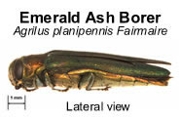
Fig. 1. Emerald Ash Borer (Purdue Extension 2008).

in North America. Knowledge of the ash tree distribution could help identify the potential risk that North American forests face if EAB continues to spread (McFarlane and Meyer 2005).
The elimination of ash trees by EAB could potentially have a negative impact on the ecosystem as well as the economy. Heavy loss of ash trees within forests could dramatically alter the biodiversity of the local ecosystem. In urban areas, where ash is commonly planted as street trees, dead trees create a burdensome cost for removal. The wood of ash trees is commonly used in the manufacturing of baseball bats, furniture, cardboard and paper (Poland and McCullough 2006). The total compensatory value of ash trees has been estimated to be as high as $282.3 billion in the United States alone (Poland and McCullough 2006).
As of 2005, prior to the discovery of EAB presence in 16 additional counties in Indiana (Purdue Extension 2008), a total of 48 United States counties had a confirmed

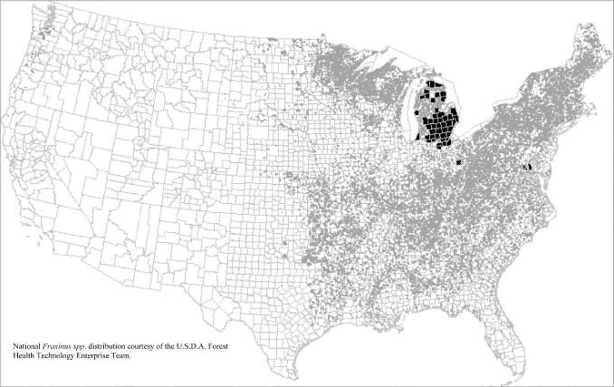
presence of EAB populations (McFarlane and Meyer 2005) (Figure 2). In 2003, there
were an estimated 7 billion ash trees in the country. Of these, 150 million or 2 percent are in Indiana (Liu et al. 2003). Green, white, and black ash species are the preferred hosts of EAB, and trees experiencing greater stress are more susceptible (Poland and McCullough 2006).
As residents of Indiana and the DePauw University campus community, we were interested in whether EAB had spread to Putnam County. There are three quarantined counties each within a 75 mile radius of Putnam County (Purdue Extension 2008). We conducted a survey of the Arboretum and Quarry South of the DePauw University Nature Park in Greencastle, Indiana for the presence of EAB. If the beetle was found to be present, the correct authorities would be notified and a plan to eradicate all infected trees would have been implemented.
Additionally, we mapped the potential impact that EAB would have on older and younger eastern deciduous forest stands in the Nature Park if EAB were to reach Putnam County and the DePauw University Nature Park. The Nature Park was given to DePauw University in 2004, and over the past 35 years since the abandonment of the quarry, the Arboretum and the areas around the quarry have been undergoing ecological succession (DePauw University 2008). Therefore we chose our site locations to represent the young and old forest stands of the Nature Park, Quarry South and the Arboretum, respectively. Identification of EAB presence in the Nature Park as well as its potential impact on our forest could provide valuable information for prevention or management strategies on campus as well as within the Putnam county communities.
We hypothesized that it would be unlikely for EAB to be present in Putnam County. If EAB were present, we expect that younger tree stands will be more affected than older tree stands. Thus the forest plots located in the Arboretum may be more affected than Quarry South. Additionally, the presence of EAB, and the resulting loss of ash trees will likely have a large detrimental effect on tree canopy.

Methods

Study Area and Sampling Design

Methods were modified from the Breeding Biology Research and Monitoring Database (BBIRD) developed by Thomas E. Martin et al. (1997). We restricted our study to Quarry South and the Arboretum of the DePauw University Nature Park located in Greencastle, IN. These locations contain young (Quarry South) and old (Arboretum) eastern deciduous forest stands found in the Nature Park. They also contain an unknown proportion of ash trees. To examine the presence of Emerald Ash Borer (EAB) as well as the proportion of ash trees within these two areas, five additional plots per site were sampled and compiled with data collected by Dr. Vanessa Artman during 2004 and 2006. Dr. Artman’s ecology students collected data on tree species composition of 20 plots in each site. The inclusion of these data enabled us to more accurately determine the ash composition in each of the sites.
We chose our sample sites using random computer-generated numbers for grid point (location in Nature Park assigned by a grid system by Dr. Artman), compass direction and distance from grid points. This location was assigned as the center of our vegetation plot and was marked with an orange flag indicating the site name.

Adult Tree Data Collection

Latitudinal and longitudinal GPS coordinates were collected at the center of each plot and recorded using handheld GPS units. After site location was determined and recorded, a radius of 11.3 meters was marked using a tape measure (Figure 3). All trees within the 11.3 meter radius of the plot were measured for circumference using a tape measure. All trees with trunks located at least half-way inside the circumference of the sample plot were included. Trees were placed into one of three size categories determined by diameter at breast height (1.38m): small trees (8-23cm), medium trees (23-38cm) and large trees (>38cm) (Martin et al.). Trees with a diameter less than 8.0 cm were not considered trees for this study and were thus not included in the data.
All ash trees identified within the plots were marked with orange flagging tape as well as a numbered metal tag at breast height facing west. The tag number was recorded in our data. All other tree species were recorded as “other”. Upon identification of ash trees (Purdue Extension 2008), we surveyed the tree trunk from ground to breast height for the presence of EAB. Key identifiers included D-shaped exit holes, vertical splitting of bark, epicormic shoots forming from latent buds on the trunk (often a result of severe defoliation), die-back of leaves and evidence of unusually high presence of woodpeckers (Purdue Extension 2008).
Tree height was recorded for all ash trees, within our plots using a clinometer. To determine ash tree age, core samples were collected from the ash tree closest to the center of the plot using a tree corer. Core samples were placed into plastic drinking straws to protect them from breaking and marked with the ash tree tag number.
These methods were completed during early spring, prior to leafing-out, to obtain accurate GPS coordinates and clinometer readings.
Fig. 3. Vegetation plot diagram, modified from the BBIRD Field Protocol (Martin et al. 2007).

Sapling/Shrub Data Collection

After leafing out occurred, we returned to our sample vegetation plots and recorded the number of tree saplings and shrubs located within a 5 meter radius of the center of each plot (Figure 3). Only saplings and shrubs at breast height or taller were included. We also counted the number of ash tree saplings within this 5 meter radius. Identification of ash tree saplings was done by leaf identification. We double-checked our identification of adult ash trees using leaf characteristics to ensure that our previously collected data were accurate.

Core Sample Age Identification

All ash tree core samples were sanded using 220 and 320 grit sandpaper until individual rings were visible to the naked eye. Linseed oil was brushed over the core sample with gauze to create enough contrast in color that age could be determined. Rings were counted using a dissecting microscope. Due to poor quality of the core samples, correct age could not be determined and these data was not included in the study.

Data Compilation and Mapping

We compiled our data with the 2004-2006 tree data provided by Dr. Vanessa Artman into a spreadsheet using Microsoft® Excel. These data were mapped using ArcGIS software. The maps show ash and non-ash density and size in both Quarry South and the Arboretum (Figures 9 & 10). They also show the location of our sample sites in an aerial photograph of the Nature Park (Figure 4).
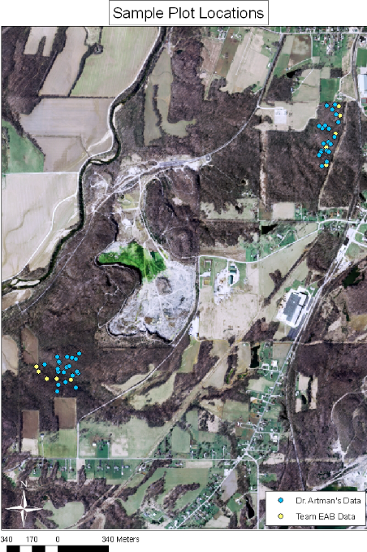Fig. 4. GIS map of our plot locations (yellow) in addition to Dr. Artman’s plot locations (blue) in the Arboretum (upper right) and Quarry South (lower left).

Data Analysis

Data were analyzed using a one-way ANOVA to determine if differences existed between Quarry South and Arboretum ash tree densities and size, average number of trees per plot, and forest structure (tree size). Additional one-way ANOVA tests were run to compare densities of ash tree saplings between the two sampling areas.

Relevance to Conservation Biology

This study pertains to conservation biology because it is an observational study of the potential impact of an invasive species on a forest community’s biodiversity and ecology. An invasive pest can considerably change the ecological composition of the environment in which it is introduced. In the case of EAB, its introduction could drastically impact the tree canopy and thus ultimately alter the flora and fauna of the forest floor. Fragmentation of forest habitat could occur in extreme cases of EAB outbreak. Conservation strategies, such as quarantines and eradication of infected trees are important actions to take to protect the forests of the Midwest. The data that we collect on ash composition in the DePauw Nature Park could help us identify risk as well as create prevention and management protocols. Our data and analysis are relevant to the goals and ethical principles of conservation biology in that our efforts could lead to greater awareness of the potential risks that the forest stands of DePauw University face. If we had found EAB in our study sites, we could have played an immense role in protecting the biological community.

Results

Fig. 5. Average number of trees per plot in the Arboretum versus Quarry South.

As shown in Figure 5, the Arboretum had an average of 21.88 trees per plot, whereas Quarry South had an average of 28.92 trees per plot. There was a significantly greater number of trees per plot in Quarry South than in the Arboretum (F_{1,48} = 7.841, p=0.007).

Fig. 6. Comparison of forest structure between the Arboretum and Quarry South.

The number of large trees in the Arboretum was significantly higher than in Quarry South (F_{1,48}=9.164, p = 0.004). The number of medium and small trees was significantly higher in Quarry South than in the Arboretum. (F_{1,48}=7.010, p = .011; F_{1,48}=8.954, p = 0.004, respectively) (Figure 6).

Fig. 7. Number of ash trees of each size category in the Arboretum versus Quarry South.

The number of ash trees did not differ between the Arboretum and Quarry South (F_{1,48} = 0.637, p=0.429, Figure 7).
Fig. 8. Number of ash versus non-ash saplings and shrubs in the Arboretum versus Quarry South.

Non-ash saplings and shrubs were significantly more abundant than ash saplings in both the Arboretum and Quarry South (χ²<0.001, df=1). For every ash sapling in a Quarry South plot, there were 16.1 non-ash saplings and shrubs. And for every ash sapling in the Arboretum, there were 8.7 non-ash saplings and shrubs. There was a greater proportion of ash saplings in the Arboretum than in Quarry South.

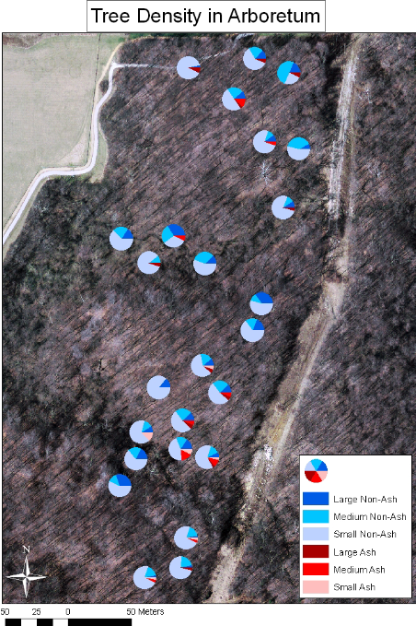
Fig. 9. GIS map of ash and non-ash tree density and size in the Arboretum.

As shown in Figure 9, ash trees comprised a small proportion of the total trees in the Arboretum. Most of the ash trees were in the medium and large size categories. Non-ash trees, comprising the majority of the Arboretum forest site, were primarily found in the small size category.
As shown in the map, there were three separate clusters of ash trees in the Arboretum. One is found at the northernmost region of the site, another in the west-central region, and another at the southernmost region.
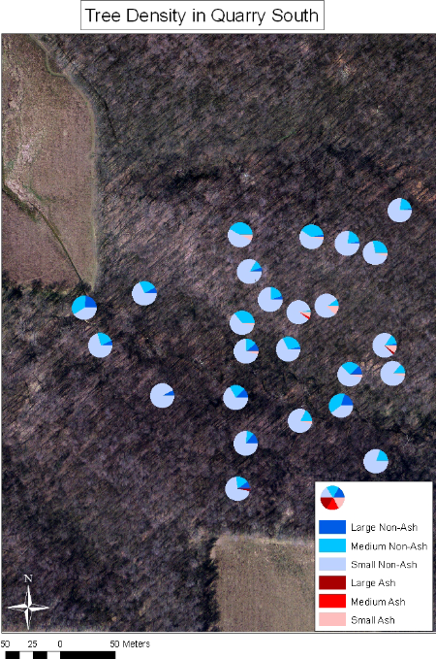
Fig. 10. GIS map of ash and non-ash tree density and size in Quarry South.

As shown in Figure 10, there was a higher proportion of small non-ash trees in Quarry South compared to the Arboretum. Additionally, very few ash trees are located in Quarry South compared to the Arboretum. Small non-ash trees were predominant in Quarry South. Most of the ash trees in Quarry South are located in a cluster in the east-central region of the site.

Discussion

Our results show that Quarry South has, on average, more trees per plot than the Arboretum (Figure5) and that the trees found in the Arboretum are typically larger than those found in Quarry South (Figure 6). This makes sense given that the Arboretum is the older forest site. Thus an older site will likely contain fewer young trees because its canopy is further developed and older trees are already established.
Our results suggest that the estimated threat to Quarry South and the Arboretum is relatively minimal given that each site contains less than 1% ash.
There was a significantly higher proportion of ash saplings per plot in the Arboretum than in Quarry South (Figure 8). This may be due to the presence of better quality soil for ecological succession in the Arboretum, given that it has gone undisturbed by humans much longer than Quarry South, which was left as an abandoned quarry site 35 years ago (DePauw University 2008).
The trend of finding ash trees in small clusters as shown in the GIS maps (Figure 9 & 10) can be explained by soil type or slope of the land. In locations where past human activity included logging, particularly in Quarry South, the forest at one point may have been fragmented and resulted in a clustered distributions of trees in areas such as slopes that were too steep to log. The Arboretum would likely have better quality soil as well due to its older age in comparison to Quarry South, and may be the reason that it has three main clusters of ash trees, whereas Quarry South only has one. It would have been beneficial to perform this study in three different forest sites instead of two in order to make more conclusive hypotheses for the reasons behind this cluster effect.
If we performed this study again, we would have checked all sites provided by Dr. Artman for the presence of EAB, rather than just checking our own. This would have provided a more accurate means of determining if EAB had reached Putnam County. Additionally, we should search for EAB presence again during late summer because the larvae emerge as adult borers beginning in late April and continuing through the remainder of the summer (Purdue Extension 2008). Thus, it is likely that when we made our observations in late April and early May that we could have missed the signs of EAB presence.
We also suggest that future studies include data collection in residential areas in addition to forests. Ash trees appear to comprise a greater proportion of tree canopy in residential areas than in forests. In a formal letter to the residents of Marion County, Indiana in 2006 the Marion County Tree Board declared that ash trees comprise 14% of Indianapolis’ residential tree canopy (Holdsworth 2006). Thus, introduction of EAB would likely have the most detrimental impact in residential areas than it would in forest sites.

References Cited

BenDor, T.K., S.S., L.E. Fontent, B. Sangunett, and B. Hannon. 2006. Modeling the spread of the emerald ash borer. Ecological Modeling 197: 221-236.
DePauw University Nature Park. 2008. DePauw University. 7 May 2008 <http://www.depauw.edu/univ/naturepark/>.
“Emerald Ash Borer in Indiana.” Purdue Extension. 17 March 2008 <http://www.entm.purdue.edu/EAB/>.
Haack, R.A., E. Jendek, H. Liu, K. Marchant, T.R. Petrice, T.M. Poland, and H. Ye. 2002. The emerald ash borer: a new exotic pest in North America. Newsletter of the Michigan Entomology Society 47: 1-5.
Holdsworth, K. Letter to the Residents of Indianapolis or Marion County. 5 Dec. 2006.
Liu, H., L.S. Bauer, R. Gao, T. Zhao, T.R. Petrice, and R.A. Haack. 2003. Exploratory survey for the emerald ash borer agrilus planipennis (Coleoptera: Buprestidae), and its natural enemies in China. The Great Lakes Entomologist 191-203.
MacFarlane, D.W., and S.P. Meyer. 2005. Characteristics and distribution of potential ash tree hosts for emerald ash borer. Forest Ecology and Management 213: 15-24.
Martin, T.E., C. Paine, C.J. Conway, W.M. Hochachka, P. Allen, and W. Jenkins. 14 March 1997. Breeding Biology Research & Monitoring Database.
Poland, T. M., and D.G. McCullough. 2006. Emerald ash borer: invasion of the urban forest and the threat to North America’s ash resources. Journal of Forestry 118-122.
Timms, L.L., S.M. Smith, and P. de Groot. 2006. Patterns in the within-tree distribution of the emerald ash borer Agrilus planipennis (Fairmaire) in young, green-ash plantations of south-western Ontario, Canada. Agricultural and Forest Entomology 8: 313-321.

