Invertebrate and Leaf Litter Dynamics
in the DePauw Nature Park

Karl Koehler and Vanessa Artman
Biology Department and SRF Program, DePauw University
November 2005

Introduction

Our study focuses on the interaction between invertebrate abundance and the decomposition of leaf litter. The decomposition of leaf litter plays a major role in the nutrient cycling process, which is critical to the health of an ecosystem (Spurr and Barnes 1980). The dynamics between invertebrates and leaf litter are of particular importance because invertebrates are good indicators of the activity of the decomposer community. Abiotic factors such as soil pH and temperature are also important influences on decomposition rates (Petersen and Luxton 1982, Seastedt 1984). Our goal was to determine the nature of this interaction. Ultimately, this information could provide us with a more accurate illustration of the efficiency and health of the Nature Park and Arboretum ecosystems.

We hypothesized that certain invertebrates would appear in high abundance in specific areas. If these invertebrates are integral in the decomposition process then there would be a noticeably higher amount of leaf litter decomposition in these areas.

Study Sites

We studied three sites: the Arboretum, Quarry Hillside, and Quarry South. These sites are relatively undisturbed deciduous forest. Each site has a similar make-up of rugged topography with upland and lowland regions, and at least one bisecting stream.

Methods

We set up two transects in each of the three study sites. In each site we set up a lowland transect near a stream and an upland transect on one of the ridges. Each transect included 10 stations, with stations located 10 meters apart.

Each station contained three wire mesh bags in which we placed 10 grams of oven-dried leaf litter (Figure 1B). After 6 weeks we collected one leaf litter mesh bag randomly from each station. The contents of each bag were oven dried for 48 hours at 140°F. The litter was then weighed to measure remaining biomass after decomposition.

Each station also contained one pitfall trap in which we collected invertebrates (Figure 1A). We constructed pitfall traps using chicken wire, two plastic cups, a masonite board, tent stakes, and propylene glycol. We collected invertebrates from the pitfall traps once a week during June and July 2005 (Figure 1C). We placed the contents of each trap in a jar containing 70% alcohol solution (Figure 1D). In the lab we sorted through the invertebrates categorizing them by order (i.e. spider, isopod, cricket, etc.). After sorting, the invertebrates were oven-dried at 105°F for 24-48 hours and weighed to measure biomass (Figure 1E). Raccoons and other vermin disturbed some traps during the initial weeks of the study. We thus calculated the relative abundance and biomass by accounting for the number of active (undisturbed) traps each week. We ran a two-way ANOVA to compare invertebrate biomass among sites (Arboretum, Quarry Hillside, Quarry South) and transects (upland vs. lowland).

We collected vegetation data in 2004 and 2005 using standard protocol (Martin et al., 1995). We established randomly located plots throughout each site. We estimated the percent cover of leaf litter on the ground (vs. bare ground) within a 5 meter radius at each plot. We measured leaf litter depth at 12 points within each plot. We measured biomass of leaf litter by collecting all litter within a 0.5 x 0.5 meter subplot at randomly chosen coordinates. We ran one-way ANOVAs to compare leaf litter cover, depth, and biomass among sites (Arboretum, Quarry Hillside, Quarry South).

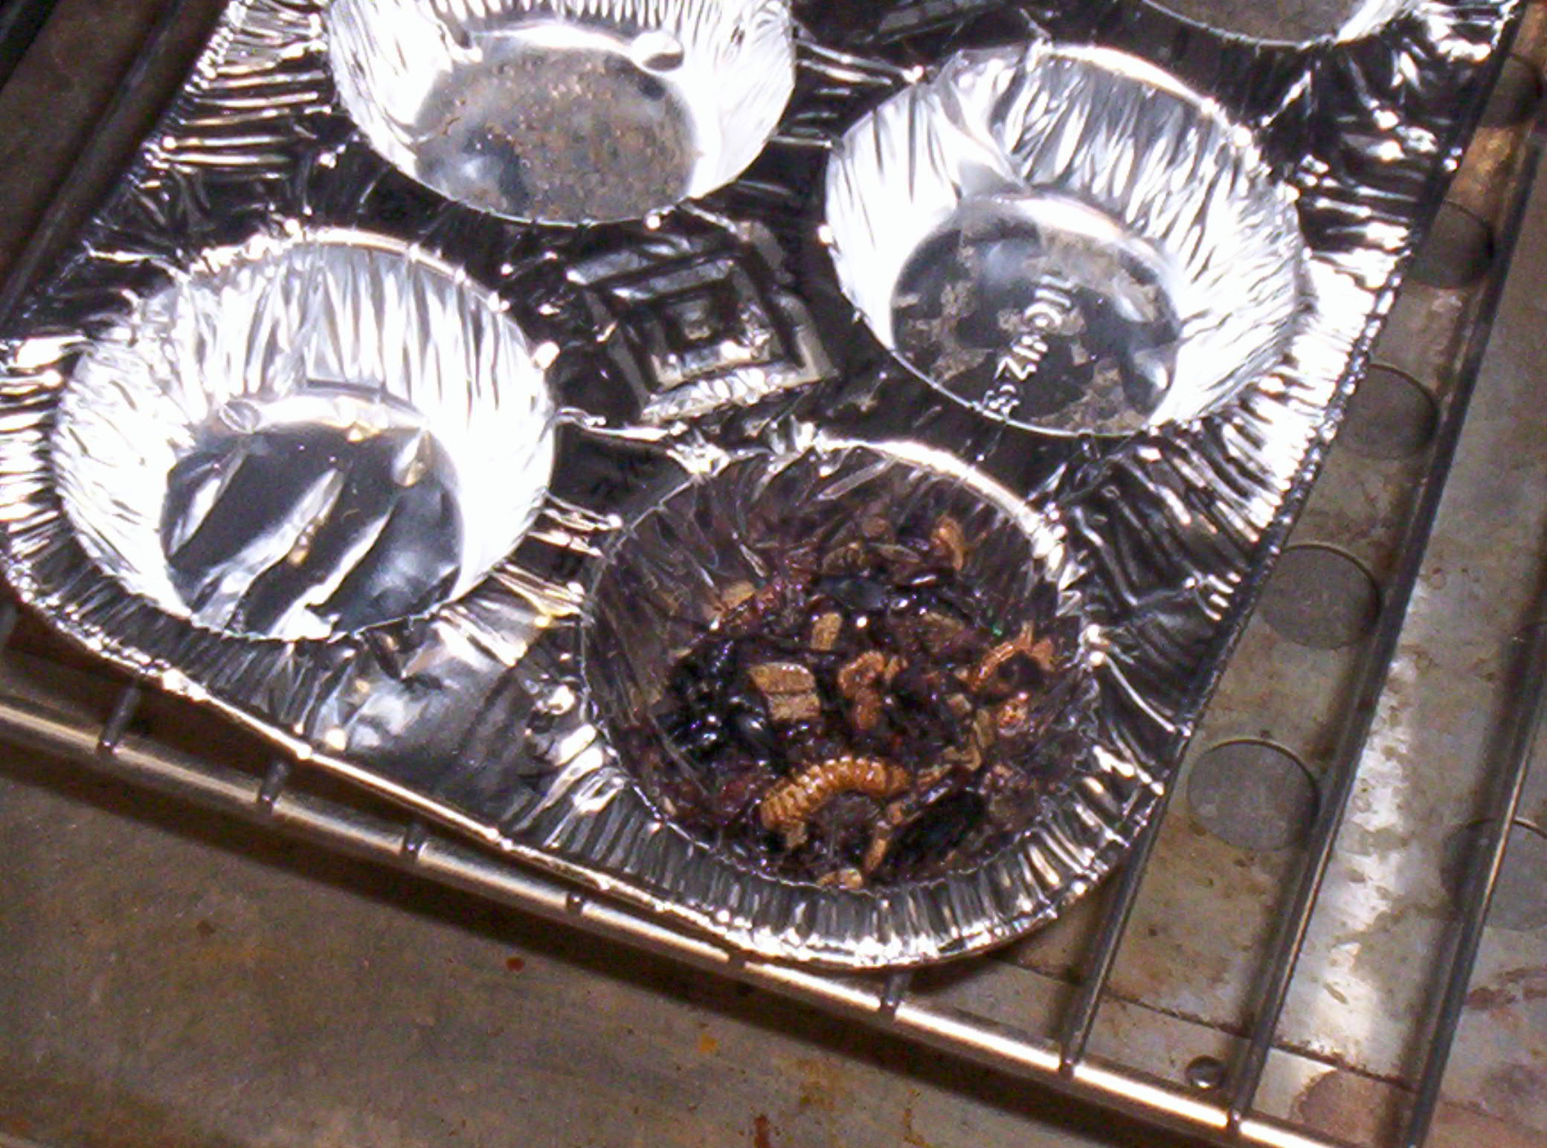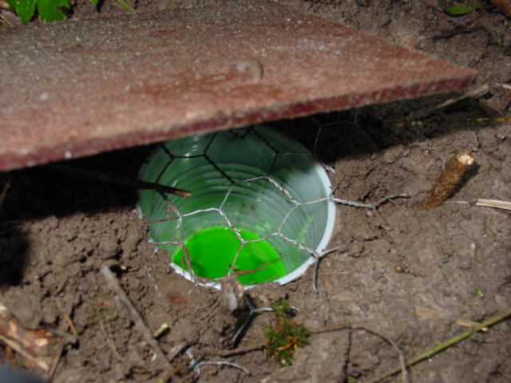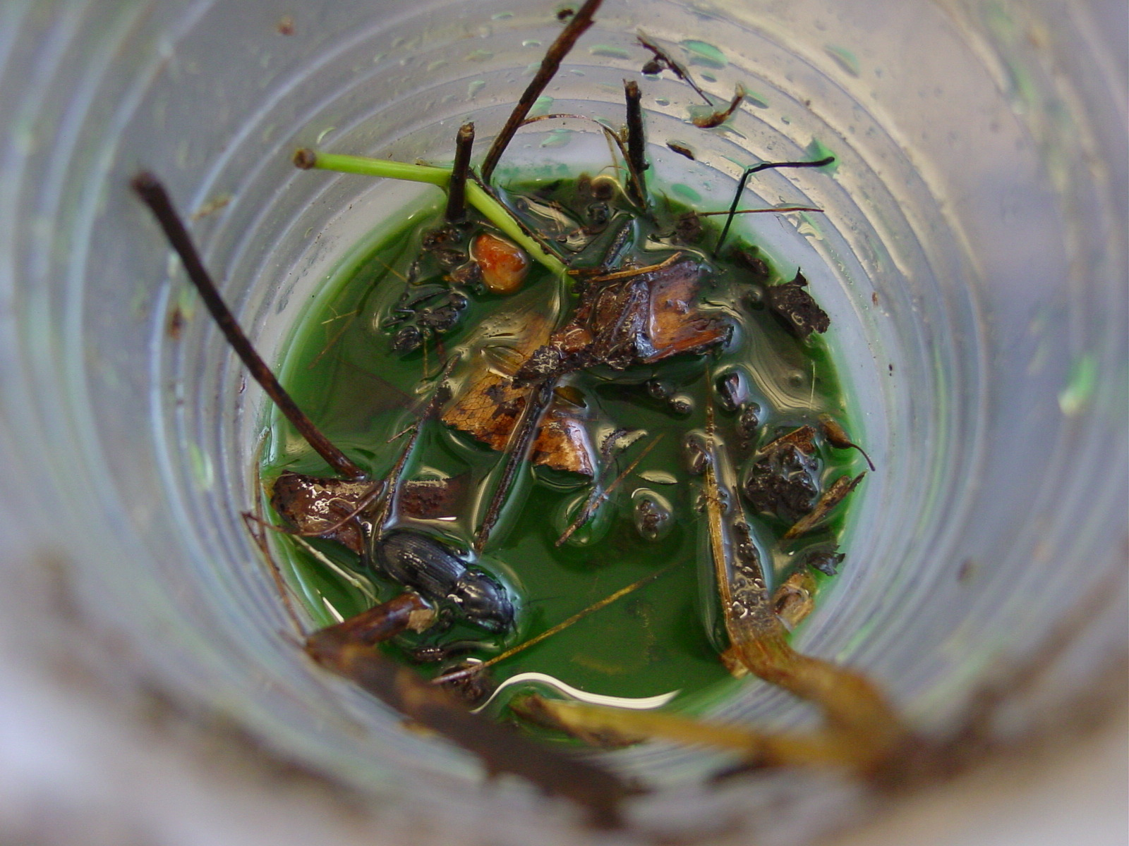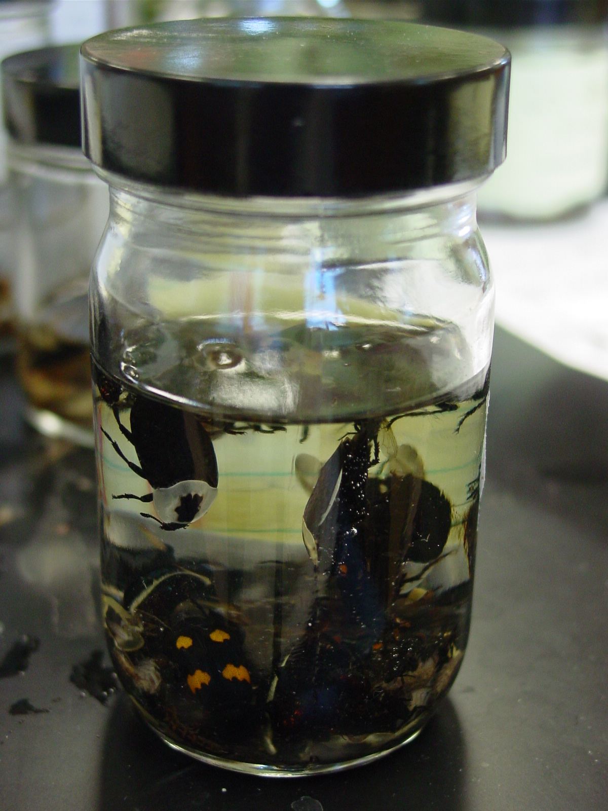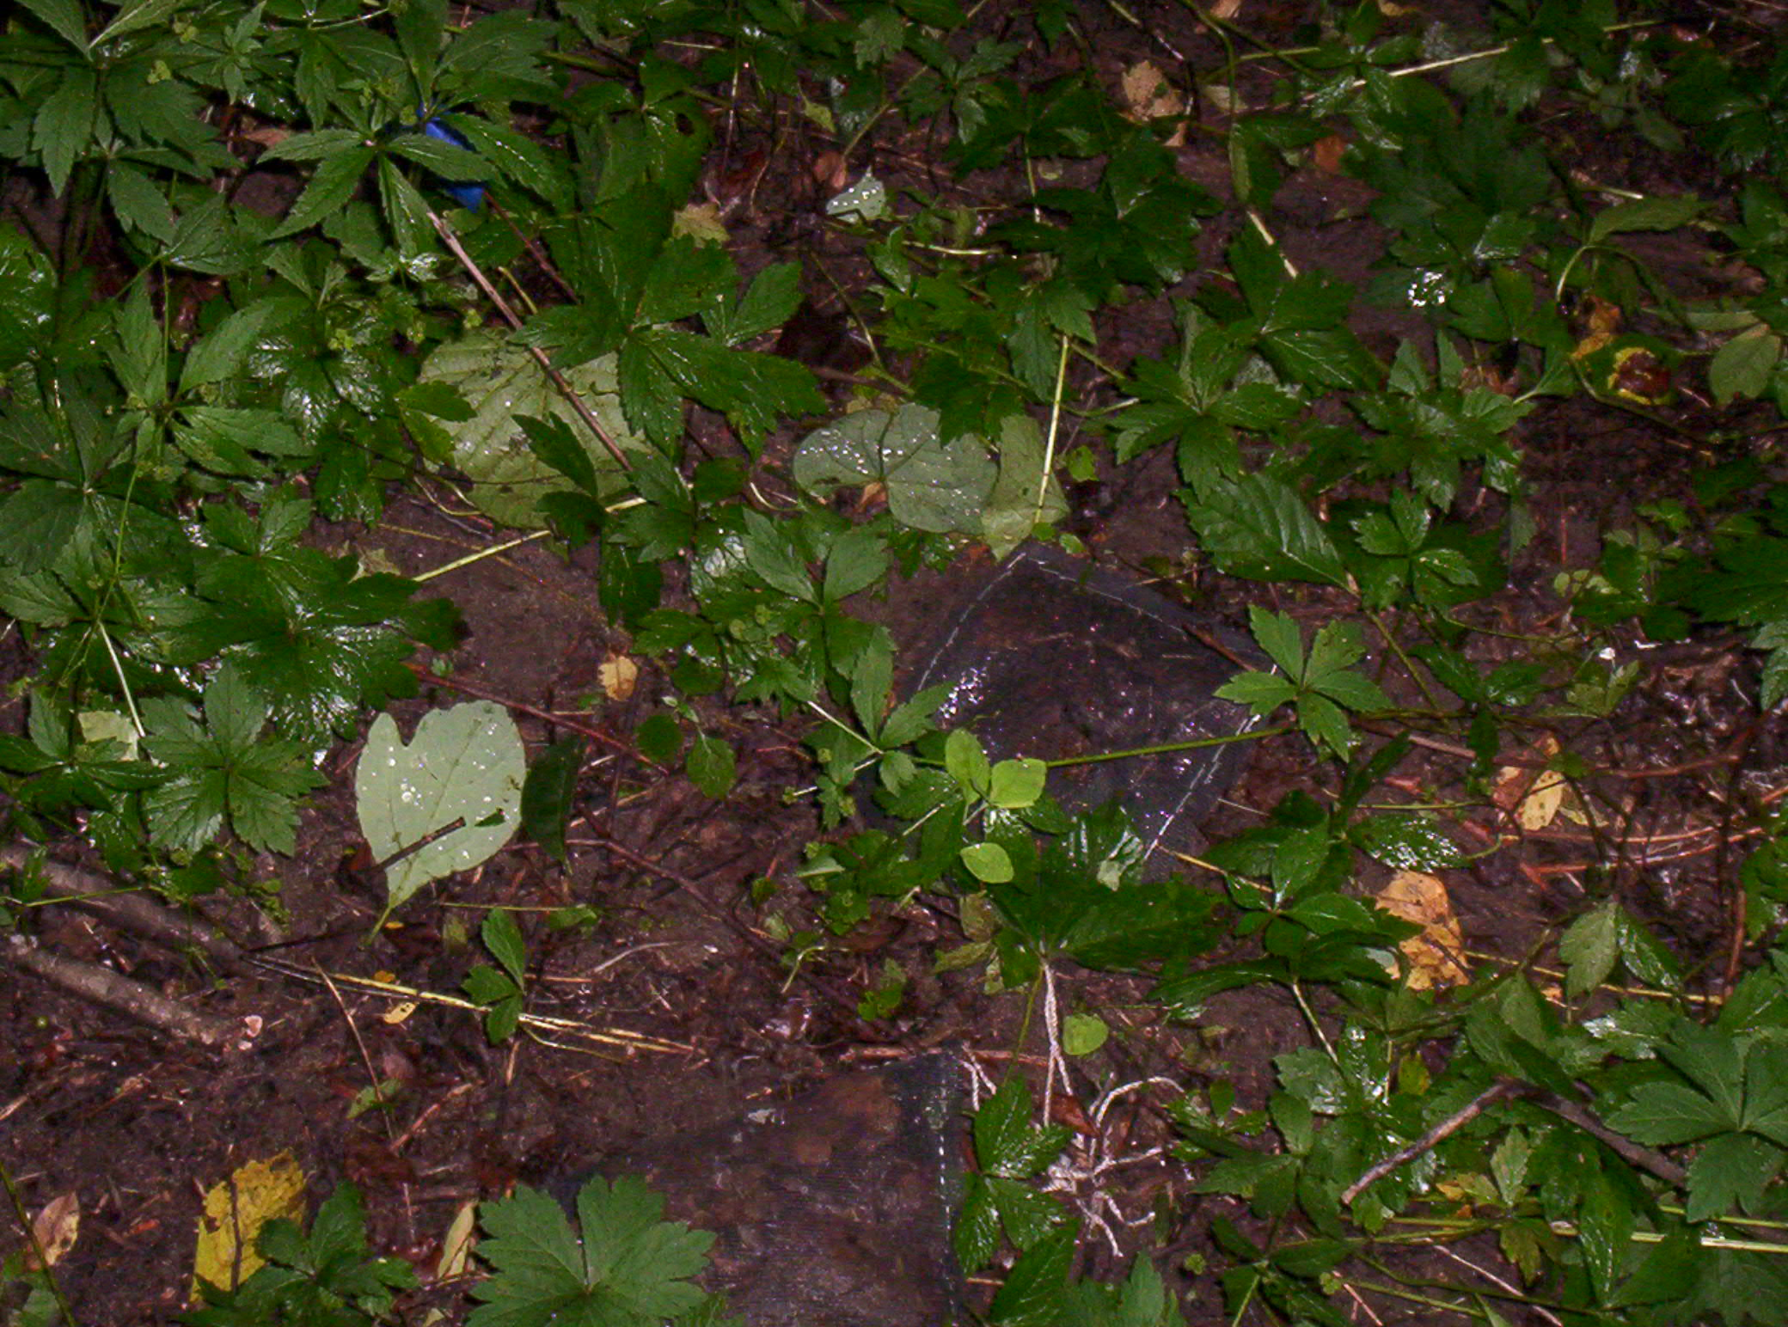
Photograph by Aaron Randolph
Photograph by Aaron Randolph
Photograph by Aaron Randolph
Photograph by Karl Koehler
Figure 1

A. Pitfall Trap

B. Leaf Litter Bags

C. Invertebrates in Trap

D. Sorted Invertebrates

E. Oven-dried Invertebrates
A
B
C
D
E
Photograph by Karl Koehler
Results

We collected a total of 8,604 invertebrates from the pitfall traps over the six week period. The most abundant invertebrates were isopods (2,651), crickets (2,112), spiders (733), ants (674) and centipedes (695). Isopods and crickets were in high abundance at all three sites (Figure 2).

Figure 2. Composition of surface-active invertebrate communities

Arboretum Lowland
Arboretum Upland

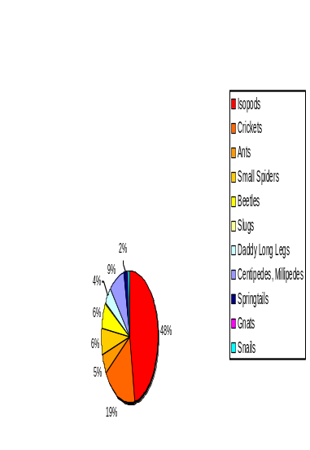
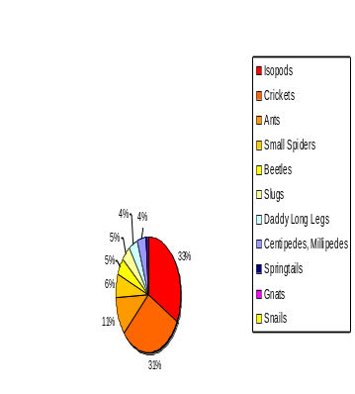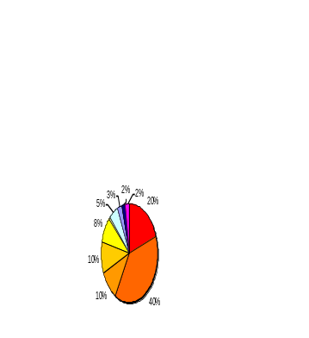
Quarry South Lowland
Quarry South Upland

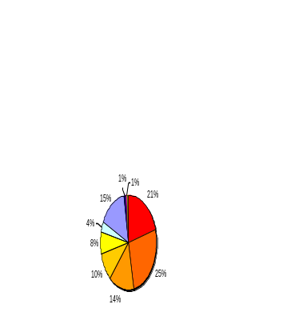
Quarry Hillside Upland
Quarry Hillside Lowland
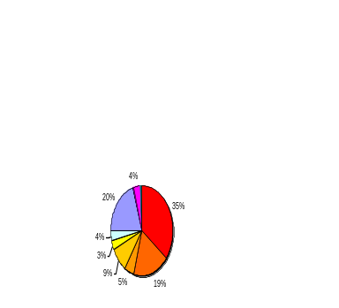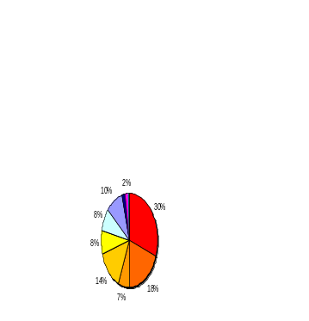

The abundance of invertebrates was directly correlated with invertebrate biomass at each site (Figure 3). There were no differences in total abundance of all invertebrates among sites (Arboretum, Quarry Hillside, Quarry South; ANOVA: F_{2, 25} = 0.2, p = 0.8) or between transects (upland vs. lowland; ANOVA: F_{1, 25} = 0.2, p = 0.6).

Figure 3. Abundance and biomass
of surface-active invertebrates by location.

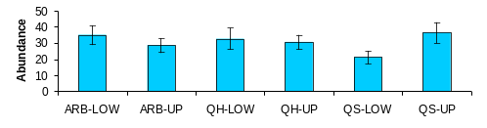
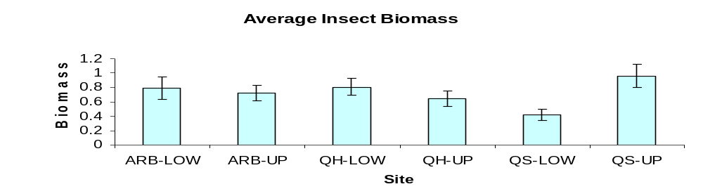

The abundance of several taxonomic groups of invertebrates differed among sites, as shown in Figure 4. Abundance of other groups (isopods, ants, spiders, daddy-long-legs, springtails, and gnats) did not differ among sites.

- Crickets were more abundant at the Arboretum than the other sites (F_{2, 25} = 6.8, p = 0.004).
- Centipedes were more abundant at the Quarry sites than the Arboretum (F_{2, 25} = 4.7, p = 0.02).
- Slugs occurred primarily at the Arboretum, were uncommon at Quarry South, and were absent from Quarry Hillside (F_{2, 25} = 7.3, p = 0.003).
- Snails were more common at the Quarry sites and were nearly absent from the Arboretum (F_{2, 25} = 4.7, p = 0.02).
- Beetles were more abundant in upland than lowland areas (F_{1, 25} = 5.4, p = 0.03).

Figure 4. Abundance of specific taxonomic
groups of invertebrates by location

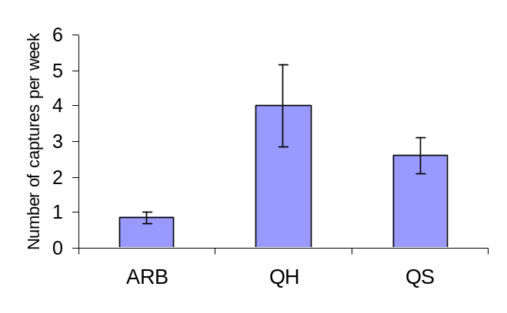
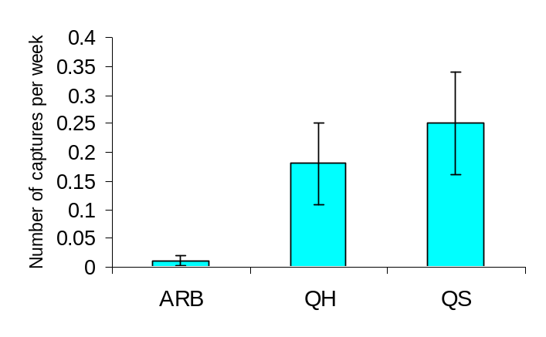
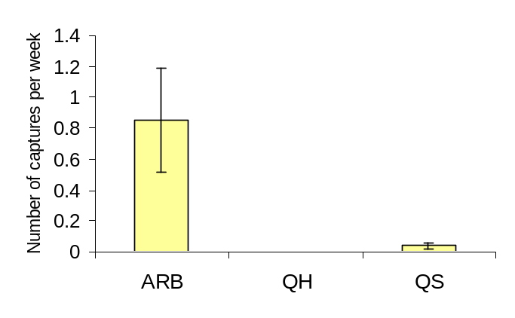
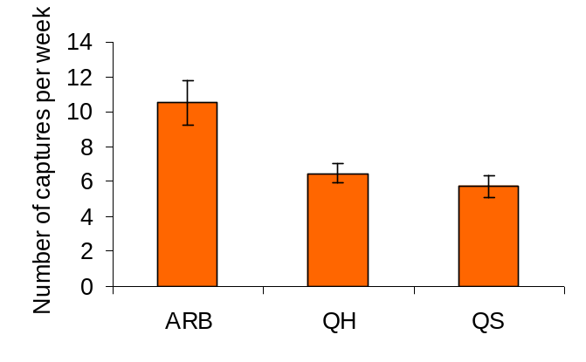

Crickets
Centipedes

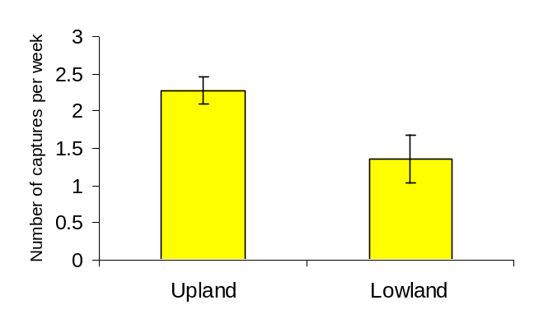
Beetles
Snails
Slugs
Leaf litter biomass was significantly higher at the Arboretum and Quarry Hillside than at Quarry South (Figure 5; ANOVA F_{2, 87} = 9.6, p < 0.001). These data were collected during early winter 2004, indicating that the amount of new leaf litter input into the ecosystem before decomposition was higher at the Arboretum and Quarry Hillside than at Quarry South.
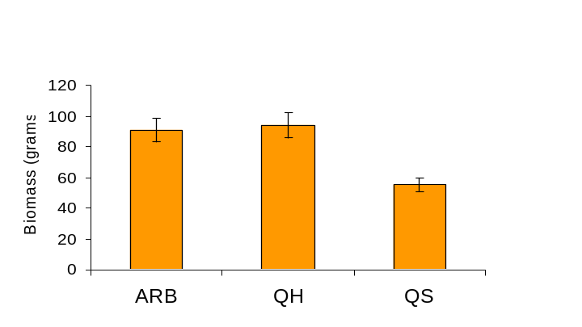

Figure 5.
Biomass of leaf litter.

Leaf litter cover was significantly higher at the Arboretum and Quarry Hillside than at Quarry South (Figure 6; ANOVA F_{2, 48} = 6.2, p = 0.004). These data were collected during the summer in 2004 and 2005. These pattern suggests that rates of leaf litter decomposition from winter to summer were similar among the three sites, and that the difference between sites may be due to initial inputs of leaf litter during autumn.
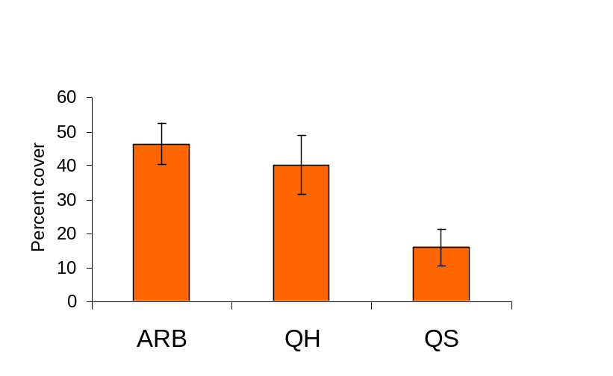
Figure 6.
Percent cover of leaf litter.

Leaf litter depth varied among the sites, as shown in Figure 7, but the differences were not statistically significant (ANOVA F_{2, 48} = 1.7, p = 0.2). However, the pattern is consistent with the trend illustrated in Figures 5 and 6, with deeper leaf litter observed at the Arboretum and Quarry Hillside in comparison to Quarry South..
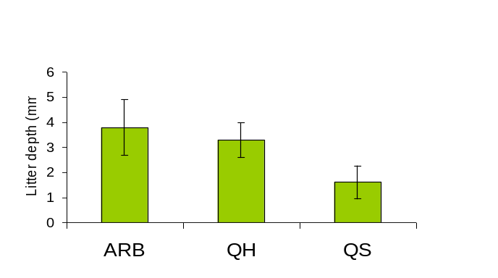

Figure 7.
Depth of leaf litter.

We conducted an experiment to test whether rates of leaf litter decomposition differed among the sites. This experiment was conducted during summer 2005. We placed 10 grams of oven-dried leaf litter in mesh bags and placed these on the ground at each site. We collected the mesh bags after a six week period. The leaf litter was oven-dried and weighed to measure remaining biomass. Approximately 3 to 7 percent of the leaf litter in the mesh bags decomposed during the six week period (Figure 8). There were no differences in decomposition rates between sites (ANOVA F_{2, 54} = 0.5, p = 0.6) or between upland and lowland transects (ANOVA F_{1, 54} = 0.7, p = 0.4).

It is somewhat surprising that more litter decomposition did not occur during the six week period. During a study conducted in an Appalachian forest, 10 to 20 percent of the leaf litter decomposed after a similar time period (Mudrick et al. 1994). This variance could be attributed to the difference in tree species.

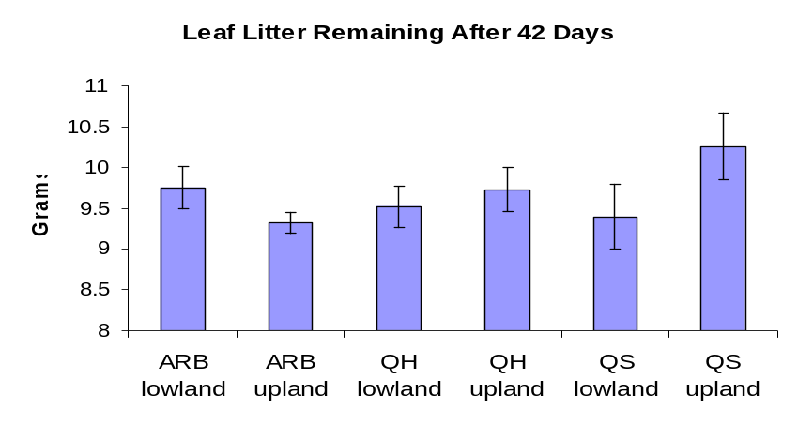
Figure 8. Leaf litter decomposition after six week period.

Figure 5. Percent cover of leaf litter on the ground.

Discussion

We observed differences in the amount of cover, depth, and biomass of leaf litter at the three sites. The differences suggest a slower rate of decomposition or a higher rate of accumulation at the Arboretum and Quarry Hillside in comparison to Quarry South. Low accumulation of leaf litter at Quarry South may be due to other factors such as tree species composition. Elm trees are more common at Quarry South than the other sites (Reed, 2005). Elm leaves decomposed faster than oak leaves in a microcosm experiment, apparently because microbial activity was higher on elm leaves than oak leaves (Eichem et al. 1993). The Arboretum has a high abundance of oak which may explain the relatively higher leaf litter accumulation.

From our data it is unclear whether the high abundance of one or more groups of invertebrates has a direct effect on leaf litter decomposition. Macroinvertebrates with a key role in decomposition include beetles, springtails, centipedes, millipedes and ants (Burghouts et al. 1992). The presence of these invertebrates is apparent at each site, but no discernable patterns in abundance were consistent with differences in leaf litter accumulation. If the abundance of certain invertebrate groups plays a major role in the rate of litter decomposition at the sites, then we would expect that abundance of some invertebrates should be higher at Quarry South than the other sites.

Over time, our experiment with litter mesh bags should yield more data on differences in decomposition rates between the sites and between upland and lowland areas. We will continue collecting these mesh bags after a six month period and twelve month period. The data on decomposition rates should be particularly illuminating in regards to our objective of finding correlations between invertebrate abundance and litter decomposition.

Future Research

It is important that we continue our study, for the ecosystem and the inherent food web depend on the nutrient cycle of which litter decomposition is an integral component. Looking to the future we may want to consider some of these avenues of study:
    - Collect leaf litter using a series of traps and nets to measure input of new litter during autumn.
    - Collect leaf litter to extract invertebrates and gain better insight into which organisms are pivotal in the decomposition process.
    - Continue collecting data on invertebrates to identify key biotic factors acting on the leaf litter.
    - Conduct chemical analyses of leaf litter and soil to see which abiotic properties (moisture, pH, nutrient levels, etc.) may be contributing to rapid or slow decomposition rates.
    - Compare our data with that recorded in surrounding areas. For example, leaf litter depth in forests of Ohio averaged over 20 mm compared to our average of only 4 mm.
Acknowledgments

This study could not have been completed without the tireless perseverance and help of my fellow team members Libby Allard and Kyra Reed and the unwavering tutelage and guidance of our supervisor, Professor Vanessa Artman. I would also like to give a shout out to my parents for always supporting me and to DePauw University for funding the Science Research Fellows summer program.

References

Burghouts, T., G. Ernsting, G. Korthals, and T. Devries. 1992. Litterfall, leaf litter decomposition, and litter invertebrates in primary and selectively logged dipterocarp forest in Sabah, Malaysia. Philosophical Transactions of the Royal Society of London Series B 335:407-416.

Mudrick, D.A., M. Hoosein, R.R. Hicks, and E.C. Townsend. 1994. Decomposition of leaf litter in an Appalachian forest: effects of leaf species, aspect, slope position, and time. Forest Ecology and Management 68:231-250

Petersen, H., and M. Luxton. 1982. A comparative analysis of foil fauna populations and their role in decomposition processes. Oikos 39:287-388.

Seastedt, T.R. 1984. The role of microarthropods in decomposition and mineralization processes. Annual Review of Entomology 29:25-46.

Spurr, S.H. and B. V. Barnes, 1980. Forest Ecology. 3rd edition. Wiley, New York.

