Ecological Composition and Relative Health of the Forested Sites
at the DePauw Nature Park and Proposed Management Strategies

Kyra Reed and Vanessa Artman
Biology Department, DePauw University
November 2005

Introduction

DePauw University’s Nature Park, encompassing 192-ha of diverse habitats, provides a unique opportunity for education, ecological research, recreation, and conservation practices. The park includes deciduous forests, early-successional meadows, wetlands, a river, several freshwater ponds, and a large abandoned limestone quarry. Each of these habitats has been affected by human activity through mining, continuing construction, and logging.

In creating optimal use of the park, it is important to figure out how to reconcile educational, research, and recreational uses of the land while still maintaining the integrity of the ecosystem and perhaps promoting forest recovery. Thus, we are faced with some central questions – Is human intervention required to maintain ecosystem integrity or can the forest be “left alone”? If human intervention is necessary, what measures need to be taken? Before this can be decided upon, we must first determine whether the forest is healthy or not. A healthy forest is one having the capacity across the landscape for renewal, for recovery from a variety of disturbances, and for preservation of its ecological resiliency while meeting present and future needs of people for desired levels of uses, services, values, and products (USDA Forest Service, 2004).
Mature, healthy forests are ecosystems that have had time to undergo extended compositional change and structural development. They are distinguished from younger forests by high levels of stand structural diversity, such as size and condition of live trees, standing dead trees, and downed logs in varying stages of decay. Healthy forests contain great diversity in tree age, providing various habitats for animals, and often have a few large, old trees with little biomass accumulation, which includes shrubs and dead trees. High biomass decreases the health of a forest by reducing diversity and by out-competing other species, and is typically seen in younger, less mature forests.

Here, we present some baseline data on the ecological composition of several forested sites in the park. We intend to determine the relative health of the sites by analyzing such factors as stand structural diversity, tree size composition, and forest capacity for renewal. Using a characteristic healthy, older forest in Ohio as our model, our focus is to compare it to the vegetation composition we gathered from the nature park sites. This information can allow us to make predictions on what future courses of action need to be taken to promote/sustain forest health.

Study Sites

We studied three forested sites: the Arboretum (ARB), Quarry Hillside (QH), and Quarry South (QS). All three sites have remained relatively undisturbed. Surrounded by a combination of rural and suburban developments, the habitat quality at each site has been restricted due to extensive fragmentation.

We also used data gathered from several study sites in Ohio from 1995-1999. These sites have been moderately undisturbed and exhibit the characteristics of older, healthy forest. These sites were used as a standard for comparison of ecological diversity.

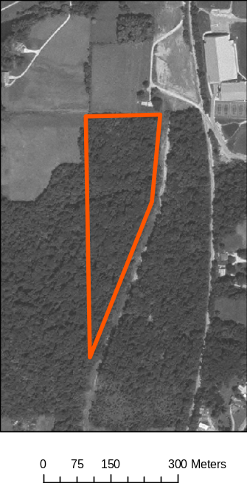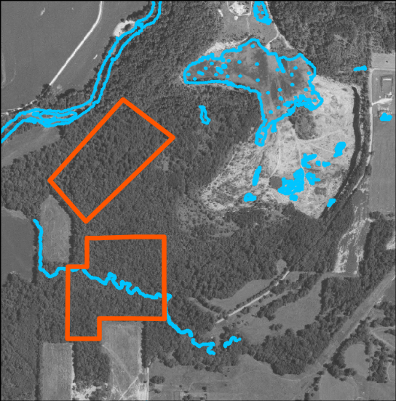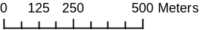
Arboretum
Figure 1. Study sites at DePauw University

Quarry Hillside
Quarry South
Methods

We measured vegetation characteristics at each of the three sites using randomly selected plots. Within a 5-m-radius subplot, we estimated leaf-litter depth, estimated percent cover of understory vegetation (<50cm tall), and counted the number of shrubs and saplings (<8.0cm tall) by species and size category. Within an 11.3-m-radius subplot, we counted the number of trees and dead trees (>8.0cm dbh) by species and size category. We analyzed data gathered previously in the same method from these sites and also from the Ohio sites.

We measured and cored one representative tree from each randomly selected plot. The age was determined by sanding the core sample and counting the rings.
Results

The three sites varied extensively in vegetation composition and forest structure, despite the relative closeness of the sites. The plant composition of the sites is also atypical for eastern deciduous forests. The forests at the Arboretum, Quarry Hillside and Quarry South differed substantially from that of the Ohio sites.

The understory vegetation at the sites is shown in Figure 2. Coralberry, a native shrub, was the dominant shrub at Quarry Hillside and Quarry South. A mix of tree seedlings (ash, dogwood, sugar maple) and shrubs were dominant at the Arboretum. Spicebush was abundant at the Arboretum and the Ohio sites.

Quarry Hillside
Quarry South

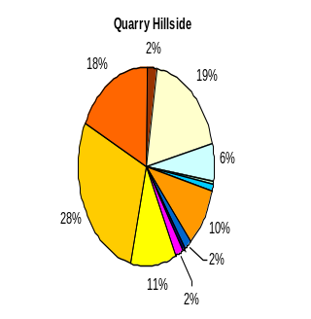
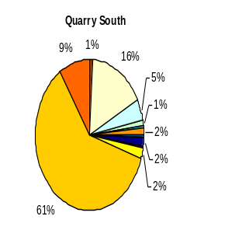
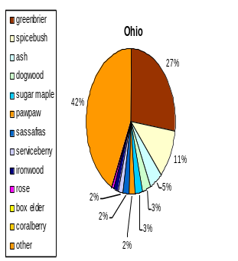

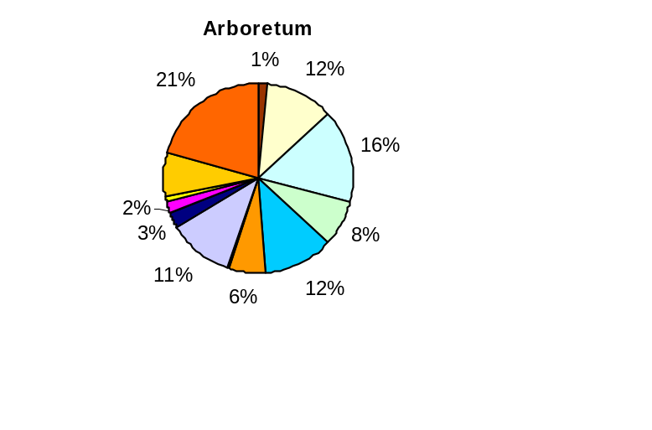
Ohio

Figure 2. Composition of forest understory vegetation at the study sites.

The overstory composition at the sites is shown in Figure 3. Forest composition at the Ohio sites and the Arboretum is characteristic of eastern deciduous forests, with large proportions of oak, sugar maple, and hickory. The composition at Quarry Hillside and Quarry South, however, consist of unusually high proportions of elm, cherry, and walnut, and lack oak and hickory, which are characteristic to this region.
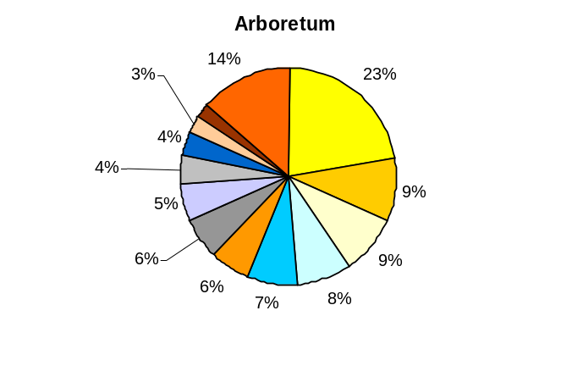
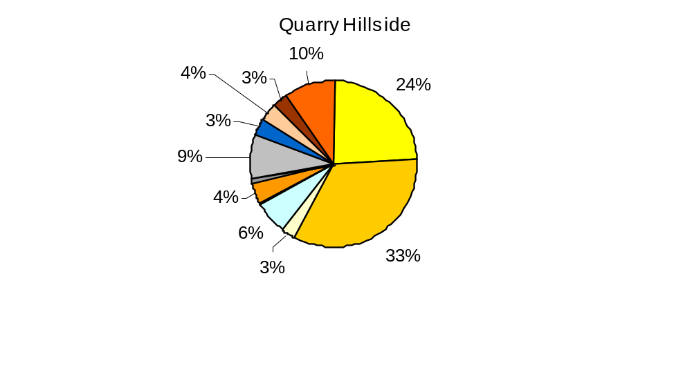
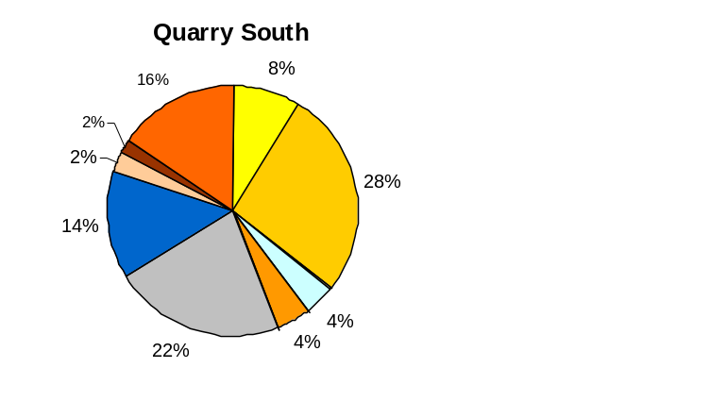
Ohio
Arboretum
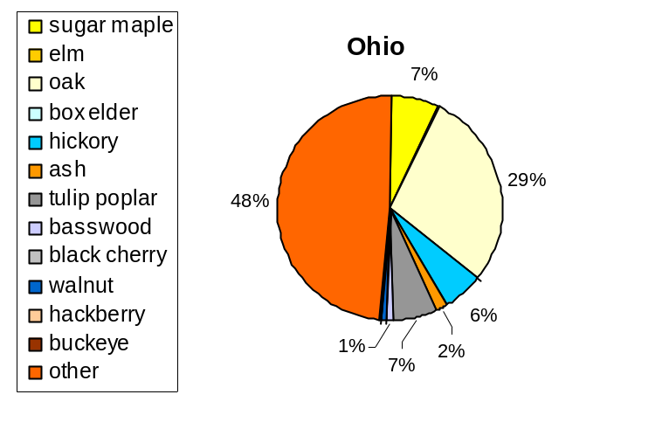

Quarry Hillside
Quarry South

Figure 3. Composition of forest
overstory vegetation at the sites.

Stem composition of shrubs vs. seedlings is shown in Figure 4. The Ohio and Arboretum sites contain similar numbers of seedlings vs. shrubs per hectare. The Quarry Hillside and Quarry South sites, however, contain higher numbers of shrubs than seedlings.

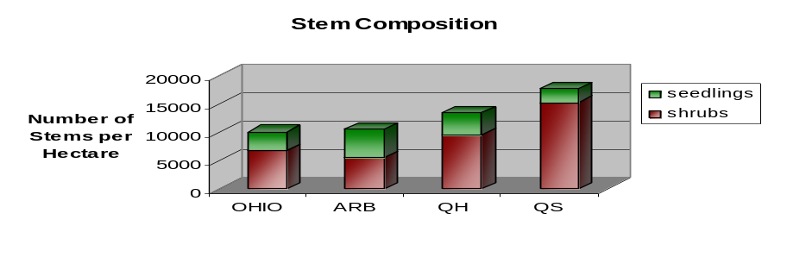

Figure 4. Stem Composition

T
The size distribution of trees (small, medium, and large) is shown in Figure 5. The forest at Quarry South contains proportionally more small trees and fewer large trees than the other sites.

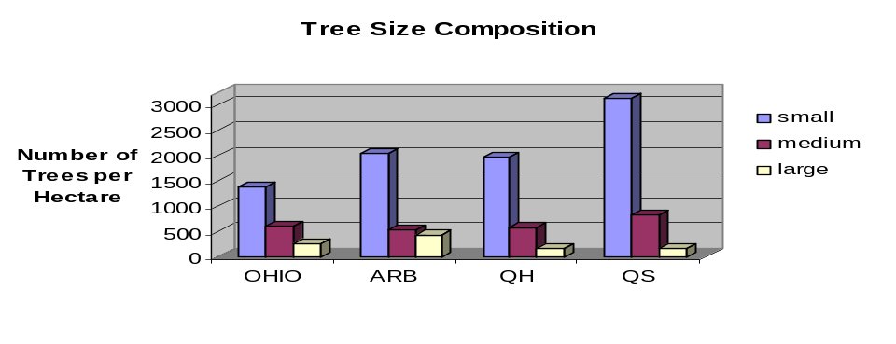

Figure 5. Tree Size Distribution

The composition of large trees (> 38 cm diameter) is shown in Figure 6. Oak dominates the large tree composition in Ohio and the Arboretum, but is scarce or virtually absent in the Quarry sites. Cherry and ash are abundant in Quarry Hillside and Quarry South.
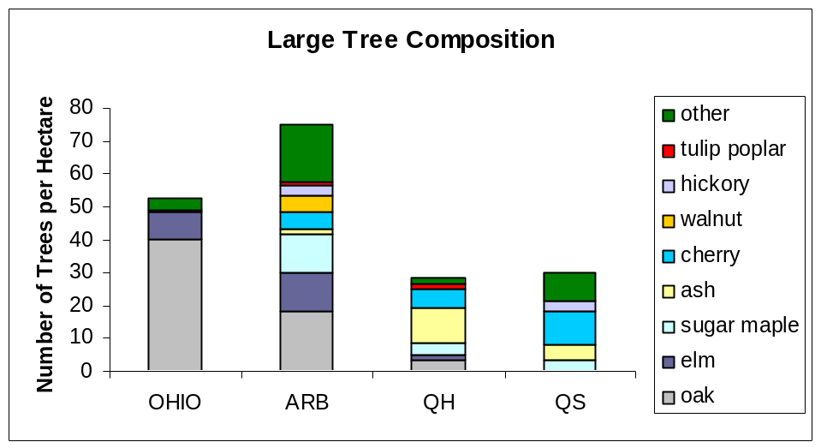
Figure 6. Large Tree Composition

Age of cored trees is shown in Figure 7. The Arboretum has a wider range of core ages than Quarry Hillside and Quarry South, with the oldest core being 98 years old. Quarry South contained trees as young as 29 years old.

Figure 7. Age of cored trees.
Site | Range of Ages | Sample Size
Ohio | 100-120 | *
Arboretum | 38-98 | 11
Quarry Hillside | 50-63 | 3
Quarry South | 29-48 | 8
(* = Sutherland et al. 2003)

Discussion

The extreme variation in ecological composition between the Arboretum, Quarry Hillside, and Quarry South, despite their geographic proximity, raises some interesting points concerning the effects of fragmentation and human activity on forest health. The Ohio site clearly displays the characteristics of a mature, eastern deciduous forest. Its large proportions of oak, sugar maple, and hickory are signature of the region. The similar proportion of seedlings to shrubs suggests that the forest can sustain its canopy composition. The Ohio site also displays a balanced variation in tree size composition, with a considerable number of large trees compared to small trees, mostly large oaks. The well-proportioned spatial heterogeneity of the Ohio sites, as seen in the tree size composition, suggests that the area is older, more mature, and has remained relatively undisturbed.

Is the forest capable of sustaining itself? Can the plant species replace themselves in the next generation?

Arboretum: Yes. The Arboretum displays a similar vegetation composition to the Ohio sites, with large proportions of oak, sugar maple, and hickory. The understory of the forest contains a variety of native shrubs, with similar numbers of seedlings and shrubs per hectare, giving the seedlings less competition for resources and increasing the likelihood of growing to maturity.

Quarry Hillside: Maybe. It is possible that the forest at Quarry Hillside could maintain itself, but the site does contain a larger proportion of shrubs to seedlings than the Arboretum. This suggests that there could be more competition between the seedlings and shrubs for resources, which is likely to limit seedling growth into an established overstory. The composition of the site also shows an abundance of elm and cherry, and only a small amount of oak and hickory, which is telling of a younger forest undergoing succession in this area.

Quarry South: No. With the substantial proportion of shrubs compared to seedlings, it is likely that the seedlings will be outcompeted and their growth inhibited. The large number of small trees and very small number of large trees supports this point that the increased amount of shrubs are inhibiting the growth of the trees. Thus, it is likely that the existing native tree species may not replace themselves in the next generation.

Are the forested sites at the ARB, QH, and QS “healthy”?

Our data indicates that the forest at Quarry Hillside and Quarry South may be in relatively “poor” health when compared to the Arboretum and Ohio sites. These forests may continue as they are, but we are concerned about their relative health given the prevalence of shrubs in the understory, which could outcompete native species of tree seedlings. Also, oak and hickory, typical overstory trees in the region, are scarce at Quarry Hillside and virtually absent at Quarry South.

What are some possible maintenance strategies that could be carried out at Quarry Hillside and Quarry South in order to improve the health of the forest? What would be the benefits?

One option for improving the health of the forested areas at the Nature Park would be to actively remove non-native plant species and excess shrubs that are crowding the understory, opening up resources for seedlings and allowing them to mature. Over time and constant monitoring, the forest would begin to resemble that of a mature, healthy forest.

Another suggestion is to limit fragmentation of the forested areas in the quarry as much as possible. These areas have already been fragmented extensively by fields, roads, and powerlines, decreasing their overall health.

Caution must be taken as we implement management strategies within the forest to minimize the effects on currently existing native plants and animals, such as the Cerulean Warbler and the Indigo Bunting (Allard, 2005). A healthy forest would improve the quality of habitat for plants and animals, as well as creating beneficial research opportunities. A healthy forest is also aesthetically pleasing and would enhance the overall enjoyment by visitors to the park.

Implications and Further Research

Continued monitoring of the forest’s health should occur to either observe the effects of active management or the absence of human intervention. Such research on the forested sites of the nature park would give valuable insight on the health of the forest and on the process of succession in a young forest. Future research on forest health at the sites could address some of the following issues:

- Is there large biomass accumulation, such as dead trees, downed logs, and shrubs, in the forests at Quarry Hillside and Quarry South? Is it inhibiting the growth of seedlings?

- What management strategies should be undertaken to improve the health of the forest at the Nature Park? What long-term effects would such management have on wildlife populations?

- Is management a necessary option to promote recovery and health of the forest?

- Along the line of thought held by environmental philosophers/ethicists, should we even intervene with the forest’s natural processes?

Acknowledgments

I would like to give a special thanks to my research group, Libby Allard and Karl Koehler, for hard work in the field. I would also like to thank Professor Vanessa Artman for her constant guidance and patience. A big thanks to DePauw University for the opportunity to do research this summer. Finally, a grateful thanks goes out to my parents, Jim and Cathy, for all of their love and support.
References

Sutherland, E.K., et al. 2003. Characteristics of Mixed-Oak Forest Ecosystems
in Southern Ohio Prior to the Reintroduction of Fire. USDA Forest Service General Technical Report NE-299.

USDA Forest Service. 2004. Monitoring in the Northeastern United States: Disturbances
and Conditions during 1993-2002. http://fhm.fs.fed.us/pubs/tp/dist_cond/introduction.pdf

