Anthocyanin Content of Apocynum cannabinum
in Variable Light Environments

Lauren Guggina and Dana Dudle
Biology Department and SRF program, DePauw University
November 2005

Anthocyanins

Anthocyanins are the pigments in plants that give them their red, purple, and blue coloring. Anthocyanins are water soluble, non-photosynthetic, polyphenolic substances that are glycosides of anthocyanidins (Jackman et al.1987). Anthocyanins have a variety of purposes for different plants. Those that are relevant to this study include: providing photoprotection, dealing with osmotic stress (Chalker-Scott 1999), and protecting photolabile defensive compounds (Gould 2004).

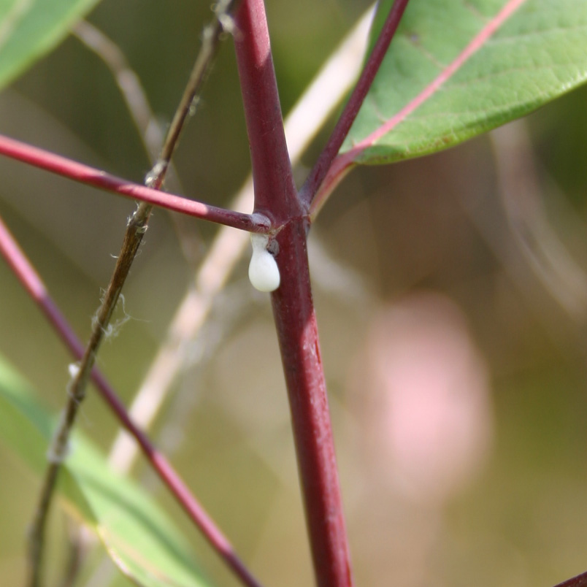
Figure 1. Cardiac glycosides (milky sap) and
anthocyanins (reddish pigment) in Apocynum
cannabinum.

Study Species

Apocynum cannabinum is an herbaceous perennial native to the Midwest. This species grows in variable environments and is a common crop weed in the United States. A. cannabinum contains defensive cardiac glycosides, found in the milky substance stored in its stem and leaves (Figure 1). This substance protects A. cannabinum from many herbivores. A unique feature of A. cannabinum is that its stem and leaf color varies from green to deep red, as seen in Figure 2, due to varying anthocyanin levels in these parts.

Figure 2. Variation in stem and leaf color in Apocynum cannibinum.

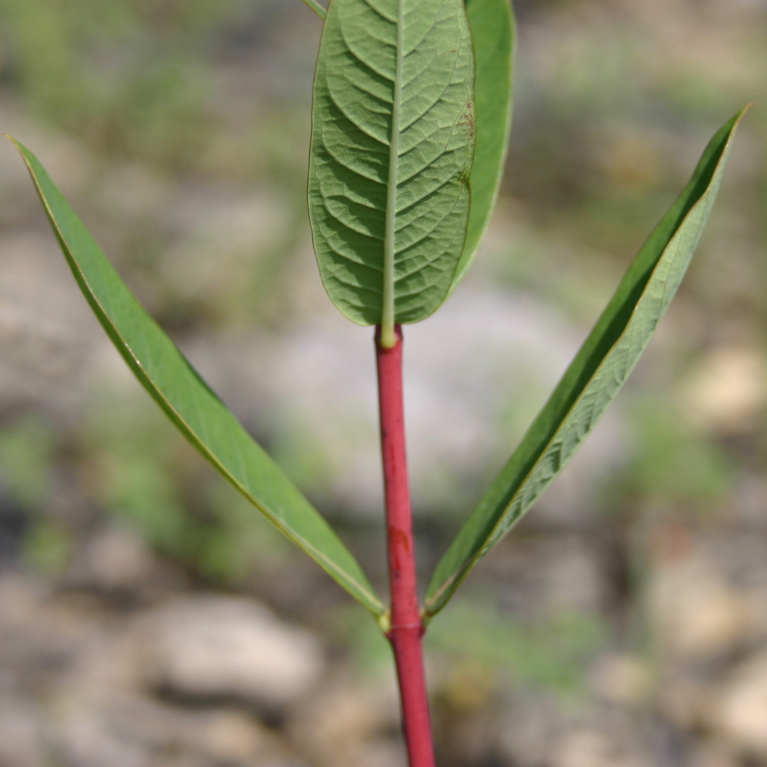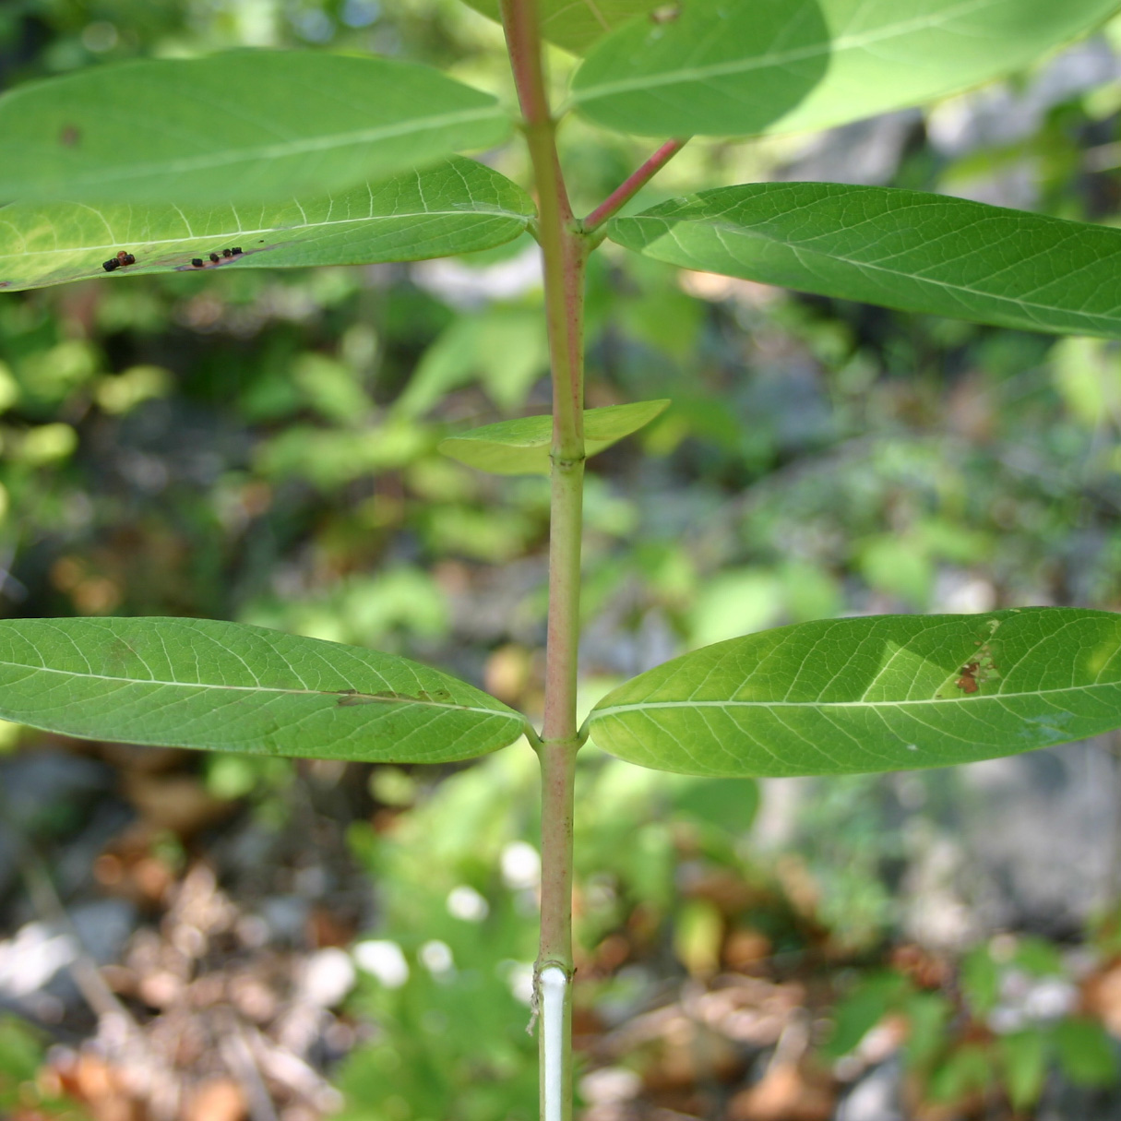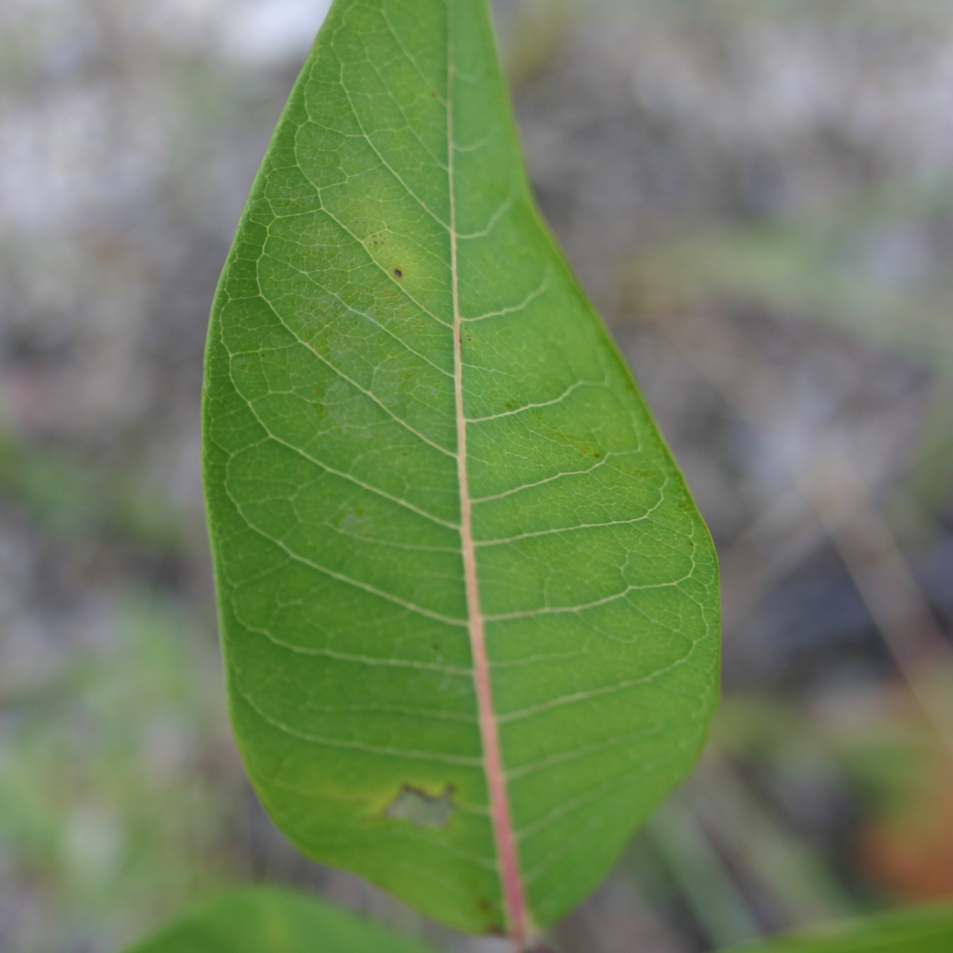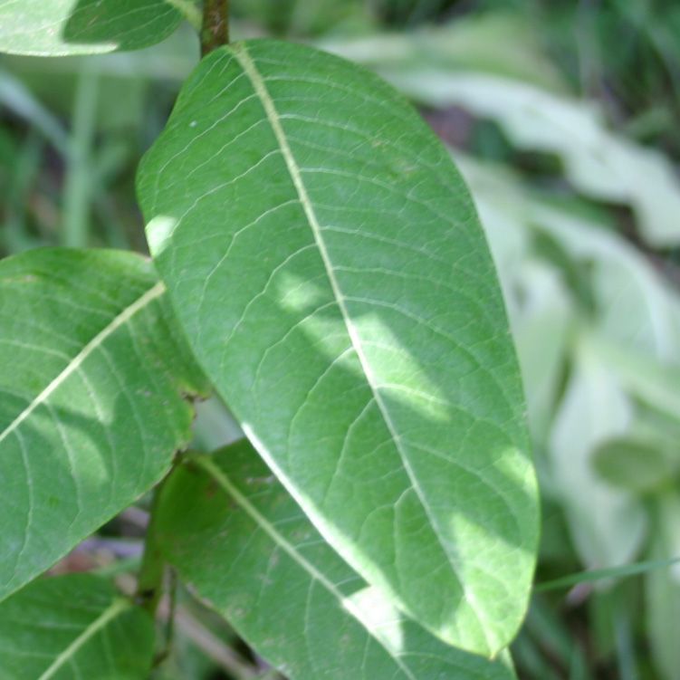

Study Sites

In this study, we compared the anthocyanin content of stems and leaves of A. cannabinum in relation to the light intensity in order to see if the anthocyanin content of this plant’s stems and leaves is dependent on this variable. We studied A. cannabinum in two distinct areas within the DePauw University Nature Park. Approximately half of the plants were located in the abandoned limestone quarry bottom (Figure 3). The other half were located along the wooded edge around the parking lot (Figure 4). The conditions in the quarry bottom environment are stressful for plants. There is increased light irradiance because of the reflective white limestone, limited water availability, and poor substrate composition. In other research, anthocyanins have been shown to aid various plants in dealing with all of these stressful conditions (Chalker-Scott 1999, Gould 2004). The edge of the parking lot is less harsh than the quarry bottom. There is better soil and more foliage. These factors contribute to the fact that there are more nutrients, a more consistent water supply, and less irradiance available to the A. cannabinum growing there.

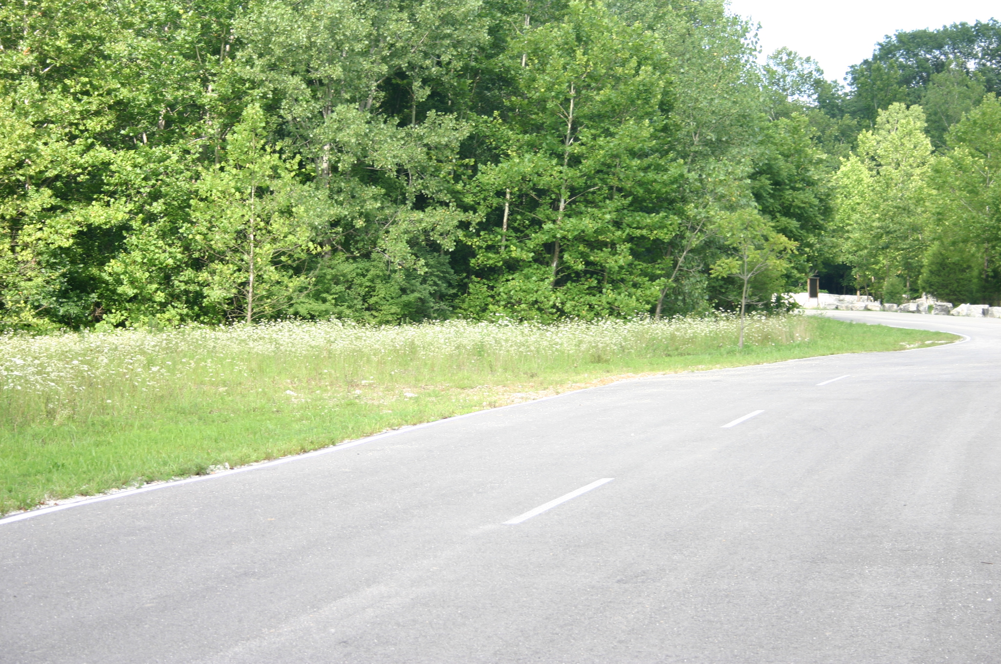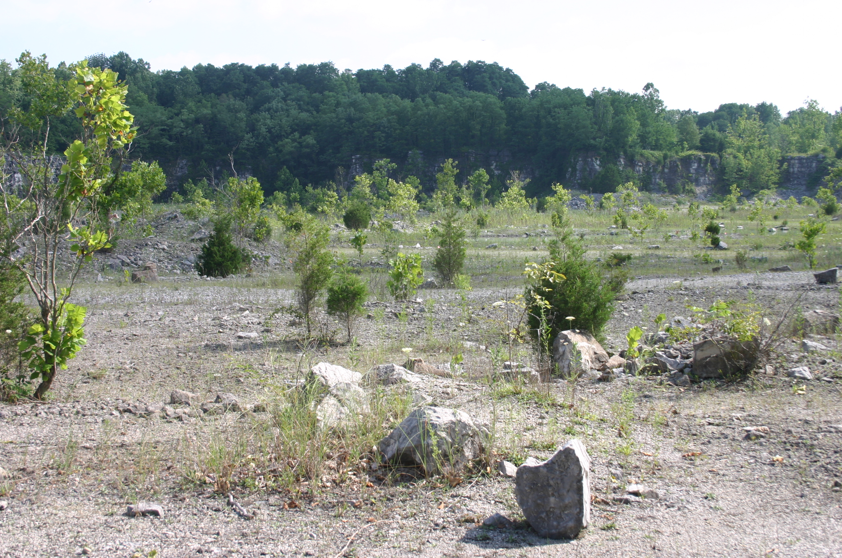
Figure 3: Quarry Bottom
Figure 4: Parking lot area

Methods

We tagged plants and designated individual plants as “sunny” or “shady” according to visual observation of their surroundings. Irradiance was measured with a light meter (Figure 5), at three hour intervals for three different days. Because of variable weather conditions, light readings from different days could not be compared directly. To standardize the light measurements, we used the maximum values at each measured point.

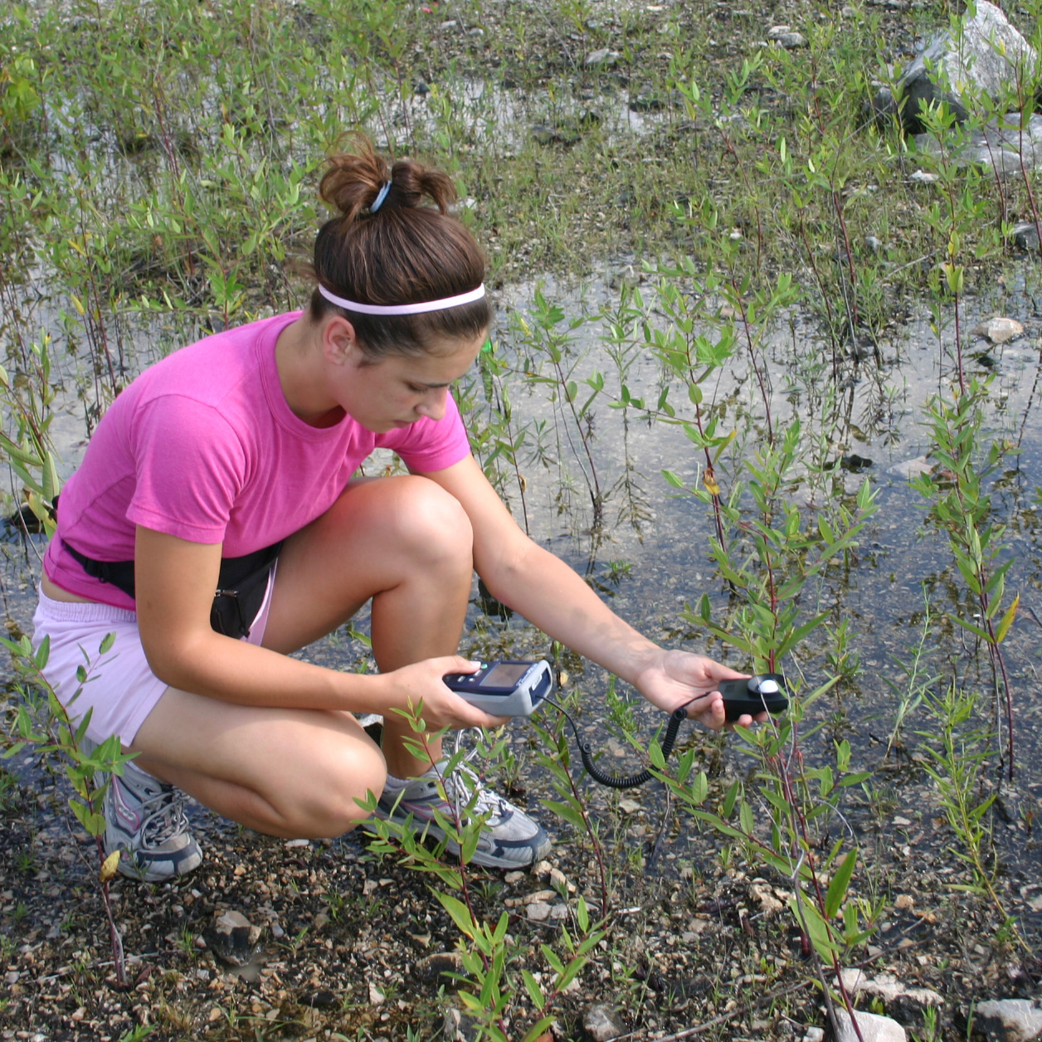
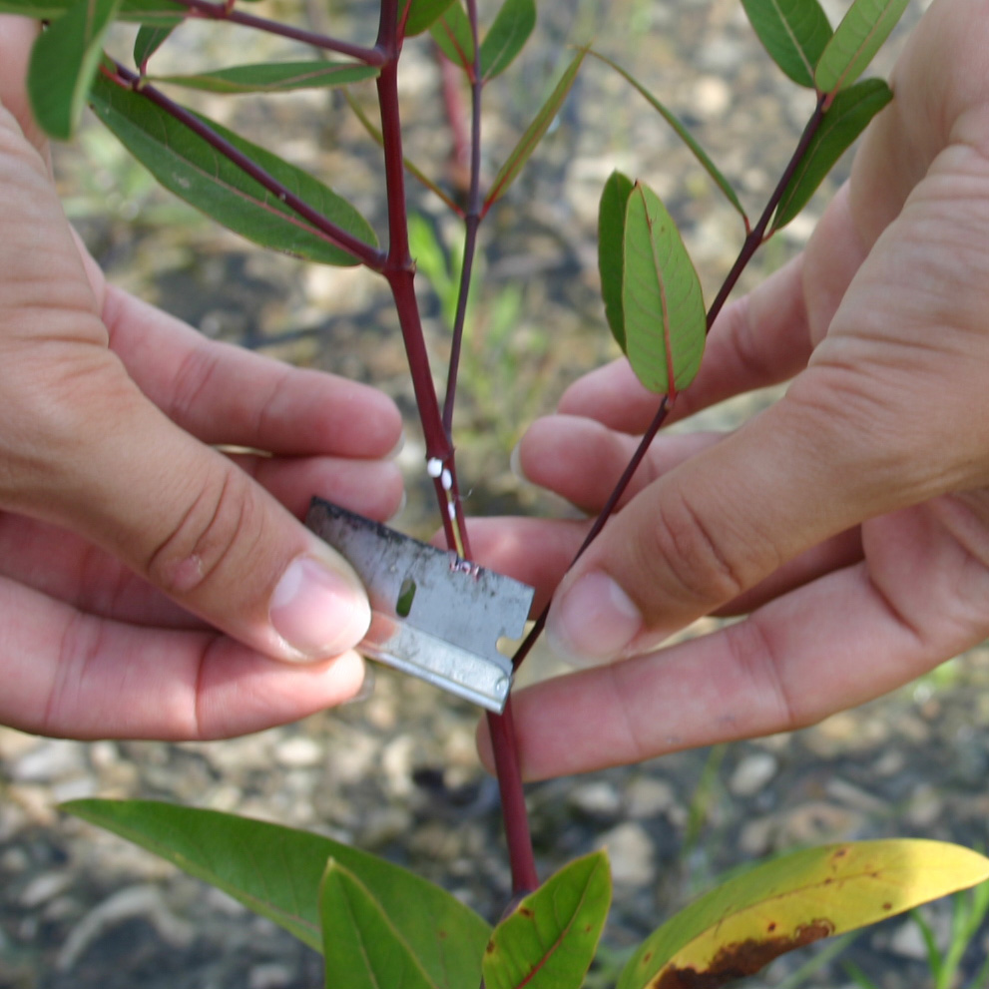
Figure 5: Taking light reading
Figure 6: Obtaining stem sample

After light readings were measured for each plant, we collected stem and leaf samples (Figure 6). I extracted anthocyanins from the stems and leaves with acetated methanol using a standard procedure. The anthocyanin content was assessed using a UV Spectrophotometer (Figure 7), and the absorbance at the anthocyanin peak of 530 nm was recorded. The peak seen at 650 nm in the leaf reading is due to chlorophyll. The readings for all samples were standardized by dividing the absorbance by the mass of each sample.

Procedure for Measuring Anthocyanin Content of Stems and Leaves of Apocynum cannabinum:

- Used a razor to peel outer layer of stem. Was careful to only shave off the red colored plant material. Carefully removed leaf from node where stem sample was taken.
- Measured biomass of stem material. Punched 4-5 holes out of green leaf material randomly and measured biomass.
- Inserted leaf and stem samples in separate bead beater tubes.
- Added 600 µl of acetified methanol (0.05% HCl) to each sample.
- Added 5 beads to each tube.
- Bead beat stem material for 80s at speed 25 and beat leaf material for 40s at speed 25, using the bead beater machine.
- Poured solution into eppendorf tube while keeping beads in the first tube with a magnet.
- Centrifuged for 3 min.
- Removed solution into new tube while making sure to leave the pellet left after centrifugation.
- Diluted 300 µl of leaf material solution with 700 µl of solvent (methanol + 0.05% HCl). Diluted 200 µl of stem material solution with 800 µl of solvent.
- Took spectrum at 530 nm (absorbance should be below 1.0). Sample UV Spec reading shown in Figure 7.

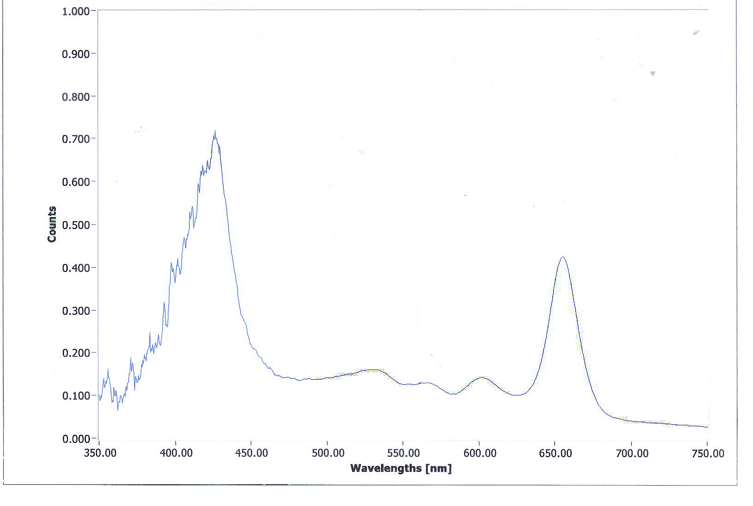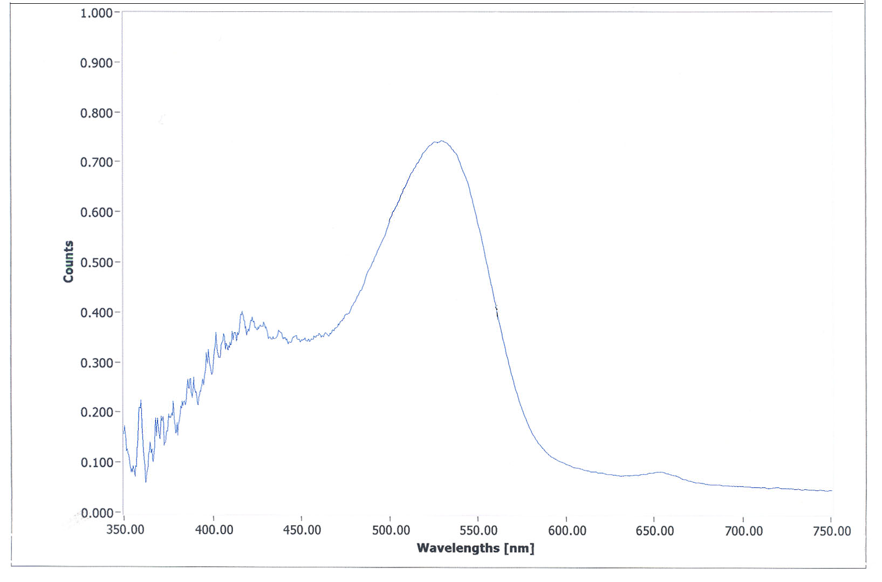
Figure 7. Sample UV spectrophotometer readings for a stem (left) and a leaf (right).

Results

Figure 8: There was a significant positive relationship between light intensity and anthocyanin content of stems.
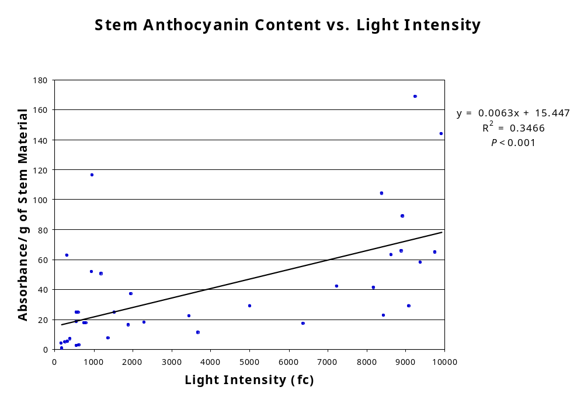

Figure 9: Anthocyanin content differed significantly between stems in the sun vs. shade. Surprisingly, however, anthocyanin content did not differ significantly between leaves in the sun vs. shade. Anthocyanin content of the stems was significantly higher than the leaf anthocyanin content.
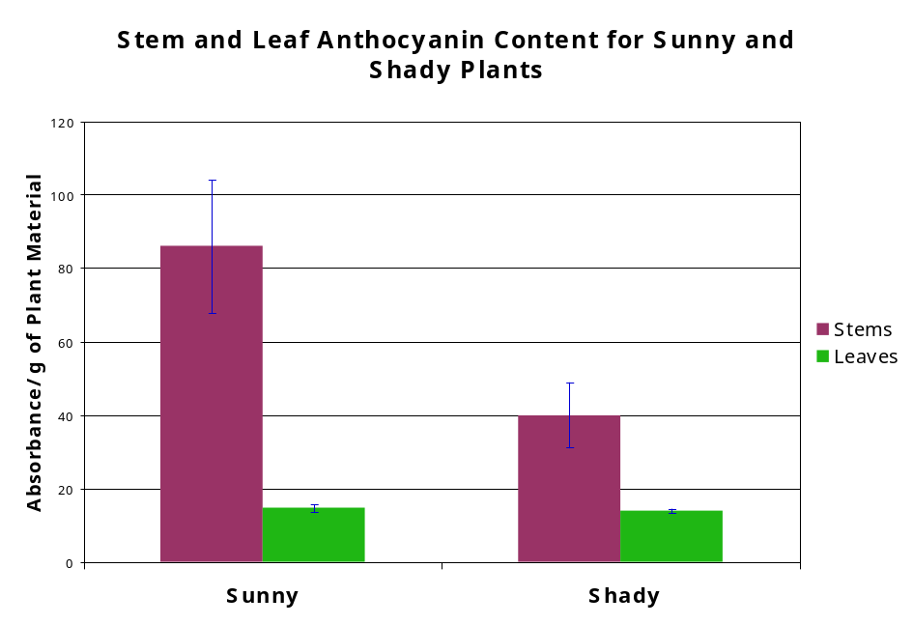

Figure 10: Average light intensity readings were significantly higher for plants in the sun vs. plants in the shade. The fact that the light readings were significantly higher for the sunny plants shows that my a priori designation of “sunny” and “shady” plants was appropriate.
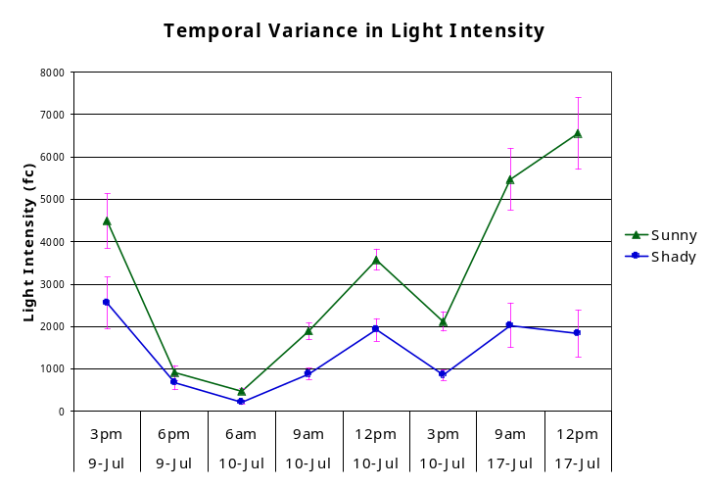

Discussion

Anthocyanins in Leaves

Anthocyanin content did not differ between sunny and shaded leaves. Leaves also had significantly lower anthocyanin content that stems. Research usually focuses on the roles of anthocyanins in leaves, therefore, these results are interesting. Anthocyanins found in leaves have been found to play various important roles for different plants. For example, they have been shown to protect plants against herbivory, free radicals, and photoinhibition (Gould 2004).

Though we did not find a relationship between light and anthocyanin content, there were varying amounts of pigment among individual plants. Interestingly, in A. cannabinum, the anthocyanins in the leaves seemed to be concentrated in the vascular tissue. One possible explanation for this fact is that the anthocyanins may be protecting defensive cardiac glycosides. Since it is metabolically costly for plants to synthesize anthocyanins (Chalker-Scott 1999), it seems likely that A. cannabinum leaf anthocyanins improve its fitness, and are induced by some stressful factor.

Anthocyanins in Stems

Anthocyanin presence in stems has been noted and studied, but not to the extent of its presence in leaves. Since the stems do not contain much photosynthetic material, a simple explanation for why anthocyanin content in A. cannabinum stems is related to light intensity cannot be made.

Research has found that stem anthocyanins help plants deal with osmotic stress in other plant species (Chalker-Scott 1999). Since drought stress is a major problem that A. cannabinum must deal with, especially in the quarry bottom, it is likely that anthocyanins may help alleviate some of that stress.

The anthocyanins could also be protecting a compound found in the stem that is photolabile. The silver beachwood (Ambrosia chamissonis) contains a photolabile defensive secondary compound, Thiarubrine A, that it shields with anthocyanins (Gould 2004). A. cannabinum stores its cardiac glycosides in its stems and leaf veins. Interestingly, the stems and leaf veins are the plant parts in A. cannabinum that are most visibly red. It is possible that A. cannabinum protects its defensive cardiac glycosides, or some other vital photolabile compound, with anthocyanins.

Future Research

Investigating the presence of anthocyanins in A. cannabinum gives insight into what makes this plant fit for primary succession. Though significant results were found in this experiment relating stem anthocyanins to light intensity, in order to get more definitive results, more extensive research must be done.

One source of error in this experiment was the equipment used to measure the light intensity at each plant. It would be useful to measure light intensity with a smaller light meter that could more accurately gauge light exposure at specific areas over the plant.

A. cannabinum experiences multiple environmental factors and stresses. Anthocyanins may help alleviate stress due to drought, poor substrate, or limited water availability for A. cannabinum. Future studies should measure and compare these variables to anthocyanin contents.

In a future experiment, I would advise transplanting sets of several clones into a controlled growing environment. In this controlled environment, there should be variation in light intensity, water availability, and substrate composition. In doing so, one would be looking at three primary stress variables that A. cannabinum has adapted to grow amidst. Additionally, one could determine the extent to which variance in anthocyanin levels depends on genetics.

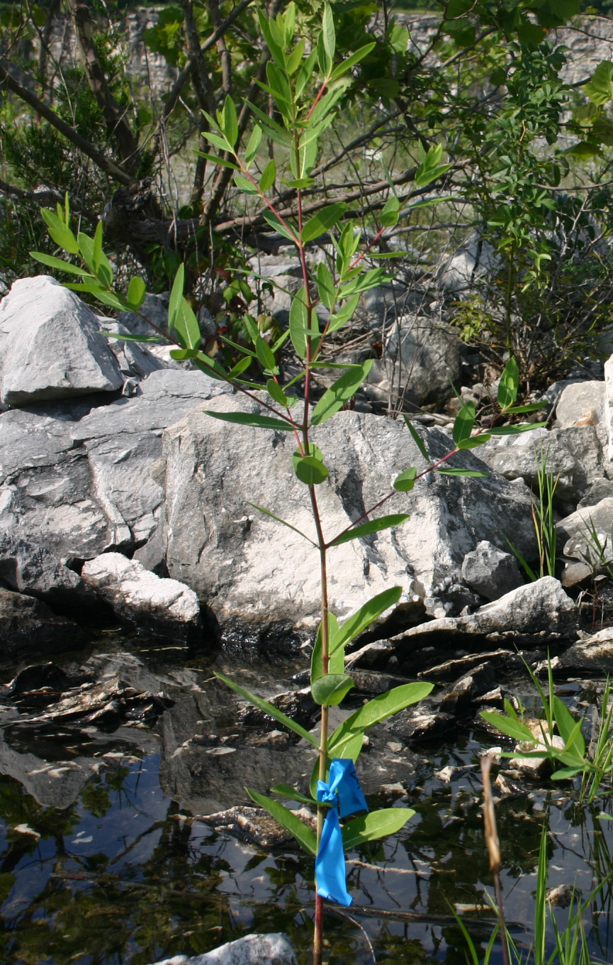
References

Chalker-Scott, L. 1999. Environmental significance of anthocyanins in plant stress responses. Photochem. Photobiol. 70: 1-9.

Gould, K.S. 2004. Nature’s Swiss army knife: the diverse protective roles of anthocyanins in leaves. J. Biomed. Biotech. 5:314-320.

Jackman, R.L., Yada, R.Y., and Tung, M.A. 1987. A review: separation and chemical properties of anthocyanins used for their qualitative and quantitative analysis. Food Biol. 11:279-308.

Merzlyak, M.N., Chivkunova, O.B. 2000. Light-stress-induced pigment changes and evidence for anthocyanin photoprotection in apples. J. Photochem. Photobiol. B: Biol. 55:155-163.

