Composition of the Songbird Community
at the DePauw Nature Park and Arboretum

Libby Allard and Vanessa Artman
Biology Department and SRF Program, DePauw University
November 2005

Introduction

DePauw’s Arboretum and Nature Park contain many different habitats. Vegetation and forest continuity vary, affecting the fauna that inhabit different regions. We collected data on songbird and plant communities at three forested sites: the Arboretum, Quarry South, and Quarry Hillside. Until recently there have been little data collected describing the composition of the songbird community at the three DePauw sites.

Here, we describe the composition of the songbird community within these sites, examining the relationship between songbirds and the habitat characteristics. We compare our data on the songbird communities to data that were previously collected (from 1995 to 1999) at several forested sites in southern Ohio. The Ohio sites were used as a comparison because some species of songbirds with widespread distributions were only present in the Ohio sites. Some of the specific differences between the Ohio and DePauw sites that may contribute to the presence and absence of some songbird species are:

- Age of the forest: the sites in Ohio represent relatively undisturbed mature forest whereas the DePauw sites were more recently disturbed with younger forest

- Composition of the vegetation: the forest in Ohio is dominated by a mix of oaks and hickories, typical overstory trees in the region. The DePauw forests are dominated by a mix of sugar maple, elm, ash, cherry, and walnut, with the composition perhaps reflecting the recent disturbance, abiotic conditions, and the alternative pathway of secondary succession.

- Landscape fragmentation: the sites in Ohio are situated in a relatively unfragmented landscape whereas the DePauw sites are within a more fragmented landscape with multiple land uses and habitats (open fields, powerline rights-of-way, building developments) within the vicinity of the forest.

- Size of the forest: the forested sites in Ohio range in size from 25 to 30 hectares in extent whereas the forested sites at DePauw range in size from 5 to 10 hectares (1 hectare = 2.5 acres).

Hypothesis

Differences in songbird communities between Indiana and Ohio sites are related to differences in the age of the forest and the extent of forest fragmentation.

Methods

We conducted songbird surveys during May and June in 2004 and 2005. During each survey, we recorded locations of singing and calling birds throughout each site. We conducted four surveys per year at each site. All surveys were conducted between the hours of 5 a.m. and 10 a.m. We transferred observations to separate composite maps for each bird species and looked for clusters of observations from multiple visits to identify individual territories. We assume that the presence of a singing male is indicative of a nesting pair. We thus estimated the relative number of breeding pairs per site based on the number of territories and singing males. We converted the number of pairs per site to the number of pairs per 10 hectares to standardize the estimates between sites.

We searched for and monitored nests during the breeding season following standard protocol (Martin et al. 1995). Nests were checked every 3 to 5 days to monitor their contents and determine their fate. Successful nests produced at least one host fledgling whereas failed nests had no fledglings. Causes of nest failure included predation, parasitism by Brown-headed Cowbirds, abandonment, and weather. We estimated daily nest survival rates using the Mayfield (1975) method.

We collected vegetation data at randomly located plots and nest sites following standard protocol (Martin et al. 1995). Within a 5 meter radius of each plot and nest site, we counted the number of shrubs and seedlings by species and size class and estimated percent cover of understory vegetation. Within an 11.3 meter radius, we counted the number of trees by species and size class. We cored one tree at each plot to estimate the relative age of the forest. We also measured height of the nests and height of the nest trees.

Results and Discussion

The three forested sites at DePauw support a variety of songbird species that are typical of eastern deciduous forests (Table 1). Our census data also indicate some differences in breeding bird populations among locations, suggesting intriguing avenues for future work on a subset of these species.

Table 1. Songbird population levels

 | # of territories per 10 hectares
 | Arboretum |  | Quarry Hillside |  | Quarry South |  | Ohio
 | 2004 | 2005 | 2004 | 2005 | 2004 | 2005 | 1995-99
Acadian Flycatcher | 9.1 | 11.0 | 8.8 | 12.1 | 12.0 | 14.8 | 3.3
Eastern Wood-pewee | 1.8 | 7.3 | 4.4 | 6.6 | 0.9 | 3.7 | 1.9
Red-eyed Vireo | 16.4 | 14.6 | 9.9 | 8.8 | 9.3 | 7.4 | 10.5
Tufted Titmouse | 3.7 | 7.3 | 9.9 | 5.5 | 4.6 | 3.7 | 0.5
Cerulean Warbler | 0 | 0 | 0 | 0 | 3.7 | 5.6 | 2.6
Northern Parula | 3.7 | 3.7 | 0.0 | 2.2 | 1.9 | 2.8 | 0
Ovenbird | 0 | 0 | 0 | 0 | 0 | 0 | 10.2
Black-and-white Warbler | 0 | 0 | 0 | 0 | 0 | 0 | 0.9
Hooded Warbler | 0 | 0 | 0 | 0 | 0 | 0 | 2.3
Worm-eating Warbler | 0 | 0 | 0 | 0 | 0 | 0 | 2.5
Scarlet Tanager | 1.8 | 3.7 | 1.1 | 3.3 | 1.9 | 1.9 | 3.3
Eastern Towhee | 5.5 | 9.1 | 3.3 | 2.2 | 3.7 | 4.6 | 0
Northern Cardinal | 18.3 | 18.3 | 9.9 | 13.2 | 9.3 | 11.1 | 0.5
Indigo Bunting | 12.8 | 9.1 | 3.3 | 3.3 | 12.0 | 9.3 | 0

Northern Cardinals were the predominant bird species in both the Arboretum and Quarry Hillside, while Acadian Flycatchers were the predominant bird species in Quarry South.
Wood Thrushes were more abundant in Ohio than at the DePauw sites. In Ohio, however, Acadian Flycatchers were less common with Ovenbirds having the dominant population percentage. Although the Ovenbird’s distribution extends into west-central Indiana, Ovenbirds were absent from the DePauw sites. Other breeding species that were present in the Ohio forests but absent in DePauw’s sites were the Black-and-white Warbler, the Hooded Warbler, and the Worm-eating Warbler.
Hooded Warbler
Worm-eating Warbler
Wood Thrush
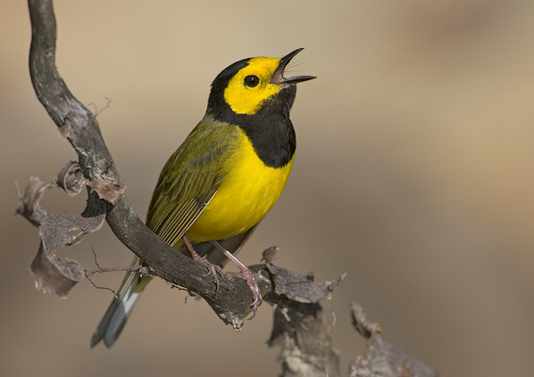
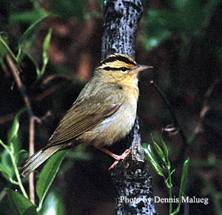
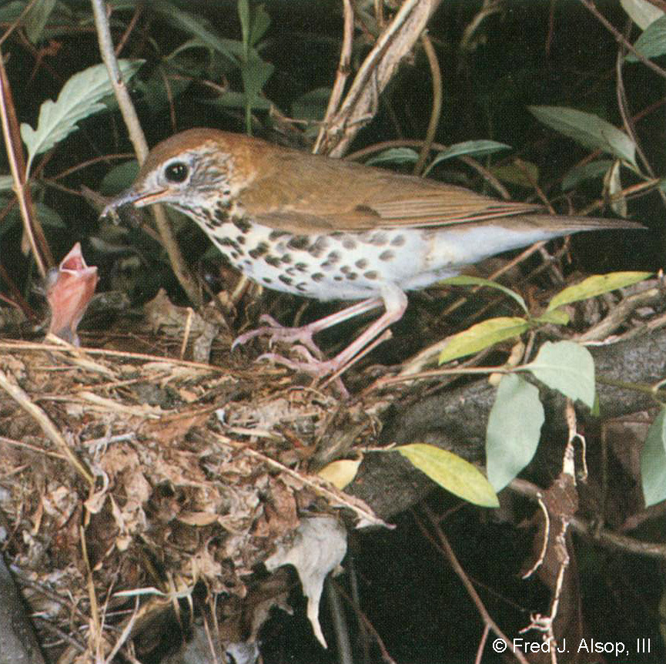
Acadian Flycatchers were common at all three of DePauw’s sites. Population levels at our sites were surprisingly large (Table 2), considering the comparison to the Ohio sites and the habitat preference of the species. Acadian Flycatchers are typically associated with mature forest habitat. Why the difference between Ohio vs. DePauw? It is possible that since the Ohio sites were so large, Acadian Flycatchers were more spread out, with fewer territories per hectare. However, this doesn’t explain why levels were so high at the DePauw sites. Even more surprising is that while the Arboretum is the oldest of the three sites with the typically most ideal habitat conditions (less understory vegetation and more mature trees), Acadian Flycatcher populations were higher at Quarry South. As an insectivore, Acadian Flycatchers may be attracted to the higher numbers of mosquitoes in Quarry South.

Table 2. Acadian Flycatcher population levels
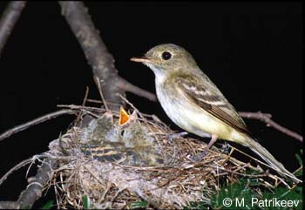
Number of pairs per 10 hectares
Location | 2004 | 2005 | 1995-1999
Arboretum | 9.1 | 11.0
Quarry Hillside | 8.8 | 12.1
Quarry South | 12.0 | 14.8
Ohio |  |  | 3.3

Acadian Flycatchers nests tend to be in predictable and accessible locations and thus are relatively easy to find and monitor. We found and monitored 12 nests at the three DePauw sites each year (Table 3). Our results show that nesting success was higher in 2005 (98.1% daily survival rate) vs. 2004 (95.5% daily survival rate). The daily survival rate is a measure of the likelihood that an individual nest will survive during a given day during the nesting season and is a reflection of the number of days that all nests are observed. The higher rate of nesting success in 2005 may be an artifact of doubling the number of observation days (133 vs. 266). We will continue monitoring Acadian Flycatcher nests at the sites during future years to assess annual levels of nesting success.

Table 3. Nesting success of the Acadian Flycatcher.
 | DePauw sites |  | Ohio sites
 | 2004 | 2005 | 1995-1999
# of nests monitored | 12 | 12 | 95
# of successful nests | 6 | 7 | 52
# of nests failed due to predation | 5 | 5 | 40
Observation days | 133 | 266 | 1,471
Daily nest survival rate | 95.5% | 98.1% | 97.3%
The Cerulean Warbler is a species of significant conservation concern in eastern North America, where declines in its population have been documented over the past several decades.
Of the three DePauw sites, Cerulean Warblers occurred only at Quarry South, with slightly higher populations observed in 2005 than 2004. Although the forest tracts in Ohio are larger and less fragmented, the 2005 Cerulean Warbler population at Quarry South was over double that of the Ohio sites (Table 4). Quarry Hillside and the Arboretum have no Cerulean Warblers.

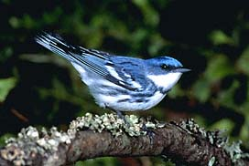
Table 4. Cerulean Warblers
 | Number of pairs per 10 hectares
Location | 2004 | 2005 | 1995-1999
Arboretum | 0 | 0
Quarry Hillside | 0 | 0
Quarry South | 3.7 | 5.6
Ohio |  |  | 2.6

Why was this species only found in Quarry South and why were its population levels double that of Ohio? Cerulean Warbler territories tend to be clustered or grouped together in suitable habitat, but reasons for this clustering are unknown (Hamel 2000). Thus it is not surprising that Cerulean Warblers occurred only at Quarry South and not at the other sites. What is surprising, however, is that Cerulean Warblers occurred at Quarry South, given the rarity of this species and the fragmentary nature of the forest habitat in the landscape. Cerulean Warblers tend to occur only in large tracts of unfragmented forest, although they have been observed in other small tracts similar to Quarry South (Hamel 2000).

The presence of Cerulean Warblers at Quarry South appears to be unrelated to differences in vegetation composition or cover but attests to the importance of maintaining the forest within its existing condition to continue to provide habitat for this rare bird. In addition, this isolated population at Quarry South is certainly deserving of more research attention. Cerulean Warbler nests are almost impossible to find or monitor, given that they are usually placed high above the ground in the top levels of the overstory canopy (Hamel 2000), but we could learn more about their population structure and dynamics within this habitat. For example, we assume that singing males are indicative of the presence of nesting females, but this is an untested assumption. We can look for females early during the nesting season, when they first arrive from migration and begin pairing with males. This type of monitoring is logistically feasible but would require focused effort during the field season.

In addition to continued monitoring, we recommend that this forest habitat at Quarry South should be protected indefintely. We plan to consult with the National Audubon Society to designate this portion of the Nature Park as an “Important Bird Area” (IBA), based on the presence of this rare species.

Population levels of the Northern Cardinal were much higher at DePauw’s sites than at the Ohio sites (Table 5). The Northern Cardinal is an edge-dwelling, fragmentation-loving species (Halkin and Linville 1999). In our sites they only chose territories along borders (powerlines, streams, or meadows). As the forests age, there will be fewer clearings and more dense forest; thus, Northern Cardinal population levels may decline as there will be less suitable habitat.

Table 5. Northern Cardinals
 | Number of pairs per 10 hectares
Location | 2004 | 2005 | 1995-1999
Arboretum | 18.3 | 18.3
Quarry Hillside | 9.9 | 13.2
Quarry South | 9.3 | 11.1
Ohio |  |  | 0.5

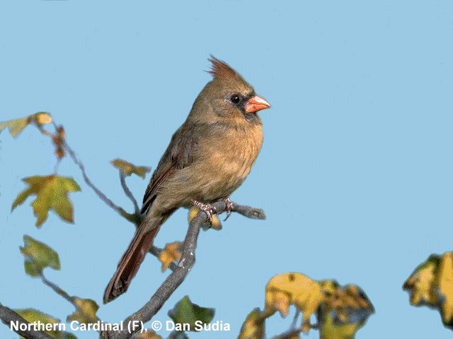
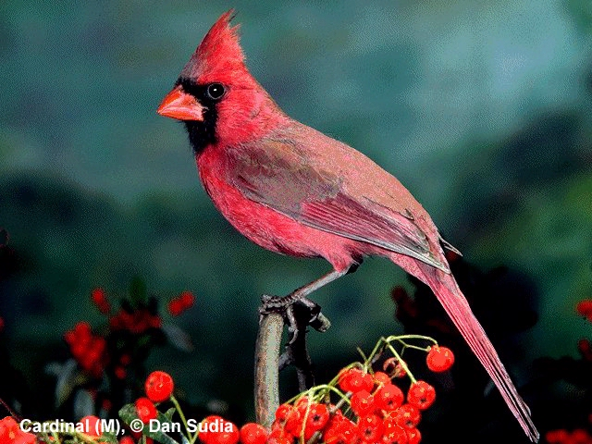

The Indigo Bunting was common at the DePauw sites but absent from the Ohio sites (Table 6). The Indigo Bunting is an early-successional species that is usually found in grasslands and meadows (Payne 1992). They were common in the Arboretum, but occurred only in edge habitat, adjacent to the powerline and athletic fields with none occurring in the forest interior. Surprisingly, Indigo Buntings were common throughout the closed-canopy forest of Quarry South, apparently because of the prevalence of low shrubs (coralberry) growing throughout this site.
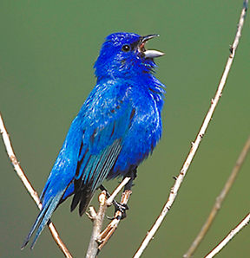
Table 6. Indigo Buntings
 | Number of pairs per 10 hectares
Location | 2004 | 2005 | 1995-1999
Arboretum | 12.8 | 9.1
Quarry Hillside | 3.3 | 3.3
Quarry South | 12.0 | 9.3
Ohio |  |  | 0
We found and monitored multiple Indigo Bunting nests in 2004 and 2005 (Table 7), but sample sizes were insufficient to draw any conclusions about their levels of nesting success. The distribution of this bird species across such a variety of habitats (edge, meadows, and closed-canopy forests) in the Nature Park provides an excellent opportunity for future research within an easily accessible environment close to campus.

Table 7. Nesting success of the Indigo Bunting.
 | DePauw sites
 | 2004 | 2005
# of nests monitored | 7 | 5
# of successful nests | 2 | 2
# of nests failed due to predation | 3 | 3
Observation days | 85.5 | 37
Daily nest survival rate | 94.2% | 91.9%

Implications, Suggestions and Future Research

Overall, the closed-canopy forest at Quarry South, Quarry Hillside, and the Arboretum provides valuable habitat for a variety of songbirds, several of which are of conservation concern. We recommend that disturbance in all of these habitats be minimized to maintain the integrity of the forest habitat. We also recommend that forest management practices proceed with caution throughout the natural areas given what we have learned about the associated bird communities at the sites.

Further research on the topic of songbirds is important because it relates to the health of the ecosystem and may provide information that affects decisions made about management of the Nature Park. Further research could address important ecological concerns, such as:

- What environmental factors could further increase population levels of the Cerulean Warbler?
- How could we manage the Nature Park to attract additional species of forest songbirds, such as the Ovenbird and Hooded Warbler?
- How does the composition of invertebrates affect the type of songbirds abiding in the three study sites?
- Does a correlation exist between levels of leaf litter and abundance and distribution of songbirds?
- How do we promote forest health and minimize spread of invasive plant species in the Nature Park without disturbing songbird nesting habitat?

Acknowledgments

A thank you to my group, my professor, and my parents, who made this project possible.
References

Halkin, S.L., and S.U. Linville. 1999. Northern Cardinal. In The Birds of North America, No. 440 (A. Poole and F. Gill, eds.). The Birds of North America, Inc., Philadelphia, PA.

Hamel, P.B. 2000. Cerulean Warbler. In The Birds of North America, No. 511 (A. Poole and F. Gill, eds.). The Birds of North America, Inc., Philadelphia, PA.

Martin, T. E., C. Paine, C. J. Conway, W. M. Hochachka, P. Allen, and W. Jenkins. 1997. BBIRD (Breeding Biology Research and Monitoring Database) field protocol. Montana Cooperative Wildlife Research Unit, University of Montana, Missoula.

Mayfield, H. F. 1975. Suggestions for calculating nest success. Wilson Bulletin 87:456-466.

Payne, R.B. 1992. Indigo Bunting. In The Birds of North America, No. 4 (A. Poole, Peter Stettenheim, and F. Gill, Eds.). Philadelphia: The Academy of Natural Sciences; Washington, DC; The American Ornithologists’ Union.

