HOW TO APPLY

Interested applicants are encouraged to submit the following materials by February 9, 2026, via email or postal mail, to be considered for an interview.

- A letter of interest that addresses the following four prompts:
  - Self-introduction: Who are you? Tell us about your background, interests, hobbies, etc.
  - How did you become interested in pursuing graduate work in psychology? What are your career goals?
  - What interests you about completing a practicum at a university counseling center? Is there anything specific about DePauw University Counseling Services that appeals to you?
  - What experiences have you had (paid/unpaid or formal/informal) that have helped prepare you for working in the counseling profession?
- A current CV/resume
- Two completed recommendation forms – templates available at https://www.depauw.edu/campus-life/wellness/counseling-services/practicum-training-program/

Please submit your materials and direct any questions to:

Heather Woodall
Office Manager
DePauw University Counseling Services
Buehler Health and Wellness Suites, 1 East Olive
Lilly Center, 2033
Greencastle, Indiana 46135
Phone: (765) 658-4268
Email: heatherwoodall@depauw.edu

We look forward to hearing from you!



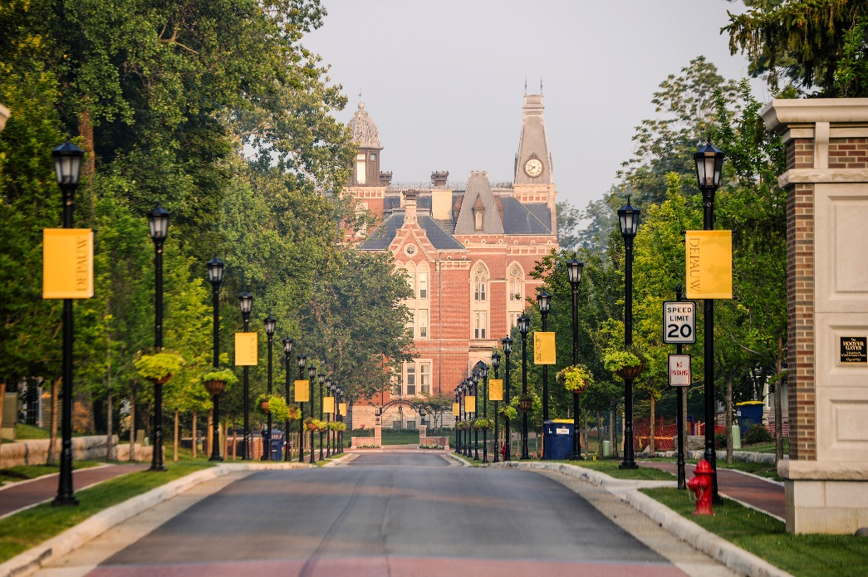

Photo Credit: Larry Ligget

DePauw University

Counseling Services

Practicum Training Program

(2026-2027)

DePauw University Counseling Services • Buehler Health and Wellness Suites
1 East Olive, Lilly Center, 2033, Greencastle, IN 46135

Welcome to DePauw University Counseling Services Practicum Training Program!

DePauw University Counseling Services promotes the emotional, interpersonal, physical, and psychological well-being of all students. Counseling Services seeks to provide effective, ethical, and professional services to help prevent, assess, and treat mental health concerns of DePauw University students. We are committed to affirming diversity in its broadest form and to serve as an advocate for social justice in our college community. We strive to build a multicultural learning community and engage in collaborative partnerships with Student Affairs and the entire university community. Counseling Services is a department within Student Affairs, and is housed in the Buehler Health and Wellness Suites.

Counseling Services promotes a supportive atmosphere committed to training future counselors and psychologists. We typically host 2-3 part-time practicum training positions each academic year (August to May). These practica are available to doctoral and master’s level students enrolled in Clinical or Counseling Psychology programs. There is also a stipend available to each trainee, which is approximately $1000 per academic year (before tax), in order to reimburse trainees for their travel expenses while commuting to DePauw University. These funds will be distributed in full at the end of the academic year.

DESCRIPTION OF PRACTICUM TRAINING PROGRAM
Counseling Services provides a wide variety of training activities and opportunities for our trainees. Our program is designed to allow trainees to learn and develop knowledge, skills, awareness, and practical experiences related to professional work at a university counseling center. As such, we incorporate didactic training seminars, individual and group supervision with case consultation, outreach programming, and clinical experiences into weekly training activity.

Each trainee is expected to be on-site with Counseling Services for a minimum of 20 hours and three days per week during regular office hours (M-F, 8:00 AM to 5:00 PM). Schedules are flexible with the exception of Friday, when each trainee is required to be present for clinical case staffing, didactic seminar, and group supervision/case consultation. We attempt to coordinate schedules in order to cover all hours that the office is open.

In addition to clinical experiences, outreach is an important aspect of the training program. As such, trainees are expected to participate in these programs throughout the academic year. Some outreach programs may take place in the evenings, and while not expected, we would like trainees to be available to participate in some evening programs.

The approximate breakdown of a typical week for trainees is as follows:

Time (hours) | Training experiences
10 | Individual, couple, and/or group therapy
2 | Intake assessment
1 | Individual supervision
2 | Didactic seminar and group supervision/case consultation
1 | Outreach programming
4 | Case management/paperwork
20 | Weekly total

Additional staff development opportunities for DePauw University and/or Counseling Services staff may be available to trainees during the year. Each trainee has access to a private office equipped with a desktop computer, camera/recording, encrypted flash drive, a DePauw University email account, and an office telephone.

INDIVIDUAL, COUPLE, AND GROUP THERAPY
DePauw University Counseling Services are available to all enrolled DePauw students. Clients may present with a variety of issues, the most common being relationship problems with family or significant others, depression, anxiety, eating/body image issues, substance abuse, trauma recovery, and stress management.

Trainees have the opportunity to co-facilitate psychotherapy and support groups with a senior staff member. Groups offered at Counseling Services vary depending on the semester and students’ needs, and have included: Understanding Self and Others Group, Sexual Assault Survivors Support Group, Coping Skills Group, Men’s Process Group, Women’s Self-Care Group, and Anxiety Support Group.

INDIVIDUAL AND GROUP SUPERVISION
Our training program embraces the use of counselor self-awareness as part of our training model. We value personal exploration and expect trainees to examine the qualities and dynamics they bring to interactions with clients, peers, and other work-related relationships. We believe such discussions, as they relate to trainees' activities throughout the year, can be particularly useful when attempting to understand transference and countertransference issues and in facilitating professional growth. This may call for trainees to reflect on and discuss personal reactions that might influence their clinical practice. Such disclosure frequently occurs within a supervisory relationship characterized by safety, trust, and respect. In addition to developing specific clinical skills, supervision includes a focus on personal exploration that is also meant to enhance a trainee’s effectiveness as a clinician.

Our culturally and professionally diverse clinical staff includes a licensed and HSPP-endorsed psychologist and three full-time, licensed mental health counselors. We also work closely with a mental health and wellness educator in addition to our office manager and a part-time, consulting psychiatrist. All of our clinical staff are engaged in the training program, and we are committed to providing a quality training experience.

DIDACTIC SEMINAR
Didactic seminars are an integral part of the training program. The seminar format includes discussion and process-oriented components. A wide variety of topics are covered that pertain to major areas of knowledge needed to build clinical and multicultural competencies for a clinician in training. Topics covered may include, but are not limited to:

- Ethics on a college campus | - Diversity and multicultural counseling
- Crisis intervention and management | - Practitioner Self-Care
- Trauma-focused work | - Solution-Focused Therapy
- AOD assessment and intervention | - Compassion-Focused Therapy
- Disordered eating  - Diagnosis and case conceptualization | - Acceptance and Commitment Therapy  - Working with student-athletes

OUTREACH

Trainees are involved in outreach programming that Counseling Services offers to the DePauw University community each semester. Topics typically include, but are not limited to:

- Mental health screenings  - Suicide prevention  - Alcohol and substance use awareness  - Mindfulness and stress management | - Self-care workshops  - Wellness Fair  - Women’s mental health  - Healthy relationships

