Patterns and processes of recovery

in and around an Indiana limestone quarry:

a preliminary report

Vanessa Artman and Dana Dudle, Department of Biology

In collaboration with Bryan Helm, David Pope, and Aaron Randolph, Science Research Fellows

August 2004

Introduction

In October 2003, DePauw University acquired a 481-acre (192-ha) “nature park”, intended for the various purposes of habitat conservation, education, and recreation. The land comprises several habitats, including deciduous forest, old fields, wetlands, a river, and several freshwater ponds, but the central feature of the land is a large limestone quarry that was abandoned approximately 30 years ago. Each of these habitats has been significantly affected by human activity, through logging, farming, fishing and mining, and some areas are highly disturbed. Some central questions of restoration ecology – Are the ecosystems recovering on their own? Or is human intervention appropriate and/or necessary to promote recovery? If intervention is necessary, what kind? – form the core of our discussions about how DePauw should use and manage this resource.

Here, we present some baseline data describing several projects begun in the quarry and surrounding habitats, as well as at the DePauw Arboretum, during summer 2004. We established several permanent grids marking study plots throughout the park and Arboretum (Figure 1): in three of the forested areas (ARB, QH, QS), several meadows (QAM, QWM, QR), and in the quarry basin (QB). Within those plots, we began investigating the present state of breeding bird and forest tree communities, the diversity of the surface-active forest invertebrate community, and the population biology of two native plant species that are found across multiple successional habitats in the park: Apocynum cannabinum (hemp dogbane), and Platanus occidentalis (sycamore tree).

Methods
We chose three forested sites to collect baseline data on bird and plant communities: the Arboretum (ARB), Quarry South (QS), and Quarry Hillside (QH) (Figure 1). Forest habitat at all three sites has been relatively undisturbed in recent history. However, habitat quality is limited by extensive forest fragmentation, with the surrounding landscape comprised of a mix of rural and suburban development. Adjacent land is used for athletic fields, four-wheel-drive roads, powerline rights-of-way, open meadows, and an abandoned limestone quarry.

We censused bird populations using the territory-mapping method (Robbins 1970). Each site was surveyed four times between late May and the end of June, between the hours of 5 and 10 a.m. During each survey, we recorded locations of singing and calling birds. Clusters of observations over multiple visits were used to identify territories. Population sizes for songbird species were estimated based on the number of territories within each site.

We searched for and monitored nests at the sites following protocol developed by the BBIRD (Breeding Biology Research & Monitoring Database) program (Martin et al. 1997). Nests were checked every 3 to 5 days to monitor their contents and determine their fate. Successful nests produced at least one host fledgling whereas failed nests had no fledglings. Causes of nest failure included predation, parasitism by Brown-headed Cowbirds, abandonment, and weather. We estimated daily nest survival rates using the Mayfield (1975) method.

We measured vegetation and habitat characteristics at ten randomly located plots in each site following BBIRD protocol (Martin et al. 1997). Within a 5-m-radius subplot, we estimated leaf litter depth, estimated percent cover of understory vegetation (< 50 cm tall), and counted the number of shrubs and saplings (< 8.0 cm dbh) by species and size class. Within an 11.3-m-radius subplot, we counted the number of trees and snags (> 8.0 cm dbh) by species and size class.

Results and Discussion
The three forested sites differ significantly in forest structure, vegetation composition, and breeding bird communities. These differences are surprising given the relative proximity of the sites. Furthermore, the forest composition of several of the sites is unusual for eastern deciduous forests. The history of human activity at the sites may provide a partial explanation for these differences.

Forest Structure and Composition
The forest at the ARB is dominated by a mix of sugar maple, oaks, and hickories (Figure 2), Ash and sugar maple seedlings, serviceberry, and spicebush are dominant in the understory (Figure 3). The ARB forest has more large trees, more leaf litter, and fewer shrubs than the other sites (Figure 4). Habitat at this site seems to be representative of typical eastern deciduous forest with few invasive plant species. However, without human intervention (e.g., reintroduction of fire), the oaks and hickories will not be replaced, given their absence in the understory. In the next generation, the forest canopy is likely to be dominated by shade-tolerant species such as sugar maple and ash. In addition the habitat quality, especially in the understory, is somewhat degraded because of the Arboretum’s small area and large amount of edge habitat due to construction of pathways through the forest, recent ATV activity, and adjacent land uses such as the powerline, agricultural cultivation, and athletic fields.

Forest at the QH site is dominated by elm and sugar maple in the canopy (Figure 2). Elm, black cherry, and black walnut are the dominant trees at QS. Elm typically occurs along bottomland floodplains, and it seems unusual for this species to be common in the interior of these hillside forests. We were surprised by the prevalence of both the black walnut and black cherry, especially at QS, given the history of extensive timber harvesting at the sites and the significant economic value of these two hardwood species.

Trees are smaller at QS and QH than the ARB, and leaf litter cover is lower at QS than the other sites (Figure 4). Spicebush, a native shrub, is common in the understory at QH and QS, but an invasive non-native species of honeysuckle is also prevalent. Presence of this invasive shrub may be indicative of past disturbance history, and may be affecting the potential for forest regeneration: there are few representatives of hardwood canopy species in the understory at these sites.
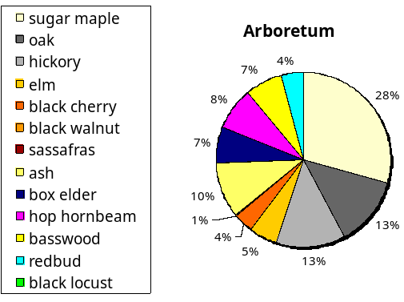
Figure 2. Forest tree composition at the three study sites. Forest composition at the ARB is typical of eastern deciduous forests. At QH and QS, forests have unusually high proportions of elm and cherry, and lack oaks and hickory, signature species of this region.

Figure 3. Forest understory composition at the three study sites. Native shrubs dominate the understory at the ARB but the regeneration layer lacks oaks and hickories. An invasive shrub forms the bulk of the understory at the quarry sites, but the dense shrub cover provides nesting habitat for songbirds such as Indigo Buntings and Northern Cardinals.

Figure 3. Size distribution of trees and cover of leaf litter at three sites. Different letters above the bars indicate significant differences between sites (1-way ANOVA with Tukey tests, p<0.05). Forest habitat is older at the ARB than at the quarry sites, and has more extensive litter; however, leaf litter at all three sites is less extensive than in typical eastern deciduous forests. Leaf litter decomposition rates may vary at the sites, which would impact communities of soil invertebrates, and thus, birds.
Figure 3. Size distribution of trees and cover of leaf litter at three sites. Different letters above the bars indicate significant differences between sites (1-way ANOVA with Tukey tests, p < 0.05). Forest habitat is older at the ARB than at the quarry sites, and has more extensive litter; however, leaf litter at all three sites is less extensive than in typical eastern deciduous forests. Leaf litter decomposition rates may vary at the sites, which would impact communities of soil invertebrates, and thus, birds.

Forest Bird Populations
All three forested sites support a variety of songbird species that are typical of eastern deciduous forests (Table 1). Our census data also indicate some differences in breeding bird populations across sites, despite the sites’ proximity, suggesting intriguing avenues for future work on a subset of these species.

Table 1. Number of bird territories at each site, 2004. Estimates are based on numbers of singing males observed during surveys

 | ARB | QH | QS
Yellow-billed Cuckoo | 0 | 5 | 4
Acadian Flycatcher | 5 | 8 | 13
Eastern Wood-pewee | 1 | 4 | 1
Red-eyed Vireo | 9 | 9 | 10
Carolina Chickadee | 2 | 5 | 6
Tufted Titmouse | 2 | 9 | 5
White-breasted Nuthatch | 2 | 5 | 2
Blue-gray Gnatcatcher | 3 | 5 | 10
Wood Thrush | 1 | 8 | 1
Kentucky Warbler | 2 | 2 | 1
Cerulean Warbler | 0 | 0 | 4
Louisiana Waterthrush | 2 | 1 | 0
Northern Parula | 2 | 0 | 2
Yellow-throated Warbler | 2 | 0 | 1
Scarlet Tanager | 1 | 1 | 2
Eastern Towhee | 3 | 3 | 4
Nothern Cardinal | 10 | 9 | 10
Indigo Bunting | 7 | 3 | 13

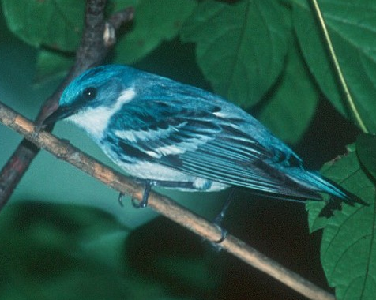
One of the most intriguing results was the presence of Cerulean Warblers at QS. The Cerulean Warbler is a species of significant conservation concern. Widespread population declines of this species have been documented throughout eastern North America, and the species is being considered for federal protection. Cerulean Warblers require large tracts of mature closed-canopy forest for nesting habitat, and populations may be declining due to loss of habitat. Their distributions are patchy within suitable habitat but reasons for this patchy distribution are unknown. It thus is not surprising that Cerulean Warblers occurred only at QS and not at the other sites (Table 1). What is surprising, however, is that Cerulean Warblers occurred at any of the sites, given the rarity of this species and the fragmentary nature of the forest habitat in the landscape. The presence of Cerulean Warblers at QS appears to be unrelated to differences in vegetation composition or cover but attests to the importance of maintaining the forest within its existing condition to continue to provide habitat for this rare bird.
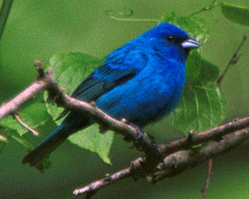
The invasive shrub cover throughout the forest at QS provides an abundance of nesting habitat for the Indigo Bunting, a Neotropical migratory songbird. Indigo Buntings usually occur in early-successional habitats such as open meadows. They were common in the ARB (Table 1), but occurred only in edge habitat, adjacent to the powerline and athletic fields with none occurring in the forest interior. In contrast, Indigo Buntings were widely distributed throughout the forest habitat of QS, nesting in low shrubs and Equisetum. We found and monitored multiple Indigo Bunting nests (Table 2) in QS and in some of the meadow habitats. The distribution of this bird species across such a variety of habitats (edge, meadows, and closed-canopy forests) provides an excellent opportunity for future research on fitness consequences of habitat selection within an easily accessible environment close to campus.

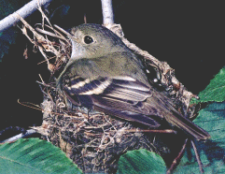
Acadian Flycatchers also occur at all three forested sites. This Neotropical migratory songbird is restricted to forest-interior habitat where it nests at the ends of long tree branches extending over stream drainages. We monitored 13 Acadian Flycatcher nests and found fairly high levels of breeding productivity (Table 2). Half of the nests failed due to predation or Brown-headed Cowbird parasitism, but the estimated rate of daily nest survival of 95.5% may be sufficient to support a healthy self-sustaining population. The Acadian Flycatcher is another appropriate species for additional research since it is common at all three sites and their nests tend to be accessible.

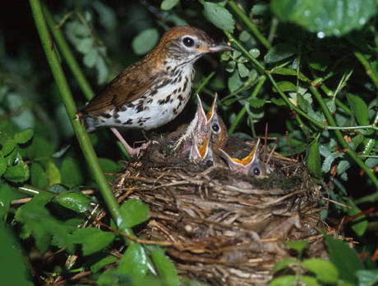
Wood Thrushes are common and uniformly distributed throughout eastern deciduous forests habitat, and their large bulky nests tend to be easy to find and monitor. We were surprised to find that Wood Thrushes were common at QH but were almost absent from the other sites (Table 1), and their nests were unusually difficult to find. The differences in forest structure and composition between the sites do not necessarily explain these results, but the Wood Thrush’s unusual distribution merits closer attention in the future.

Table 2. Nesting success for two species of forest birds at the sites

 | Acadian Flycatcher | Indigo Bunting
Number of nests monitored | 12 | 7
Number of successful nests | 6 | 2
Number of nests failed: predation | 5 | 3
Number of nests failed: parasitism | 1 | 2
Observation days | 132.5 | 85.5
Daily nest survival rate | 95.5% | 94.2%
Implications, Suggestions and Future Research
Overall, the closed-canopy forest at QS, QH, and the ARB provides valuable habitat for a variety of Neotropical migratory songbirds, several of which are of significant conservation concern. It was interesting to discover that although the forest bird composition was representative of Eastern deciduous forests, the forest tree and understory composition and structure are atypical for the region. We intend to investigate the reasons for these differences by researching the history of recent land use at the sites, and by studying the forest soils; for example, mining activities may have affected the pH of the soils in forested areas near the quarry, inhibiting the establishment of many typical hardwood trees at those sites.

We recommend that continued or expanded disturbance in all of these habitats, including camping and trail construction be minimized to maintain the integrity of the forest communities. We also recommend that forest management practices proceed with caution throughout the natural areas given what we have learned about the associated bird communities at the sites.

In addition, the sites provide an array of opportunities for research and outdoor activities for coursework in ecology, plant biology, conservation biology, and environmental science. These baseline observations have inspired many ideas for additional research. Some questions we would like to address given more effort and focus in future years include;

What biotic, abiotic, spatial and historical factors contribute to the unusual forest composition at the quarry forest sites?

How do bird population levels vary between sites and years?

Are there differences in nest site selection between sites? What are the consequences of these differences in terms of reproductive success?

How does food availability differ, given variation in the distribution of masting trees (oaks, hickories, walnuts) between the sites?

Are invasive species such as the honeysuckle spreading? How do we minimize the spread of invasive and non-native plant species such as poison ivy, stinging nettle, grapevine, and garlic mustard without eliminating songbird habitat?

What is the recent history of the sites, and how has human land use affected the sites’ biological communities?

The acquisition of the abandoned limestone quarry and its surrounding forests has opened up countless opportunities for research by undergraduate students and faculty at DePauw University. We are especially excited about the opportunity for multiple long-term experiments at common sites, addressing questions within an interdisciplinary context.

