Name:
Introductory Economics Lab http://www.depauw.edu/learn/introeconlab
Excel Workbook: Externalities.xls

Externalities Lab

Introduction

This lab is devoted to explaining the concept of externalities, why they cause a market failure, and how Pigovian taxes or subsidies can be used to fix the market. We conclude with a quick look at the EPA’s web site on emissions trading.

Open Externalities.xls and read the Intro sheet. It defines the term “externality” and explains why the market will fail to properly allocate resources. If we have a negative externality (so the full cost is not taken into account), we’ll get too much output. The market will generate too little output if we have a positive externality. There are several approaches to handling externality problems. This lab will focus on tax or subsidy schemes, pioneered and named after A. C. Pigou.

Read what your textbook has to say about externalities and applying taxes or subsidies to correct the market failure.

Q1) Find the definition of “externality” in your textbook and quote it (by typing in the text in the box below). Document your quotation, including the author’s name, title of the textbook, edition, year of publication, and page number.

Enter your answer in this box. The box expands as you type in text.

Q2) Find the definition of a “market failure” in your textbook and quote it (by typing in the text in the box below). Document your quotation, including the author’s name and page number.

Enter your answer in this box.

Proceed to the Externalities sheet.

Let’s take a quick tour of the screen (reproduced below).

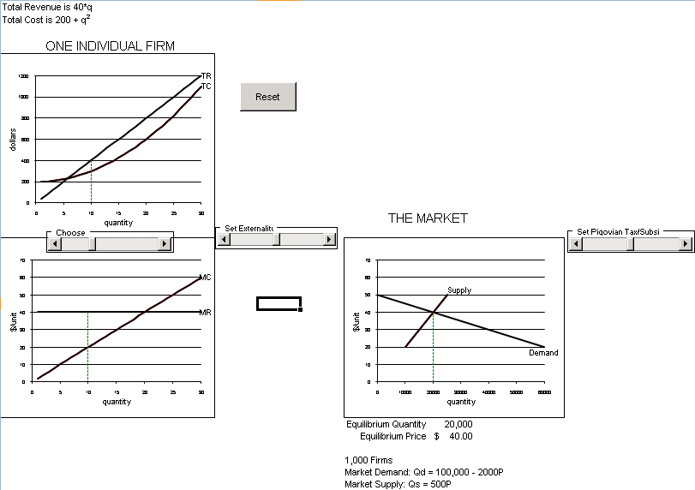

On the left are the totals and marginals graphs for a single firm. We ignore the average cost curves (ATC and AVC) because we aren’t interested in this firm’s profit position. All we care about is how much they will produce.

On the right is the conventional supply and demand graph. Notice that the y axes of the marginal and supply-and-demand graphs are the same. The x axes, however, are different. There are 1,000 firms and, combined, they produce tens of thousands of units of output.

Q3) This particular firm is currently producing 10 units of output. What would you advise this firm to do? Why?

Enter your answer in this box.

Q4) Use the Choose q control to find the firm’s optimal output. Report your answer in the text box below along with an explanation of why this is the correct answer.

Enter your answer in this box.

Q5-A) Slide the Set Externality control all the way to the RIGHT (so the red lines are above the black lines in the three graphs). What kind of externality is this?

Enter your answer in this box.

Q5-B) The red lines are not labeled. What label would you attach to the red curve in the top graph, the red line in the bottom graph, and the red line above the Supply curve?

Enter your answer in this box.

Q6) Does the firm’s individual, profit-maximizing level of output change now that the externality is in effect? Explain.

Enter your answer in this box.

Q7) Does the market’s equilibrium level of output change now that the externality is in effect? Explain.

Enter your answer in this box.

Q8) The dashed line coming down from the intersection of market demand and market MSC curve indicates a particular level of output. What is significant about this number?

Enter your answer in this box.

Key Concept
Q9) Does this situation represent a “market failure”? Explain.

Enter your answer in this box.

Use the Pigovian Tax/Subsidy control to fix the market failure.

Q10) How does the Pigovian Tax/Subsidy affect the market?

Enter your answer in this box.

Q11) Are you using a Pigovian Tax or Subsidy to correct the market failure? How do you know if it’s a tax or a subsidy?

Enter your answer in this box.

Q12-A) Fixing the allocation problem created by externality requires that the firm be forced to “internalize the externality.” What does “internalize” mean?

Enter your answer in this box.

Q12-B) How does the Pigovian Tax/Subsidy force the firm to internalize the externality?

Enter your answer in this box.

Subtle Point: If you are really careful, you might be wondering why the tax doesn’t affect the Price actually received by the firm. In fact, you could model it this way and you would get the exact same profit-maximizing behavior from the firm.

Key Concept
Q13) Have you fixed the externality? How do you know?

Enter your answer in this box.

Click the button.

Run the Set Externality control all the way to the LEFT. We now have a positive externality in production.

Q14) Give an example of a positive externality in production.

Enter your answer in this box.

Q15) The firm is currently producing 10 units of output. What would you advise this firm to do? Why?

Enter your answer in this box.

Q16) Use the Choose q control to find the firm’s optimal output. Report your answer in the text box below along with an explanation of why this is the correct answer.

Enter your answer in this box.

Q17) Why is the market’s equilibrium level of output, displayed below the supply and demand graph, not at the intersection of Demand and the red line?

Enter your answer in this box.

Q18) Describe the market failure in this case. What is the market doing wrong?

Enter your answer in this box.

Move the Pigovian Tax/Subsidy control all the way to the LEFT.

Q19) Why does moving the Pigovian Tax/Subsidy control to the left shift the black line down?

Enter your answer in this box.

Key Concept
Q20) Have you fixed the externality? How do you know?

Enter your answer in this box.

We’ll finish up this lab with a general question on Pigovian taxes and a visit to the EPA’s web site on emissions trading, then offer a couple of Advanced Thinking questions.

Q21) Since a Pigovian tax shifts the supply curve up just like a regular tax, why do we bother giving this tax a special name? In other words, what’s the difference between Pigovian taxes and regular taxes?

Enter your answer in this box.

While Pigovian taxes and subsidies are a decentralized approach to correcting a market failure caused by externality, in recent years, an even more market-oriented approach has been used.

For example, by creating a market for the right to pollute, firms are forced to take into account the full costs of their production decisions. They must buy a permit in order to pollute and this forces them to internalize the externality.

The Environmental Protection Agency (EPA) maintains two emissions trading programs, one for sulfur dioxide (SO2) and the other for nitrogen oxides (NOx).

The web site provides information and data. Let’s take a look.

Click on the link below to see an explanation of emissions trading basics.
http://www.epa.gov/airmarkets/trading/basics.html.

Check out the slideshow on cap and trade here: http://www.epa.gov/captrade/captrade-101.html

Q22) The EPA seems pretty confident that emissions trading works. To what do they attribute the success of “cap and trade”?

Enter your answer in this box.

Click on the link below to learn about allowance trading.
http://www.epa.gov/airmarkt/trading/factsheet.html and then navigate to http://www.epa.gov/airmarkt/trading/buying.html

Q23) How much sulfur dioxide does one allowance permit? How can allowances be purchased?

Enter your answer in this box.

Click on Annual Auction, and then select the most result auction results. Scroll down to Spot Auction winners.

Q24) Why might an environmental organization choose to purchase allowances in a spot auction?

Enter your answer in this box.

Click on the link below to see how the EU is implementing a tradable permits scheme.
http://europa.eu.int/comm/environment/climat/emission.htm
http://europa.eu/pol/env/index_en.htm
(If the first link does not work, follow the second link and read the “Emissions Trading” section)
The site has a great deal of information on the EU ETS program.

Other countries (including such different places as Costa Rica and China) have started emissions trading programs. The idea of creating a market for pollution in order to correct the market failure caused by externality is most definitely a real, practical solution.
Advanced Thinking

Q25) While Pigovian tax and permit trading seem to dominate command and control, let’s compare the Pigovian tax to permit trading. Of course, there are two sides to this question, but what is the argument in favor of permit trading over Pigovian taxes?

Enter your answer in this box.

Q26-A) Give an example of a positive externality in consumption. How would it affect the demand and supply graph?

Enter your answer in this box.

Q26-B) What would the market be doing wrong in this case?

Enter your answer in this box.

Congratulations! You have finished the externalities lab.

Save this document and print it.

You can save a lot of paper and ink by cutting everything out of the final, printed version except the questions and your answers.

