User Guide to Configure Excel, Open Macro-Enabled Workbooks, and Use Add-ins

Properly Configuring Excel
To make sure that Excel is able to access and run Visual Basic macros, security must be properly set. If buttons, scroll bars, and other objects do not work, it is likely that macros have not been enabled.

The interface for configuring Excel depends on the version being used, but all are basically the same: set up Excel so that macro-enabled workbooks trigger a prompt enabling confirmation that the file is to be opened. This macro setting is accessed through the Options dialog box, which is different on different versions of Excel.

In Excel 2010 and greater, from the File menu, select Options. Excel 2007 users should click the Office button, then Excel Options (at the bottom). With the Excel Options dialog box open, Excel 2013, 2010 and 2007 users should select the Trust Center and click on the Trust Center Settings button. In the Trust Center, select the Macro Settings heading, choose the “Disable all macros with notification” option (this is often the default).

For Excel 2003 and earlier, from the Tools menu, select Macros and then Security. Choose Medium in the Security Level tab (which is often the default).

Opening a workbook
When opening a workbook with macros, Excel 2007 and greater will alert you to their presence with a security warning under the ribbon, as shown, for example, in Figure 1.
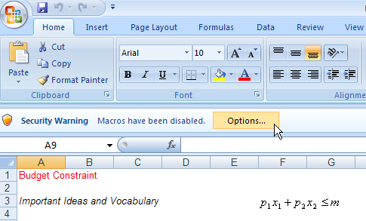
Figure 1: Opening a workbook with macros in Excel 2007 or greater.
Click the Options button, then click “Enable this content” to allow the buttons and other controls in the workbook to function properly. Users are prompted to make this file trusted so that macros will be enabled automatically the next time the file is opened.

Do not enable macro functionality unless you are completely confident that the workbook is safe.

You may also receive the warning displayed in Figure 2 when opening a workbook with macros.

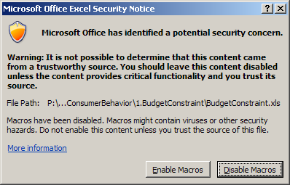
Click the Enable Macros button to have access to the features in the workbook, but do not enable macros if you are unsure of the source.

Figure 2: Macros Warning.

In Excel 2007 and greater, you may save a file as .xlsm (macro-enhanced workbooks) to preserve the macros in the workbook. Files are originally .xls to allow users with older versions of Excel access to the files and you may continue saving files in this format.

Installing and Using an Add-in
Excel add-ins are special files (with extension .xla) that extend the functionality of Excel. They should never be directly opened as a regular workbook. Instead, they are loaded and installed via Excel’s Add-ins Manager. As with macros, different versions of Excel utilize different procedures, but the basic idea is the same: use the Add-ins Manager to open add-in files and install them.

In Excel 2013, 2010 and 2007, the Add-ins Manager is accessed from the Excel Options dialog box (under the File menu in Excel 2013 and 2010 and by clicking the Office button in Excel 2007). From the Excel Options dialog box, select Add-Ins and click the Go button to bring up the Add-ins Manager shown in Figure 3.

You can check an add-in from the list or click the Browse button and navigate to an add-ins location. In Figure 3, Excel Solver and the Comparative Statics Wizard are installed and available for use. The other three add-ins are not installed.

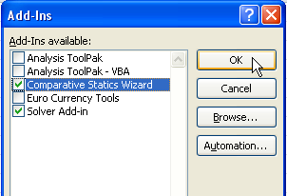

Figure 3: The Add-ins Manager.

To access the Add-ins Manager in Excel 2003 and earlier, select Add-Ins from the Tools menu.

Once an add-in is installed, Excel 2007 and greater users should look in the Add-ins group in the ribbon, except for Solver (a special and proprietary add-in) which is the Data tab. In Excel 2003 and earlier, add-ins are usually listed in the Tools menu.

